May 4, 2018
Ed Dryden
Chairman, Energy & Green Advisory Board
NCTCOG
c/o Development Services Department
Building Official
City of Lancaster
700 E. Main Street
Lancaster, TX 75146

RE: North Central Texas Council of Governments proposed IECC amendments

Dear Mr. Dryden:

Per your request as Chairman of the North Central Texas Council of Government (NCTCOG) Energy and Green Advisory Board and in accordance with Sec. 388.003 of the Health and Safety Code, the Energy Systems Laboratory (ESL) of the Texas A&M Engineering Experiment Station has performed a stringency comparison of the NCTCOG proposed amendments and trade off with the 2015 edition of the International Energy Conservation Code (IECC) and compatible sections to the energy provisions of Chapter 11 of the 2015 International Residential Code (IRC), comprising the Texas Building Energy Performance Standards (TBEPS).
A detailed report of the analysis will be forthcoming.

The proposed NCTCOG amendment package to the 2018 IECC will meet or exceed the Texas Building Energy Performance Standards (TBEPS).

Please feel free to contact us should you have any questions.

Sincerely,
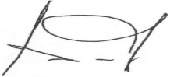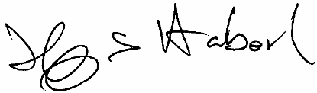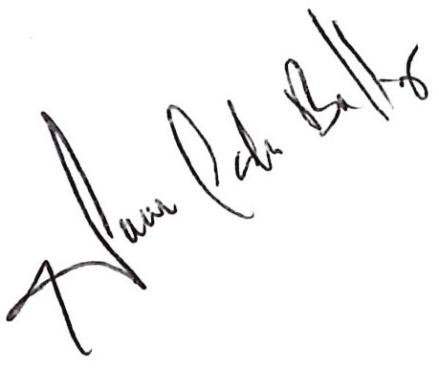
Bahman Yazdani, P.E. Jeff S. Haberl, Ph.D. Juan-Carlos Baltazar, Ph.D., P.E., BEMP
Associate Director, Associate Director, Associate Director,
Energy Systems Laboratory Energy Systems Laboratory Manager of Energy Analysis & Modeling Groups
Energy Systems Laboratory

