August AQ Health Task Force Meeting
Date: August 21, 2020
Time: 9:30 - 11:30 am (CST)
Zoom Meeting
Attendees:
Name | Organization
Abhijit Basu | SmartEx
Anthony Williams | City of Fort Worth
Emily Asbury | City of Irving
Grace Tee Lewis | Environmental Defense Fund (EDF)
Jeremy Johnson | Texas A&M Transportation Institute (TTI)
Kathy Fonville | City of Mesquite
Katy Evans | City of Dallas
Kevin Overton | City of Dallas
Lu Liang | University of North Texas (UNT)
Maia Draper | Environmental Defense Fund (EDF)
Mendie White | City of Lewisville
Pharr Andrews | City of Dallas
Razieh Nadafian | Environmental Defense Fund (EDF)
Theresa Daniel | Dallas County
Zoe Bolack | DFW International Airport
Yarcus Lewis | City of Plano
Steve Mattingly | University of Texas Arlington
Jaesik Choi | University of Texas Arlington
Kate Zielke | NCTCOG
Vivek Thimmavajjhala | NCTCOG
Lori Clark | NCTCOG
Jenny Narvaez | NCTCOG
Nick Van Haasen | NCTCOG
Laura Davila | NCTCOG
Dorothy Gilliam | NCTCOG

Meeting Summary

Project Update from the University of Texas Arlington
Presenter: Dr. Mattingly UTA
Email survey was conducted to 50 states agencies between June and July 2020
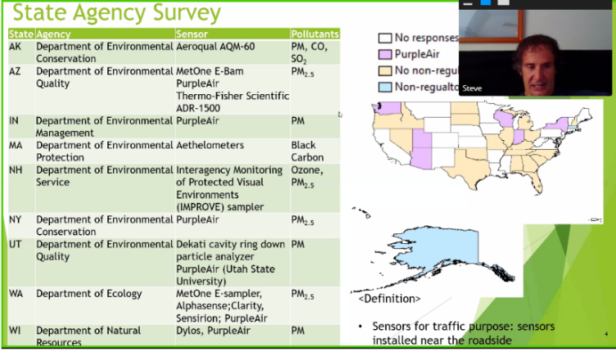
- 29 states responded

PM Sensors
PurpleAir
- Used more often
- Performs well
- Low cost
- Wi-Fi dependent

Ozone sensors
- Lifetime of sensors has concerns, as they typically have a short life span

NO2 sensors
  - Not much clarity
  - CARTOLA seems to be best option at this point

Feedback from agencies
- Most states perform maintenance to sensors about once a month
- Many states use low cost sensors
- PM seems to be the focus of most of the states

UTA Recommendations are based on:
- Cost
- Ease of operation
- Data record/logging
- Accuracy
- Longevity

Evaluating Air Quality, Health and Environmental Justice in Houston Methods and Takeaways for the DFW Region
Presenter: Dr. Grace Tee Lewis - EDF
Houston Air Quality
- Ranked 14 for high ozone days out of 229 metropolitan areas
- Ranked 56 for 24-hour particle pollution out of 216 metropolitan areas

The Houston-Galveston-Brazoria (HGB) area regularly faces challenges and Hurricane Harvey highlighted the disadvantage minority communities face

HGB Enviroscreen Tool Link: https://hgbenviroscreen.org/
Interactive maps allow you to visualize what makes an area vulnerable
- East Houston is highest ranking in vulnerable communities
In the future they want to use this for Transportation Planning, and they wish to:
- Incorporate air quality and health considerations
- Have a scientific data approach
- Get the Houston Galveston Area Council (HGAC) region on census track resolution

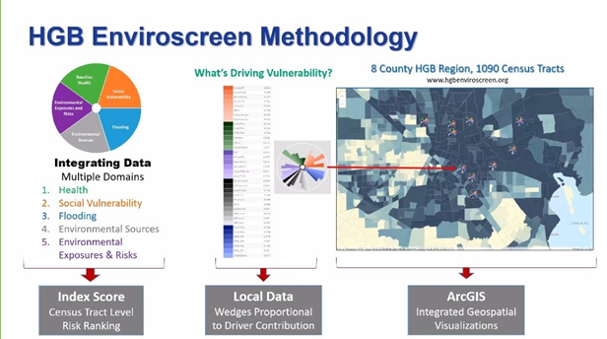

Community Action Planning
  - Rank Census tracks in the HGB Enviroscreen Tool are EPA Toxicological Prioritization Index (ToxPi)
  - Integrates pollution and vulnerability data
  - Identifies areas where vulnerable communities need help
Integration of data:
- Health
- Social Vulnerability
- Flooding
- Environmental Sources
- Environmental Exposures and Risks

PM 2.5 Ensemble Data:
Methodology
- Examining the correlation between PM 2.5 and mortality rates
- Low income communities have a higher exposure to PM 2.5
- TCEQ has approved air monitor in West Houston area
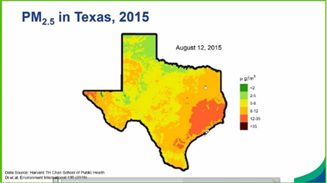
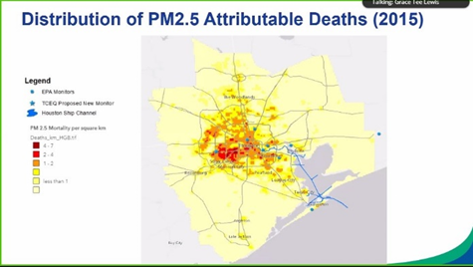
- As population expands, the need for new air monitors increases

Question and Answer:
Q: Is there any expected research to study the correlation between high PM levels and higher COVID death/hospital rates?
- Yes
Q: There is an Inconsistency in Pasadena. They have refineries, why don't they have high level of PM 2.5?
- Maybe the air current cause the PM 2.5 blows from Pasadena to the West Houston
Q: Does EDF have plans to expand this work beyond Houston?
- Yes, want to expand and incorporate transportation data
Q: Would you consider having a Webinar to explain how to use the Enviroscreen Tool?
- Yes

Advanced Fine Scale Transportation, Air Quality, Health Integrated Assessment Tool for Future Cities:
Presenter: Dr. Mahnaz Nadaf
What is the impact of transportation decisions on air quality?
- Exposure to primary PM 2.5 and disparities
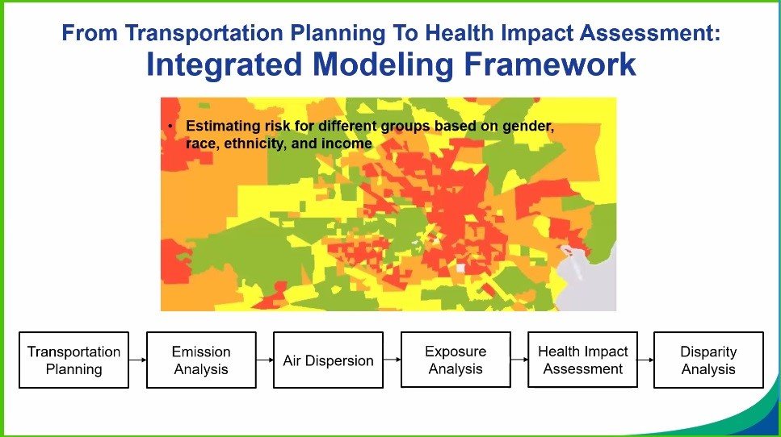
- Those with the lowest income, experience 43.3% higher exposure to vehicle emission compared to highest income group
- African Americans have 10.6% higher exposure than White Americans
- Latinos 17.1% higher compared to non-Latinos
- Groups with low income, non-white and Latinos are more likely to live closer to highways

Spatial-Temporal Air Monitoring Project (STAMP)
Presenter: Dr. Lu Liang - UNT
Background:
- Air pollution concentration is highly dynamic at the intra-urban areas
- Influence of urban morphology
  - Horizontally- urban heat island landscape affects dispersion of pollutants
  - Vertically- wind direction
Research:
- Scope of study: UNT Main Campus
- Goal: to characterize the vertical and horizontal profile
- Portable sensors
  - Easy to get started with, to get an overall sense of your study area
- Stationary sensors
PMAPS Project
Research Goals: PM 2.5 sensors to build a fine-grain monitoring network to measure air quality more accurately in DFW
- Purple Air is being used
- Multiple sensors are being used throughout Denton Area- about 15 sensors
  - Sensors are in multiple area, from high pollution to low pollution
- Data collection is still ongoing
- Outreach:
- Targeted towards 7th grade students
- Will track facial expressions to see how students feel

Update on Effects of COVID-19 Transportation and Air Quality Trends
Presenter: Nick Vanhaasen - NCTCOG
Transportation
- Traffic decrease when shelter in place order were in action, April 2020 saw a 27.8% reduction in traffic
  - Less traffic= more speed on highways
  - April low congestion, high speeds= 65mph
  - Higher levels of crashes and fatalities
- Passenger decreases on public transit
Airport Impacts
- Over 90% reduction in passengers in April 2020, compared to 2019
Bicycle and Pedestrian Impacts: Trail Counts
- Increase (30%) in March-May 2020 but decreasing in June

Air Quality
- Prior to Aug. 3, 2020: lowest frequency of high-level unhealthy exposure to Ozone
- How can we sustain impacts?
  - Electric and fuel cell vehicles
  - Telecommute

Conclusion:
Miscellaneous
- Nick Van Haasen: Sent Email to request the compiling of air quality data to have a centralized location for all of it

Next Meeting: Friday, November 6, 2020 from 9:30 to 11:30 a.m.

Action Items | Lead Person/Agency on Action | Deadline
Upload presentations and meeting recording to a dedicated webpage on NCTCOG.org | Dorothy Gilliam - NCTCOG | By November 6 Meeting
Webinar to explain how to use the Enviroscreen Tool | NCTCOG & EDF | N/A

