Name of Jurisdiction

INCIDENT SUPPORT EOC
SITUATIONAL AWARENESS
HANDBOOK
December 2020

Approval and Implementation
The (Name of Jurisdiction) Incident Support EOC Situational Awareness Handbook is designed to provide operational guidance for the (Name of Jurisdiction) Emergency Operations Center (EOC) by defining the overarching approach to (Name of Jurisdiction)’s EOC operations and position-specific guidance for the Situational Awareness Section Chief and Units. General and position-specific guidance includes general tasks, activation, operations, shift change, and demobilization checklists. Checklists will be used during operation and will continue to be refined based on subject matter expertise and lessons learned during real-world events. Handling instructions for this document are defined on page vii.
The (Name of Jurisdiction) Incident Support EOC Handbooks (Command, Situational Awareness, Planning Support, Resources Support, and Center Support) supersede all previous EOC handbooks and manuals for (Name of Jurisdiction) and implements the handbooks as the primary operational guidance for the (Name of Jurisdiction) EOC. In turn, this handbook does not supersede or replace the (Name of Jurisdiction) Emergency Operations Plan (EOP) and its annexes or other procedures already in place in (Name of Jurisdiction). Instead, it supplements those procedures with a temporary Incident Support Model (ISM) structure, which provides for the immediate management of response operations and the early transition to recovery operations.
This Incident Support EOC Situational Awareness Handbook is approved and implemented on (insert day) of (month), (year).

(Signature)
_____________________________________________________
(Name)

_____________________________________________________
(Senior Official Title), (Name of Jurisdiction)
Additional signature lines should be added to accommodate additional signatories.

This page intentionally left blank.

Record of Changes
Change # | Change Date | Change Type | Entered By

This page intentionally left blank.

Record of Distribution
Date | Office/Department | Representative | Signature

This page intentionally left blank.

Handling Instructions
The (Name of Jurisdiction) Incident Support EOC Situational Awareness Handbook is designated For Official Use Only (FOUO) and is the property of (Name of Jurisdiction) (Name of Organization). Only (Name of Organization) representatives may distribute the handbook to individuals with a need to know. Distribution by other individuals without prior authorization is prohibited. The handbook is unclassified but contains sensitive information that may be exempt from public release under the Freedom of Information Act (5 U.S.C. 552) and the Texas Public Information Act (Texas Government Code Chapter 552).
The handbook and its associated sections are to be controlled, handled, distributed, and disposed of in line with the U.S. Department of Homeland Security policy regarding FOUO designated materials. Copies of this handbook, digital and hard copy, should be stored in secure locations due to the operational content for emergency response, including materials focused on safety and security. The handbook should not be distributed to the public, media, or personnel without a valid need to know.
All questions regarding the handling of this document should be directed to (Name of Jurisdiction) (Name of Organization) (Name of Emergency Management Position).
This page intentionally left blank.

Table of Contents
Introductory Materials
Approval and Implementation i
Record of Changes iii
Record of Distribution v
Handling Instructions vii
EOC Operations 1
I. Introduction and Purpose 2
Introduction 2
Purpose 2
II. Emergency Response, ICS Fundamentals, and Community Lifelines Integration 3
Emergency Response Systems, Laws, and Authorities 3
ICS Overview 4
Unified Command 4
Unified Coordination 4
Disaster District Committees 5
ICS Organizational Elements – Roles and Responsibilities 6
Planning P 9
ICS/EOC Interface 10
FEMA Community Lifeline Integration into Situational Awareness 11
Incident Support Model EOC Structure 12
III. EOC Concept of Operations 14
Overview: Emergency Response Organization, Assignments, and Responsibilities 14
Activation Levels 15
Activation Triggers 16
ISM EOC Organization Chart 17
ISM EOC Layout 18
EOC Organization: Emergency Response Positions, Units, and Responsibilities 19
IV. EOC General Responsibilities Checklist 28
V. EOC Activation Checklist 31
VI. EOC Demobilization Checklist 33
Situational Awareness Section Chief and Units Roles, Responsibilities, and Checklists 35
I. Situational Awareness Section Chief 36
Roles and Responsibilities 36
Position Checklists (Activation, Operations, Demobilization) 37
II. Community Lifelines Unit 41
Roles and Responsibilities 41
Position Checklists (Activation, Operations, Demobilization) 42
III. Hazard Analysis Unit 44
Roles and Responsibilities 44
Position Checklists (Activation, Operations, Demobilization) 44
IV. Media Analysis Unit 46
Roles and Responsibilities 46
Position Checklists (Activation, Operations, Demobilization) 46
Handbook Maintenance, Revision, and References 49
I. Maintenance and Revision 50
II. References 51
Appendices 53
Appendix A: Damage Assessment Process A-1
Appendix B: Glossary of ICS Terms B-1
Appendix C: Abbreviations C-1

EOC Operations
The goal of the Incident Support EOC Situational Awareness Handbook is to define key information and guidance regarding the operation of the (Name of Jurisdiction) Emergency Operations Center (EOC). The handbook accomplishes this goal by providing an overall organizational approach and general procedures for the management of information, activities, and operations in the EOC during an emergency or disaster. The handbook is focused on defining EOC operations to function based on a worst-case scenario and defines how critical functions and roles of the (Name of Jurisdiction) are managed during a response.
The (Name of Jurisdiction) EOC is operated using an Incident Support Model (ISM) approach. Built on the organizational structure as defined in the National Incident Management System (NIMS), the (Name of Jurisdiction) EOC operates in line with emergency operations of other local, regional, state, and federal emergency management organizations. The ISM approach provides a flexible system, allowing for parts or the entire EOC to be activated to meet operational objectives.
The EOC Operations section begins with an introduction and a definition of the purpose of this handbook. It explores emergency response, Incident Management System (ICS) fundamentals, and community lifelines integration and documents the EOC Concept of Operations. This is followed by the EOC General Responsibilities Checklist, the EOC Activation Checklist, and the EOC Demobilization Checklist.

Introduction and Purpose

Introduction
Disasters and emergencies can happen suddenly, which can affect normal staffing levels, causing (Name of Jurisdiction) public safety departments to become overwhelmed. The (Name of Jurisdiction) Office of Emergency Management (OEM) has established this EOC handbook, which provides a guideline for the management of the immediate actions and operations required to respond to an emergency or disaster situation. The priorities of (Name of Jurisdiction) during a disaster are life safety, incident stabilization, protection of property and the environment, and the re-establishment of social norms. The overall objective is to respond to emergency conditions and manage the process of restoring the (Name of Jurisdiction) back to pre-disaster conditions.

Purpose
This handbook provides a management structure, key responsibilities, emergency assignments, and general procedures to follow during an emergency. OEM has established this handbook to address the priorities listed above. This handbook does not supersede or replace the (Name of Jurisdiction) Emergency Operations Plan and its annexes or other procedures that are already in place in (Name of Jurisdiction). It supplements those plans and procedures with a temporary ISM management structure, which provides for the immediate management of response operations and the early transition to recovery operations. The emergency operations plan and annexes will always take precedent whenever procedural conflicts occur.

Emergency Response, ICS Fundamentals, and Community Lifelines Integration
This section outlines emergency response, ICS fundamentals, and community lifelines integration based on the specific use by (Name of Jurisdiction).

Emergency Response Systems, Laws, and Authorities
This section addresses the (Name of Jurisdiction) emergency responsibilities and is consistent with the following plan, system, laws, and authorities.

(Name of Jurisdiction) Emergency Operations Plan
Emergency management response authority, policies, responsibilities, and assignments are established in the (Name of Jurisdiction) Emergency Operations Plan (EOP). This plan allows the chief elected official or designee emergency authority to take actions and make emergency expenditures of funds in response to emergency conditions.
This plan is consistent with all plans and procedures and does not supersede or replace current procedures for safety, hazardous materials response, or other procedures that are already in place.

System, Laws, and Authorities
The (Name of Jurisdiction) emergency management response system and this handbook are in accordance with the following laws, codes, and executive orders:
(Name of Jurisdiction)
- Ordinance #(Number), Emergency Management
- Ordinance #(Number), Adoption of the National Incident Management System (NIMS)
State of Texas
- Government Code 418, Emergency Management
- Government Code 421, Homeland Security
- Government Code 433, State of Emergency
- Texas Administrative Code Title 37, Public Safety and Corrections
- Executive Order RP-32, Emergency Management and Homeland Security
- Executive Order RP-40, National Incident Management System (NIMS)
Federal Government
- The Federal Emergency Management Agency (FEMA) is the federal-level authority for emergency management. A presidential declaration activates the Federal Emergency Response Plan and allows the state to access federal resources for emergency response.
- The Robert Stafford Act (Public Law 93-288, amended) provides the federal authority and program for federal congressional appropriation of public funds for disaster assistance. The Stafford Act also includes a provision for hazard mitigation projects.
- Homeland Security Presidential Directive 5 (HSPD-5) - Management of Domestic Incidents (National Incident Management System), which was issued on February 28, 2003, enhances the ability of the United States to manage domestic incidents by establishing a single, comprehensive national incident management system.
This EOC handbook is designed for response operations. The North Central Texas Council of Governments (NCTCOG) Recovery Framework and associated toolkit (https://www.nctcog.org/ep/resources/local-disaster-recovery-framework-and-toolkit) are designed to assist with local recovery planning.

ICS Overview
As defined in the National Incident Management System (2017), ICS is a standardized approach for addressing command, control, and coordination of on-scene incident management. ICS is also used in many EOCs for incident management. ICS establishes a hierarchy and a flexible, expandable organizational structure to meet the demands of an incident.
The system allows for the integration of personnel from multiple organizations with varying levels of experience across disciplines to establish a coordinated incident management approach applicable to all hazards. ICS is used by government organizations (local, state, and federal), nongovernmental organizations (NGOs), and private sector entities.
Beyond simply addressing personnel for incident management, the ICS organizational structure provides an integrated approach for communications, equipment, facilities, personnel, and procedures.

Unified Command
The overall management of an incident can be the responsibility of a single Incident Commander (IC) or a Unified Command (UC). To improve unity of effort, Unified Command can be established to integrate multiple jurisdictions or agencies that are all engaged in managing an incident. The approach allows all jurisdictions and/or organizations with authority or functional responsibilities to jointly manage an incident, working collaboratively to establish strategies, incident objectives, and a single Incident Action Plan (IAP). Once Unified Command is established, each organization and/or jurisdiction retains its own authorities and responsibilities. Communication is an essential element for the operation of an effective Unified Command.
The composition of a Unified Command is based on the demands, the location, and the type of incident. Unified Command, like a single Incident Commander, is responsible for establishing an Incident Command Post (ICP), designating Section Chiefs, establishing a single resource ordering system, approving the IAP, establishing strategic guidance and prioritized incident objectives, capturing lessons learned and best practices, and establishing a joint decision-making process.

Unified Coordination
Unified coordination describes incident management activities conducted by primary, state, tribal, territorial, insular area, and federal entities at the incident level. Unified coordination is established using an ICS structure. Though organized using an ICS structure, unified coordination does not manage on-scene response operation; instead, unified coordination focuses on support operations that may or may not extend beyond the boundaries of the incident.
The Unified Coordination Group (UCG) is composed of senior leader representatives from state, tribal, territorial, insular area, and federal government interests and in some cases, may include local governments, private sector organizations, and NGOs. Each representative in a UCG is required to have a significant jurisdictional responsibility or authority, and like Unified Command, the composition of the UCG varies by incident based on the location, scope, and nature of the disaster. The UCG sits at the top of a unified coordination organization chart. Unified coordination serves as the primary field-based entity for federal response.

Local Elected Officials
Mayors and county judges serve as emergency management directors with specific responsibilities and authorities as defined in the Texas Government Code (Section 418):
- The presiding officer of the governing body of a political subdivision (municipality or county) may declare a local state of disaster. After seven days, the declaration must be ended or renewed by the governing body.
- The county judge or mayor of a municipality has the authority to order an evacuation of part or all of the population of a stricken or threatened area to preserve life or to address other disaster mitigation, response, or recovery.
- The county judge or mayor can control ingress and regress of a disaster area inside his/her jurisdiction.
- The county judge’s authority supersedes the authority of the mayor when a conflict of decisions takes place in connection to evacuation orders and/or control of entry/exit from a disaster area.
This information is subject to change based on legal decisions associated with ongoing litigation, a change in the Texas Government Code, or other legal findings.

Mutual Aid
Under Texas Government Code (Section 418), local governments may provide mutual aid to other local governments using existing mutual agreements or through the Texas Statewide Mutual Aid System (SMA). The SMA allows local government entities to request mutual aid response capabilities without an established, written mutual aid agreement for 12 hours at no cost. Mutual aid requests are considered authorized under the SMA, unless an outside agreement is in place between the coordinating local governments. This information is subject to change.

Disaster District Committees
Disaster districts in the State of Texas serve as the initial source of state-level emergency preparedness and response assistance to local governments. The State of Texas established a minimum of one disaster district committee (DDC) in each of the Texas Council of Government regions. Each DDC is composed of local representatives from the state agencies to engage in homeland security preparedness and response activities. Several regions have multiple DDCs, including the NCTCOG region, which has two (4A and 4B). The public safety director of the Texas Department of Public Safety appoints a commanding officer from the Texas Highway Patrol to chair each DDC.

ICS Organizational Elements – Roles and Responsibilities
The following section defines key organizational elements, including organizational structures and facility types, commonly used in an ICS organizational structure. Some terms apply to EOC and field operations, which is noted.

Section
The ICS organizational element having responsibility for a major functional area of incident management (e.g., Operations, Planning, Logistics, and Finance/Admin). The organizational level is used in field incident command and EOC organizational structures. Sections can contain additional organizational structures (e.g., branches, units), but the use of lower-level organizational features is based on the needs of the incident.
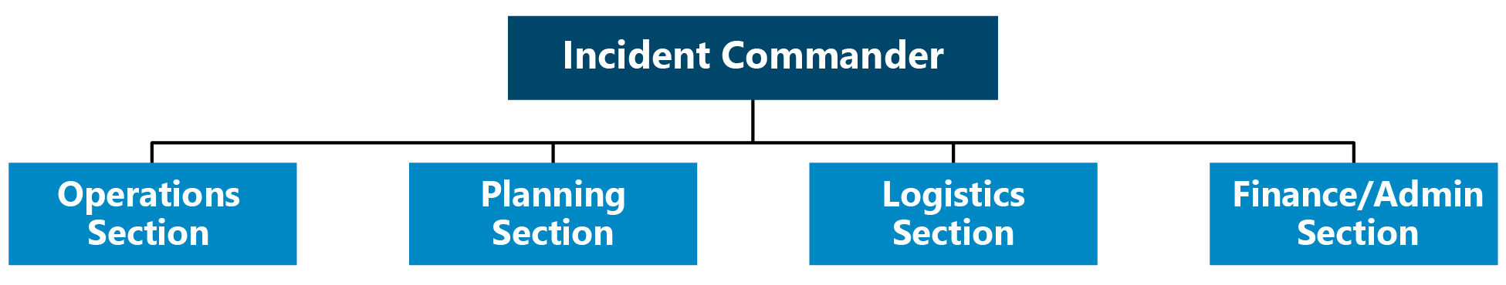
Figure 1: Incident Commander and Four Traditional Sections of an ICS Organizational Structure

Branch
A branch serves as a specific organizational level in an ICS organizational structure. A branch has functional or geographic responsibilities for major elements of an incident operations. The organizational level is used in field incident command and EOC organizational structures. Branches are used in the Operations and Logistics Sections. In the Operations Section, branches are located below a Section Chief and above any divisions or groups (see definitions below). In the Logistics Section, branches are used between the section and units.
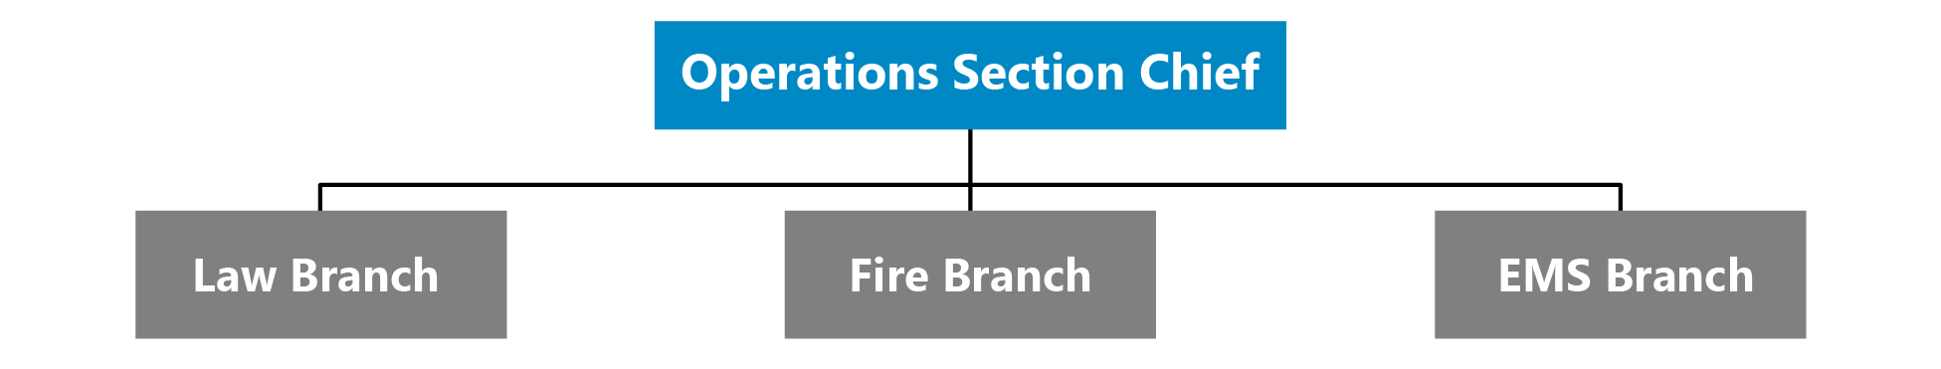
Figure 2: Example of Functional Branches of an ICS Organizational Structure

Division
A division is the organizational level having responsibility for operations within a defined geographic area. Divisions are established when the number of resources exceeds the manageable span of control of the Section Chief. Divisions are typically associated with field operations.
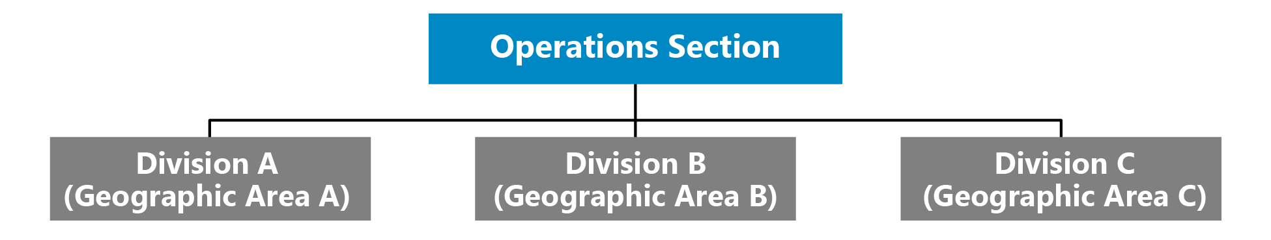
Figure 3: Example of Divisions in an ICS Organizational Structure

Group
Within an incident management structure groups are subdivisions of operations based on functional areas. Differing from divisions, the subdivision is based on a functional area not a geographic area. Each group contains the resources to perform a specific function. Groups are typically associated with field operations.
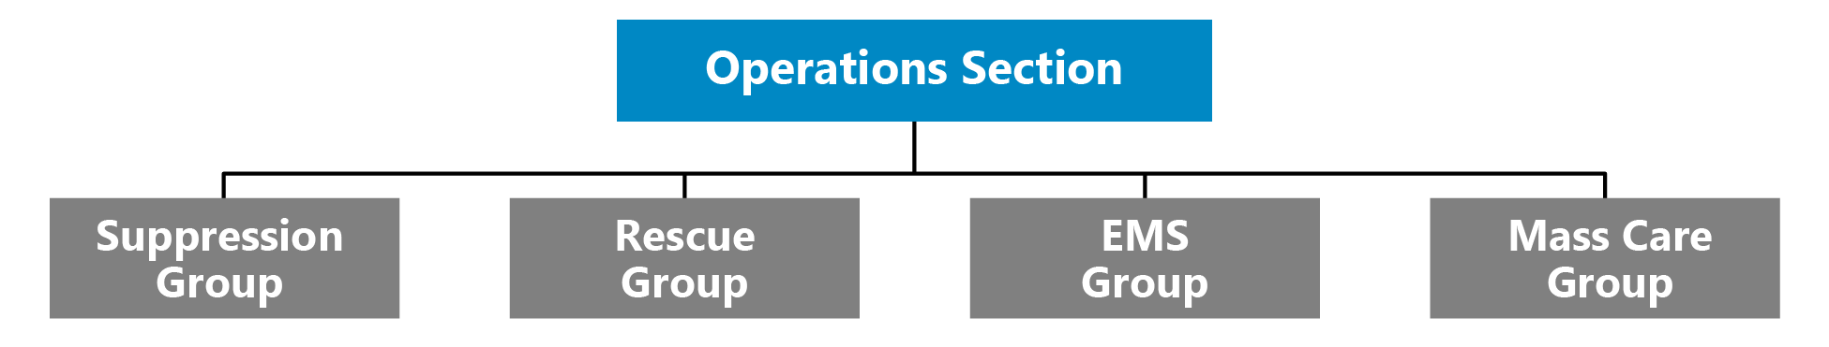
Figure 4: Example of Functional Groups in an ICS Organizational Structure

Unit
Within an ICS organizational structure, units are located within the Planning, Logistics, and Finance/ Administration Sections. Units have functional responsibility for a specific activity (e.g., Cost Unit, Transportation Unit, Communications Unit, etc.).
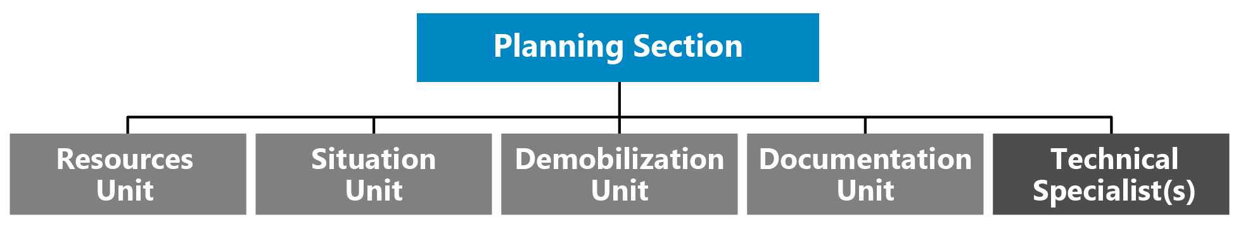
Figure 5: Example of Units and Technical Specialists in an ICS Organizational Structure

Technical Specialists
ICS functions in a wide variety of incidents that need technical specialists. Technical specialists have special expertise and skills, and they are activated only when needed. No specific qualifications are prescribed, as technical specialists normally perform the same duties during an incident that they perform in their everyday jobs, and they are typically certified in their fields or professions.
Technical specialists may serve anywhere within the organization depending on factors such as complexity, span of control, lines of communication, and subject matter expertise. They are most often assigned to the specific area (section, branch, division, group, or unit) where their services are needed. Technical specialists assigned to the Command Staff are called command advisors. In some situations, they are assigned to a separate unit within the Planning Section, much like a talent pool, and assigned out to various jobs on a temporary basis.
Generally, if the expertise is needed for only a short time and involves only one individual, that individual is assigned to the Situation Unit. If the expertise is needed on a long-term basis and necessitates several persons, a separate Technical Unit is established in the Planning Section.
Access and functional needs advisor | Agricultural specialist
Behavioral health specialist | Community representative
Decontamination specialist | Environmental impact specialist
Epidemiologist | Flood control specialist
Geographic Information Systems (GIS) specialist | Health physicist
Industrial hygienist | Intelligence specialist
Legal advisor | Meteorologist
Pharmacist | Science and technology advisor
Toxicologist | Veterinarian

Task Force
A task force is a combination of resources that are different, which may be different kinds and/or types, that are brought together to meet a specific mission or operational need. Task Forces can be used in connection with field operations and/or an EOC. A Community Feeding Task Force, for example, may be composed of representatives from a variety of county agencies and NGOs, each with different organizational focuses but with the shared mission of supporting the distribution of food in the community during a disaster.

Strike Team/Resource Team
Differing from a task force, a strike team (also known as a resource team) is composed of resources of the same kind and type with a focus on a specific mission or operational need. Strike teams, such as an Explosive Ordnance Disposal (EOD) Team, focusing on a specific mission, have an established minimum staffing requirement, common communications, and a leader.

Single Resources
Differing from task forces and strike teams, single resources are individuals, a specific piece of equipment, including supporting supplies and personnel, or a team (or crew) with an identified supervisor. Single resources are commonly used throughout an incident.

Staging Area
The staging area is a physical location that is temporarily used to station resources (personnel, supplies, and equipment) prior to operational assignment.

Planning P
The Planning P is an operational planning cycle approach for establishing strategic and operational objectives, developing on-scene IAPs and/or EOC emergency action plans (EAPs) and IAPs, operating/updating the existing plan, and maintaining situational awareness and information sharing processes. The “leg” portion of the Planning P process is only enacted during the initial response phase. Subsequent operational periods follow the circular portion of the process. The EOC Director, General Staff, Command Staff, and other EOC staff members participate in the process through effective engagement in development of the EOC IAP or EAP and communication of essential elements of information for development of situation reports (SITREPs) and spot reports. The Planning Section Chief is ultimately responsible for ensuring implementation of the operational planning cycle.

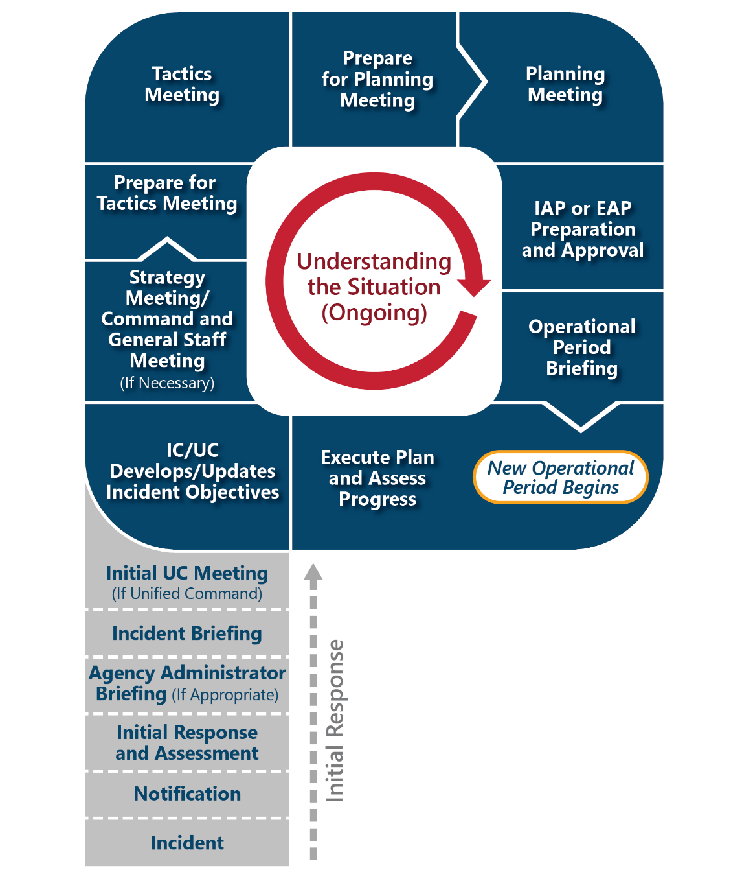
Figure 6: The Planning P

ICS/EOC Interface
When field and EOC operations are both established, these operations must be interfaced to establish and maintain a unified response. An effective interface establishes clear lines of communication, clearly defines roles and responsibilities, and establishes appropriate connection points between incident command and the EOC organizations based on activated sections, units, and positions.
The EOC can be leveraged to oversee specific operational elements and to provide coordination support to field operations. When supporting on-scene incident command, the EOC provides operational and strategic coordination; information collection, analysis, and dissemination; and logistical support (e.g., resource acquisition and tracking). Establishing direct lines of communication is essential for a coordinated approach and aligning operational objectives. EOC staff, as directed by the EOC Director and Section Chiefs, establishes coordination with appropriate field counterparts. Identifying the appropriate counterparts is aided by the (Name of Jurisdiction) EOC’s use of an ISM organizational structure, which supports the ICS established for field operations. Additionally, through adherence to NIMS, both organizations use a unified doctrine composed of common terminology and operational protocols.
The operational period of field and EOC operations can be synchronized, though not always perfectly aligned, based on each organization’s operational planning cycles.

EOC/Field Synchronization
The synchronization of planning processes between the EOC and incident command in the field is an essential process for ensuring the objectives outlined by both entities are aligned. When an incident necessitates moving into a multi-operational cycle based on magnitude, scope, or longevity of an incident, incident command will develop an on-scene IAP. When the EOC is activated, the EOC will develop an EOC (IAP or EAP). The IAP developed in the field focuses directly on field response operations, and the EOC (IAP or EAP) focuses on providing coordination and support to field operations and other objectives not directly associated with the scene such as mass care. In turn, there are circumstances when an incident does not involve a field operation overseen by an incident or area command (e.g., COVID-19). In these cases, the EOC’s (IAP or EAP) will serve as the overarching plan for establishing strategic and operational objectives.
When there is establishment of field and EOC operations, synchronization is achieved by ensuring appropriate incident command and EOC personnel are involved in shared meetings that fit within the operational tempo of both organizations, allowing for development of plans that are aligned and operating simultaneously to meet overarching incident objectives. If the EOC’s (IAP or EAP) is out of sync with the field operations’ IAP, a mismatch can occur between the two organizations’ objectives and the prioritization of objectives. The synchronization of operational planning cycles is most commonly established between On-scene Incident Commander and the EOC Director and coordinated with the planning sections.
Synchronization in terms of aligning objectives may not mean attempting to perfectly align the operational tempo and operational planning cycles of field and EOC operations. For example, the development of field operations’ objectives may need to precede the development of an EOC’s operational objectives to ensure the EOC’s focus aligns with the needs of field operations based on newly established objectives. If both planning cycles are operating on the same operational tempo with perfectly aligned meetings, it can result in plans that are not aligned because they are attempting to follow exactly the same development timeline. Also, if leadership from either organization is attending (even virtually) meetings of the other entity, they cannot attend corresponding meetings in their own planning cycle. Additionally, when there are multiple incident command structures in the field, alignment with the EOC requires additional consideration.

FEMA Community Lifeline Integration into Situational Awareness
Focused on response, the Federal Emergency Management Agency (FEMA) established community lifelines as a way to organize operational focus on seven essential categories required for incident stabilization and protection of life. The seven categories are safety and security; food, water, shelter; health and medical; energy (power and fuel); communications; transportation; and hazardous materials.
Figure 7: FEMA Community Lifelines
FEMA defines lifelines as fundamental services that when stabilized, allow all other aspects of a society to function. Each lifeline is composed of supporting components and subcomponents. For example, the energy lifeline has two components: power grid and fuel. In turn, power grid has three subcomponents: generation systems, transmission systems, and distribution systems.
During an emergency response, evaluation of community lifelines, focusing on incident impacts, allows for an assessment of the overarching impacts on a community. By focusing on community lifelines, incident impact information is used to build clear situational awareness focused on stabilization and restoration of key services and elements of the community, keeping response and support staff and decision-makers informed.
The Planning P drives the cyclical process of assessing the current situation based on community lifelines and determining stabilization targets for each community lifeline. With a focus on building and maintaining situational awareness, the EOC produces SITREPs as part of the Planning P cycle. In turn, the Planning P can drive the development of SITREPs through the EOC (IAP or EAP) development process. When using community lifelines, EOC (IAPs or EAPs) are developed through analysis of impacts to all seven community lifelines, the establishment of stabilization targets for all impacted community lifelines, and the defining response activities that result in meeting stabilization targets.
Additional information can be found in the Community Lifelines Implementation Toolkit and the FEMA Incident Stabilization Guide.

Incident Support Model EOC Structure
The ISM is a variation of the ICS structure that separates the information management/situational awareness function from the ICS Planning Section and combines the functions of the ICS Operations and Logistics Sections and comptroller/purchasing functions from the ICS Administration/Finance Section. EOC staff in jurisdictions or organizations that use an ISM structure typically focus exclusively on support functions rather than operations or managing actual response/recovery efforts.
As with the ICS/ICS-like model, the director of an ISM EOC is supported by personnel designated to key functions, subject matter experts, and technical specialists. Staff supporting the EOC director typically include a Public Information Officer (PIO) and may include others such as a Legal Advisor. The General Staff sections consist of Situational Awareness, Planning Support, Resources Support, and Center Support.

ISM EOC Director’s Staff
As with the ICS/ICS-like EOC Command Staff, the ISM EOC director’s staff typically includes a PIO and may include others such as a Legal Advisor and a Safety Officer. The EOC director and director’s staff set EOC tasks, work with senior officials to facilitate the development of policy direction for incident support, and ensure the dissemination of timely, accurate, and accessible information to the public.

Situational Awareness Section
Situational Awareness staff collect, analyze, and disseminate incident information. This section’s personnel typically create and provide a variety of products for EOC policy-level leadership, public affairs, and other internal and external stakeholders. The Situational Awareness Section essentially elevates the functions of the ICS Planning Section Situation Unit to a General Staff position in the EOC, reporting directly to the EOC director. The staff in this section also process requests for information; develop reports, briefings, and presentation products; integrate geospatial and technical information; and develop material to support public warning messages.

Planning Support Section
The Planning Support Section staff provide a range of current and future planning services that may include developing contingency, deactivation, and recovery plans. Staff in the Planning Support Section assist in developing and executing the shared goals of multiple jurisdictions and organizations involved in managing the incident and coordinate a standard planning process to achieve the objectives of the EOC leadership and foster unity of effort among all organizations represented in the center. The Planning Support Section staff coordinate closely with the ICS Planning Section to ensure that both on-scene and EOC personnel have appropriate contingency plans in place.

Resources Support Section
Staff in the Resources Support Section work to ensure that on-scene incident management personnel have the resources and operational support they need. Resources Support Section staff source, request/order, and track all resources. This includes supplies, equipment, and personnel acquired from departments and agencies represented in the EOC, other community organizations, mutual aid/Emergency Management Assistance Compact (EMAC) sources, or nongovernmental partners, as well as items purchased or leased. Staff in the Resources Support Section may be organized by department/agency or by Emergency Support Function (ESF)/Recovery Support Function (RSF).

Resource Management in an ISM EOC
The departments and agencies represented in an EOC generally have access to a variety of resources that are specific to the department or agency’s responsibilities. A typical ICS Logistics Section has expertise in ordering resources through mutual aid, purchasing/contracting/leasing, or from external government organization via requests for assistance. Funding for purchases/contract/leases or reimbursement of expenses is usually handled in the ICS Administration/Finance Section. ISM EOCs combine all these functions in the Resources Support Section, which provides a one-stop shop for acquiring, deploying, and tracking resources and services.

Center Support Section
EOCs require a variety of communications, information technology (IT), administrative, and general services, as well as staff support, such as food, to function most effectively. Staff in the Center Support Section support the needs of the facility and staff in the EOC and any associated facilities such as a Joint Information Center (JIC). In this role, staff in the Center Support Section communicate and gather requirements for supplies, equipment, administrative processes, security, maintenance, and other logistics to ensure the EOC staff have the resources and capabilities required to perform their roles.

EOC Concept of Operations
This handbook provides the organized management system for (Name of Jurisdiction) to follow during emergencies. It is designed as a flexible system in which the entire plan or parts of the plan may be activated, as appropriate to the situation. It is based on a worst-case scenario and provides for the critical functions and roles of the (Name of Jurisdiction) during a response. It is considered a management tool, because it provides an overall organization and general procedures for the management of information, activities, and operations during an emergency.
The handbook is also based on the Incident Support Model (ISM) EOC Structure outlined in NIMS. (Name of Jurisdiction) utilizes a five-section structure and each of the five sections contains sub-elements and/or positions for the critical operations needed for the (Name of Jurisdiction) to operate effectively during an emergency. An organizational chart of the sections and positions can be found on page (Page #).

Overview: Emergency Response Organization, Assignments, and Responsibilities
Emergency response management requires the establishment of an organization comprised of the most important or critical functions of the (Name of Jurisdiction). This organization is called to duty during times of emergency, when normal operations are not sufficient to meet the immediate or overwhelming needs that occur. These critical functions are necessary to provide immediate emergency response for:
- Life safety and protection of property and assets
- Restoration of lifelines
- Resumption and continuation of (Name of Jurisdiction) government operations
- Restoration of government operations to normal
- Recovery of expenses and losses through the federal disaster assistance programs under the Stafford Act (PL 94-288 amended)
The (Name of Jurisdiction) EOC handbook follows a five-section structure as the basis for organizing emergency planning and response. The five sections are (1) Command, (2) Situational Awareness, (3) Planning Support, (4) Resources Support, and (5) Center Support. The (Name of Jurisdiction) emergency response organization is based on these sections, as shown on the ISM EOC Organization Chart located on page (Page #). A description of the roles and responsibilities of EOC positions are shown within the “(Name of Jurisdiction) Emergency Response Positions, Units, and Responsibilities” table located on pages 19–27.

Activation Levels
If different than those defined in the table below, jurisdiction-specific activation levels should be used.
(Name of Jurisdiction) Office of Emergency Management EOC Activation Levels
Activation Level | Level Description | Response / Notification | EOC Staff Actions | EOC Facility
Level 4 | - Normal, day-to-day | - EOC Support | - EOC Support | - Steady State
Level 3 | - Monitoring the situation. There is potential for an emergency, but no immediate threat to life or property  - Public warning may be needed | - OEM on stand-by or monitoring situation  - OEM Director notified  - Local department heads and other officials notified of conditions  - Amateur Radio Operations may be activated  - OEM Director and local officials receive periodic updates | - Notified of condition | - Standby/Open
Level 2 | - Escalation from non-routine emergencies  - Multi- departmental response | - OEM staff respond to EOC  - OEM Director notified  - Activate appropriate department heads and other officials and have them respond to the EOC  - Notify additional department heads and other officials of conditions and place on stand-by  - Notify (Other Jurisdiction(s)) OEM | - EOC partially activated, depending on circumstances | - Open
Level 1 | - Assistance from other jurisdictions or mutual aid may be needed  - Local area disaster or multi-site incident | - OEM staff respond to EOC  - OEM Director notified  - Activate all appropriate department heads and other officials needed for full activation and have them respond to the EOC  - Notify (Other Jurisdiction(s)) OEM | - EOC fully staffed | - Open

Activation Triggers
Activation triggers describe changes in the EOC’s operational posture based on coordination demands of a threat or actual incident. Please note, Level 4 is defined as routine or normal operational posture; therefore, no trigger is defined. Jurisdiction-specific activation triggers should be used to further refine the provided activation trigger information.
- Level 3 Activation Trigger: When a potential threat or incident grows beyond the capability or capacity of Level 4 operations or is expected to do so, the Emergency Management Coordinator, or designee, makes the decision to increase monitoring, notify EOC staff, and send out periodic updates in response to potential threats or an active incident. At this point, the EOC maybe on standby or open.
- Level 2 Activation Trigger: When a potential threat or incident grows beyond the capability or capacity of Level 3 operations or is expected to do so, the transition to a partial activation of the EOC will take place. The partial activation staffing level will be tailored to meet the anticipated needs. The Emergency Management Coordinator, or designee, may move directly to activation Level 2 if deemed warranted by the potential threat or active incident.
- Level 1 Activation Trigger: When a potential threat or incident grows beyond the capability or capacity of Level 2 operations or is expected to do so, the transition to Level 1 (full activation) will take place. The Emergency Management Coordinator, or designee, may move directly to full activation if deemed warranted by the potential threat or active incident.

ISM EOC Organization Chart
The ISM EOC Organization Chart is a sample that depicts a full Level 1 Activation. Not all positions and units will be needed each time the EOC is activated. Activate the EOC positions and units deemed necessary to effectively respond to the situation then expand or contract as needed.

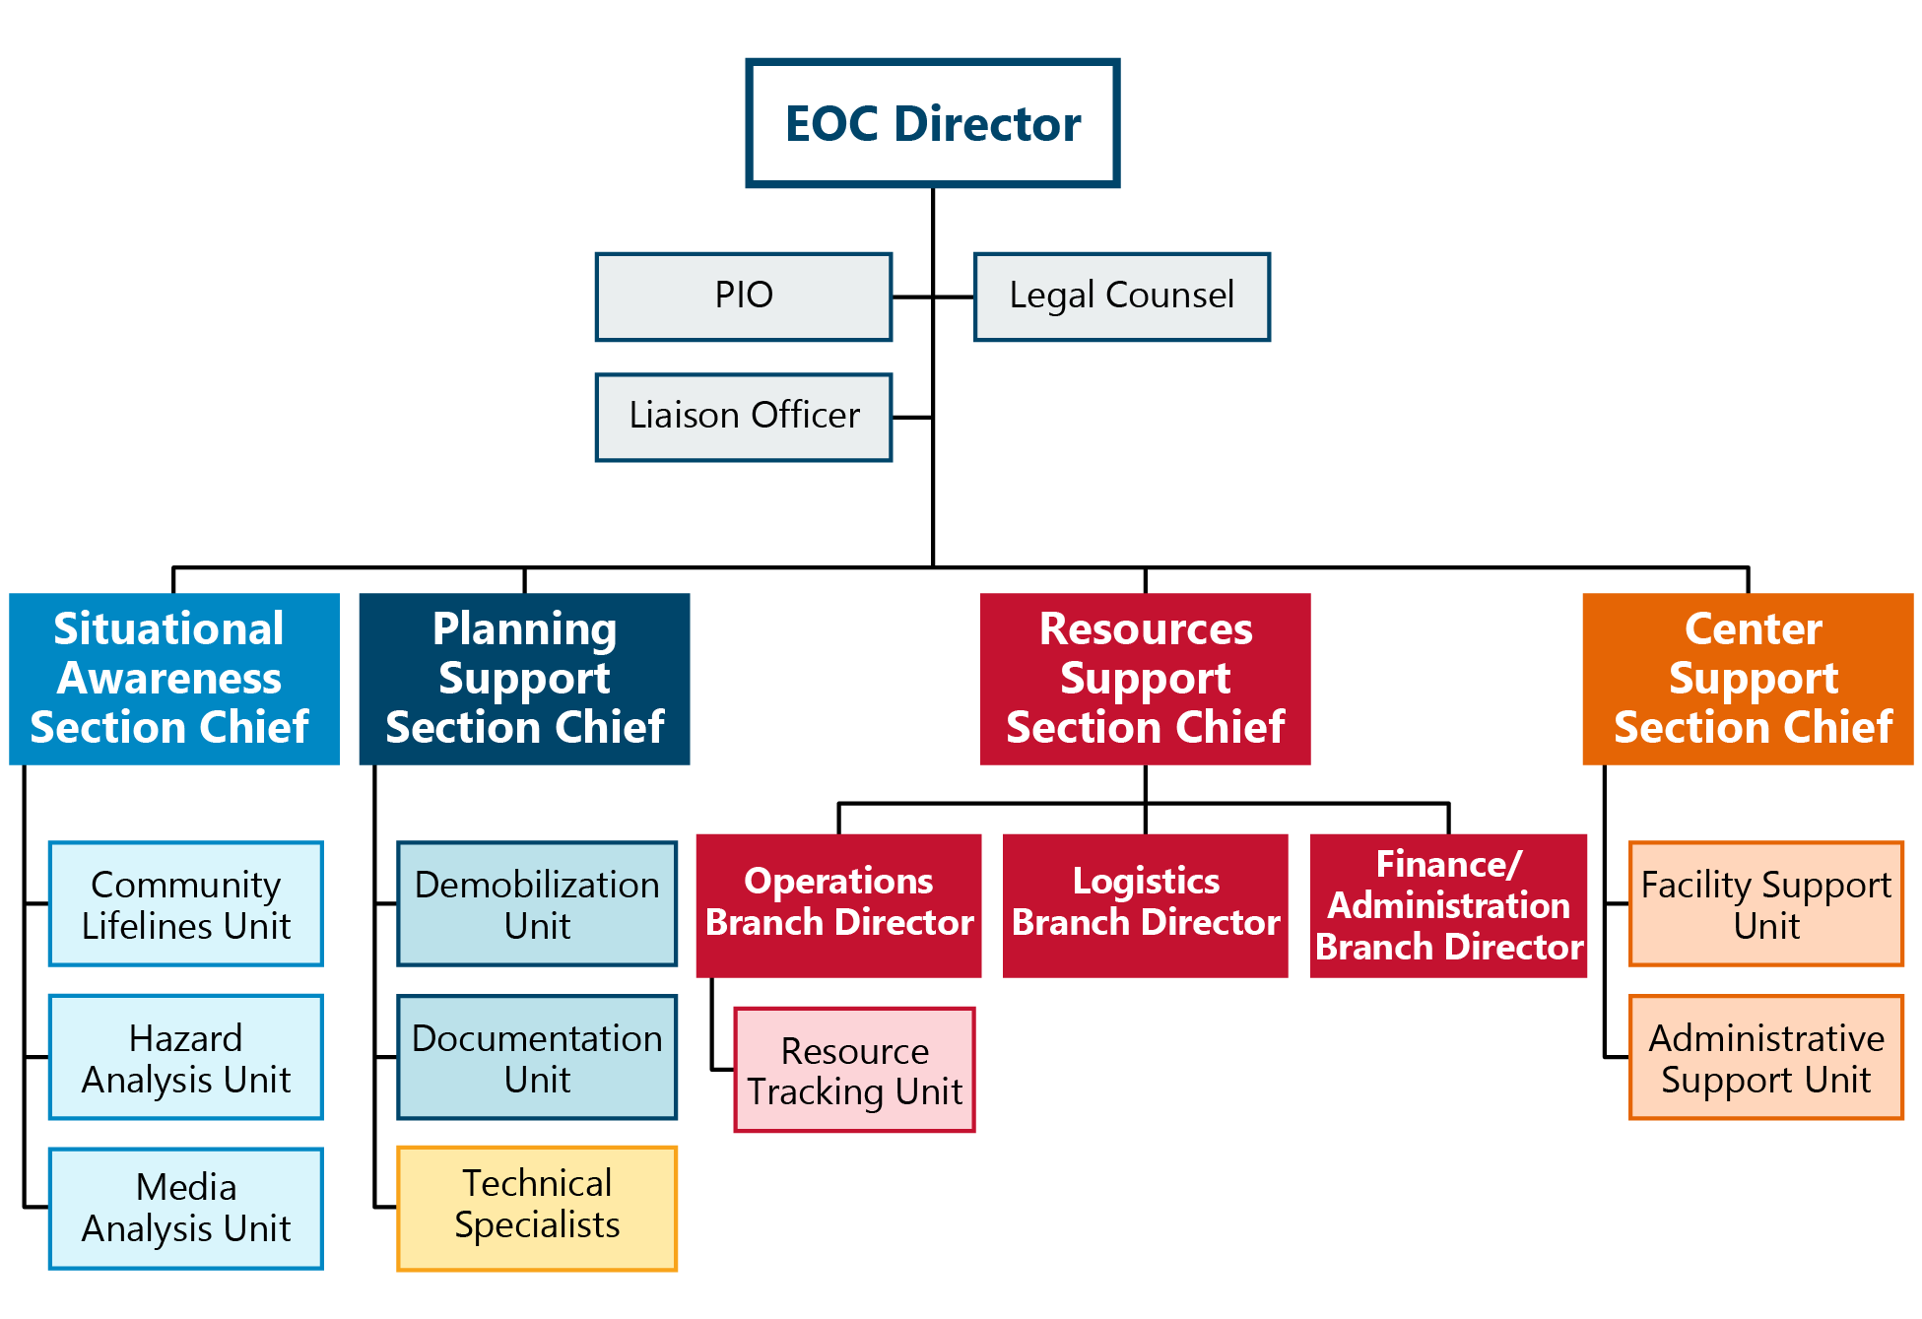

Figure 8: ISM EOC Organization Chart

ISM EOC Layout
The ISM EOC floorplan layout is provided as an example. A customized graphic should be developed based on the jurisdiction’s EOC layout to replace the example.
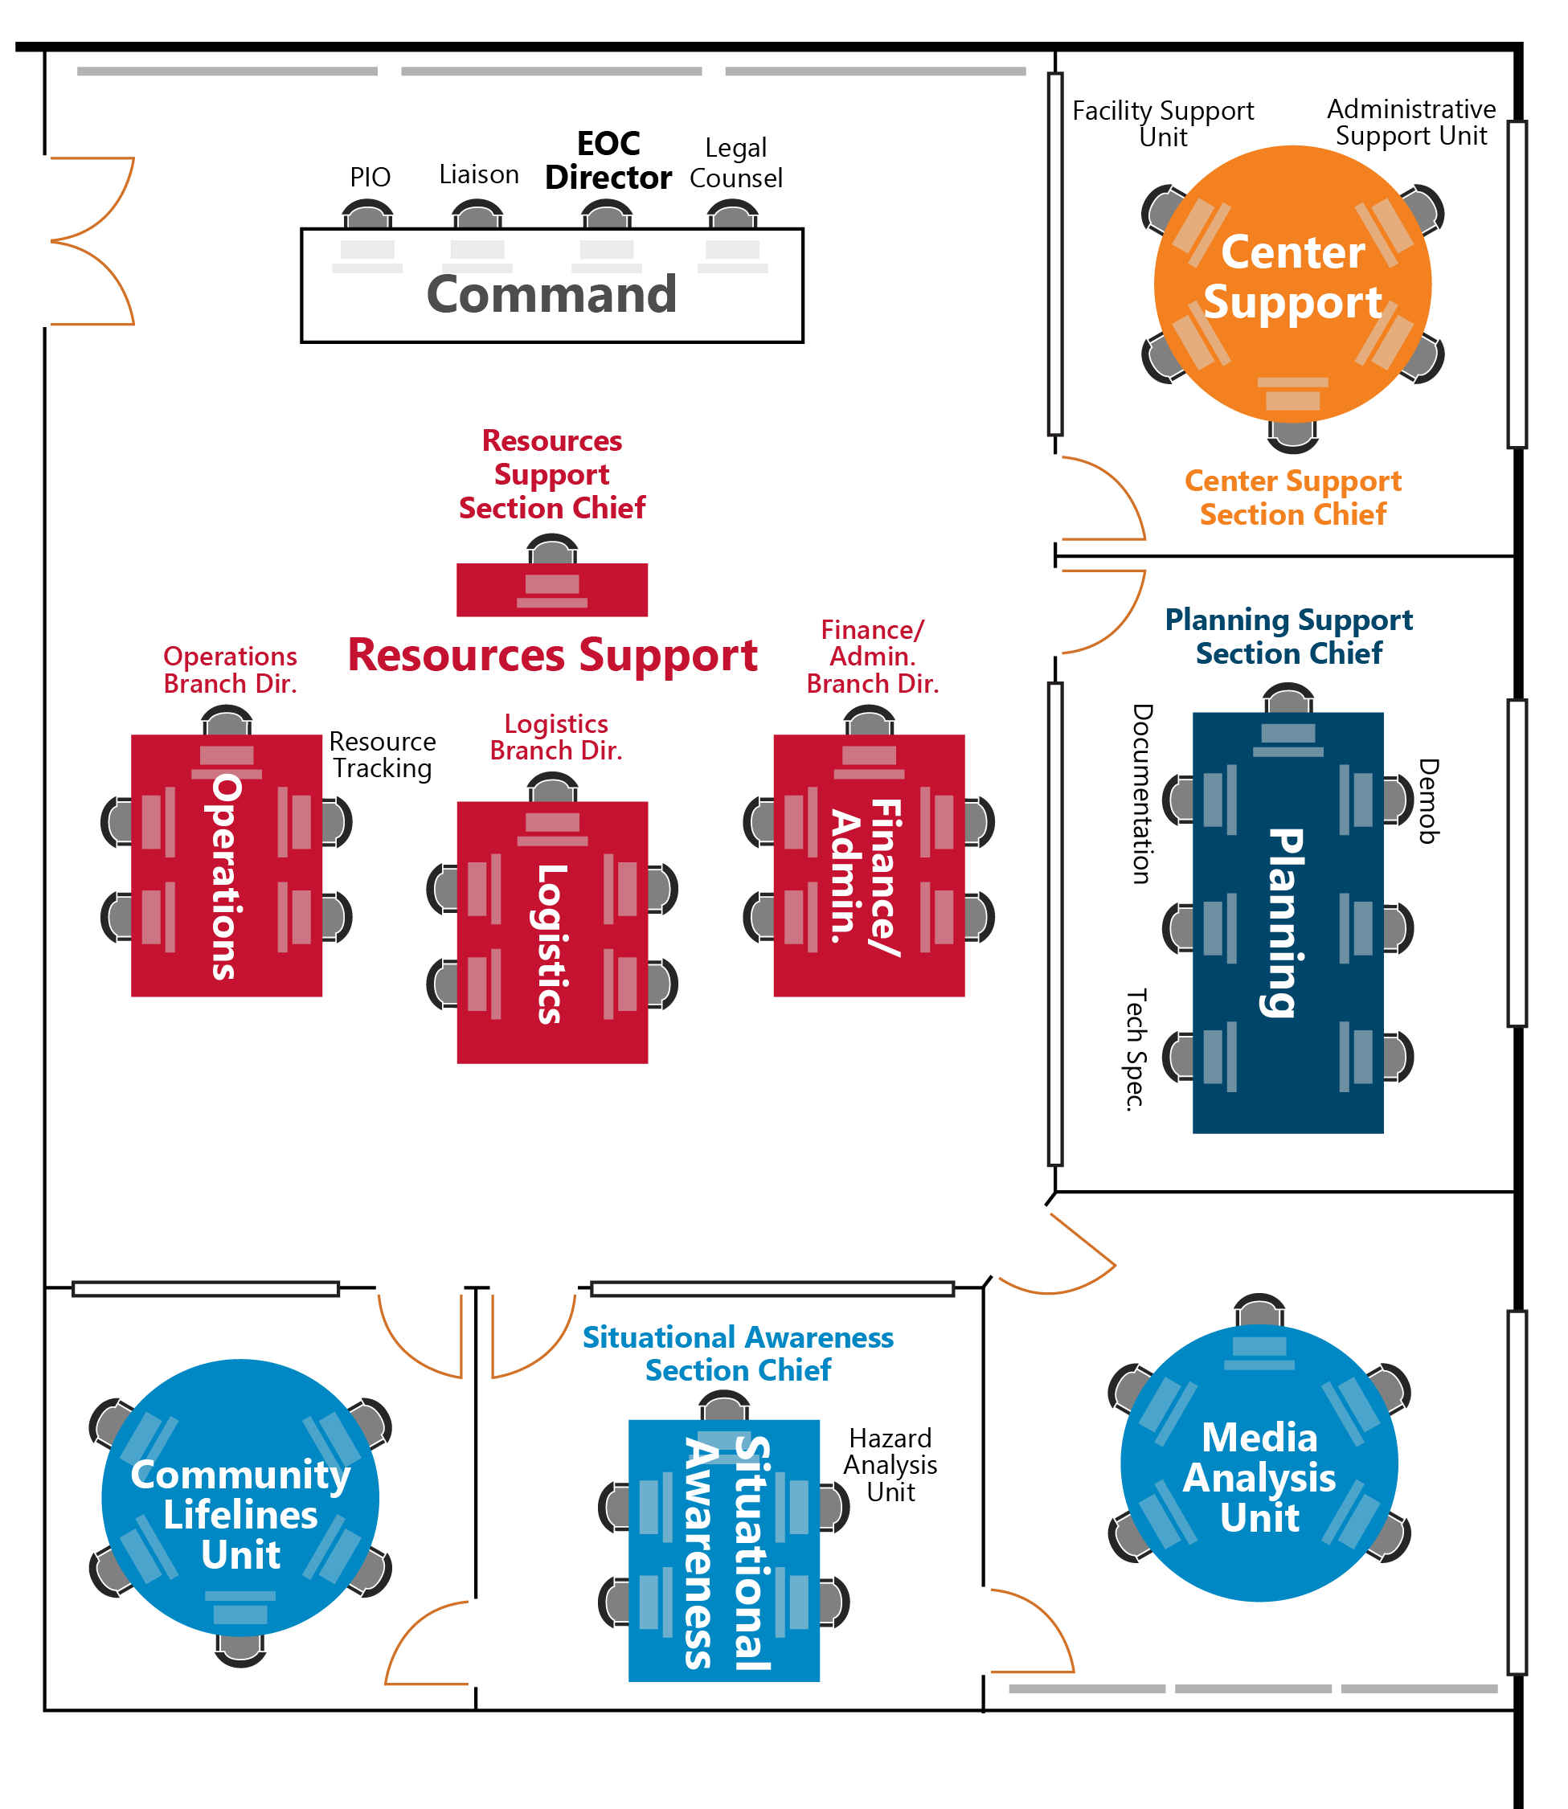
Figure 9: ISM EOC Floorplan Example

EOC Organization: Emergency Response Positions, Units, and Responsibilities
Command Section
Position/Unit | Responsibilities
EOC Director | The EOC Director manages and provides direction for the emergency response and recovery. Specific areas of management include the following:  - Establish direction and control of the overall emergency response and recovery.  - Determine needs and activate the EOC Command Staff and sections as needed.  - Coordinate with the Public Information Officer regarding public information, press releases, and media relations.  - Coordinate with the Liaison Officer about activities and coordination with surrounding jurisdictions and state, federal, and private partners.  - Coordinate with Legal Counsel regarding emergency actions, liability, legal procedures, and possible legal eventualities.  - Provide (Name of Jurisdiction) senior elected and appointed officials information about the emergency or disaster and response activities and the need for a local disaster declaration.  - Manage fiscal authorization for expenditures.
Public Information Officer (PIO) | - Serve as the (Name of Jurisdiction) central coordination point for all media releases.  - Ensure the public within the affected area receives complete, accurate, and consistent information about life safety procedures, public health advisories, relief and assistance programs, and other vital information.  - Coordinate media releases with PIOs at incidents or representing other affected emergency response agencies as required.  - Develop the format for press conferences, in conjunction with EOC Director.  - Determine the need for additional PIOs to support the incident.  - Coordinate commercial and social media analysis with the Media Analysis Unit Leader.
Liaison Officer | - Oversee all liaison activities, including coordinating with outside agency representatives assigned to the EOC and handling requests from other EOCs for (Name of Jurisdiction) representatives.  - Establish and maintain a central location for incoming agency representatives, providing workspace and support as needed.  - Ensure position-specific guidelines, policy directives, SITREPS, the appropriate EOC (IAP or EAP) are provided to agency representatives upon check-in.  - In coordination with the EOC Director, provide orientations for VIPs and other visitors to the EOC or incident scene with approval of the On-scene Incident Commander.
Legal Counsel | - Assess (Name of Jurisdiction) legal risks and liabilities resulting from the emergency or from operations.  - Provide professional counsel to the EOC Director regarding emergency actions, liabilities, legal procedures, and possible legal eventualities.  - Represent the (Name of Jurisdiction) in matters involving local, state, and federal regulatory agencies.

Situational Awareness Section
Position/Unit | Responsibilities
Situational Awareness Section Chief | - Oversee the collection, analysis, and dissemination of incident-specific and other operational information related to the emergency from all available sources (e.g., field contacts, other EOC staff, Technical Specialists, news feeds, and social media feeds).  - Ensure the responsibilities of the Situational Awareness Section are addressed as required, including the following:  - Ensure all maps, status boards, and other displays contain current and accurate information.  - Prepare SITREPs and other situational awareness products for information dissemination, such as reports, briefings, and presentation products.  - Provide briefings as requested by the EOC Director or policy-level leadership.  - Collect and maintain up-to-date information regarding the impacts and status of community lifelines including restoration timelines.  - Oversee damage assessment.  - Inform EOC Director of significant issues affecting the Situational Awareness Section.  - Ensure the Situational Awareness Section objectives, as stated in EOC (IAPs or EAPs), are accomplished within the operational period or within the estimated time frame.  - Supervise and exercise overall responsibility for the coordination of unit activities within the section.  - Establish the appropriate level of organization for the Situational Awareness Section, including the activation of Community Lifelines Unit, Hazard Analysis Unit, and Media Analysis Unit.
Community Lifelines Unit | - Establish and maintain methods to collect, analyze, and disseminate information about community lifelines including:  - Food, Water, and Shelter  - Safety and Security  - Health and Medical  - Energy  - Communications  - Transportation  - Hazardous Materials  - Ensure all maps, status boards, and other displays related to community lifelines contain current and accurate information.  - Support the development of situational awareness products, including all SITREPs and briefing materials associated with community lifelines.  - Ensure the appropriate actions are taken to address the operational objectives and assignments in the EOC (IAP or EAP) assigned to the unit.
Hazard Analysis Unit | - Establish and maintain methods to collect, analyze, and disseminate information about ongoing and other potential hazards that may impact ongoing emergency response efforts.  - Ensure all maps, status boards, and other displays related to hazards contain current and accurate information.  - Support the development of situational awareness products, including all SITREPs and briefing materials associated with hazard analysis.  - Ensure the appropriate actions are taken to address the operational objectives and assignments in the EOC (IAP or EAP) assigned to the unit.
Media Analysis Unit | - Establish and maintain methods to collect, analyze, and disseminate information regarding incident coverage by commercial news outlets (i.e., TV, radio, newspapers, and commercial media websites) and in social media sources.  - Ensure all maps, status boards, and other displays related to hazards contain current and accurate information.  - Support the development of situational awareness products, including all SITREPs and briefing materials associated with media analysis.  - Ensure appropriate actions are taken to address the operational objectives and assignments in the EOC (IAP or EAP) assigned to the unit.

Planning Support Section
Position/Unit | Responsibilities
Planning Support Section  Chief | - Provide a range of current and future planning services that may include developing contingency, deactivation, demobilization, and recovery plans.  - Ensure the responsibilities of the Planning Support Section are addressed as required, including the following:  - In coordination with the EOC Director, the Command Staff, and the General Staff, establish the operational periods, meetings schedules, and staffing plan.  - Prepare and distribute the EOC (IAP or EAP) and facilitate the Planning Meeting.  - Develop the EOC Demobilization Plan, if necessary.  - Document and maintain files on all EOC activities.  - Provide technical support services to EOC sections and branches.  - In coordination with other Section Chiefs, ensure status reports are completed and used as the basis for the EOC (IAP or EAP).  - Inform EOC Director of significant issues affecting the Planning Support Section.  - Ensure Planning Support Section objectives, as stated in EOC (IAPs or EAPs), are accomplished within the operational period or within the estimated time frame.  - Supervise and exercise overall responsibility for the coordination of unit activities within the section.  - Establish the appropriate level of organization for the Planning Support Section, including the activation of the Documentation Unit, Demobilization Unit, and Technical Specialists.
Demobilization Unit | - Develop a Demobilization Plan for the EOC based on a review of all pertinent planning documents and status reports.  - Work closely with EOC Command and General Staff to ensure a smooth and orderly release of resources.  - Coordinate with the Facility Support Unit regarding the demobilization of facilities.
Documentation Unit | - Collect, organize, and file all completed emergency-related forms, to include all EOC Activity Logs (ICS-214), SITREPs, (IAPs or EAPs), and any other related information, just prior to the end of each operational period.  - Ensure any documentation submitted to the Documentation Unit is accurate and complete. Have reporting parties correct any errors or omissions before final submission.  - Provide document reproduction services to EOC staff.  - Distribute the EOC (IAPs or EAPs) and other documents, as required.  - Maintain a permanent electronic archive of all SITREPs and EOC (IAPs or EAPs) associated with the incident to establish a historical record and assist with potential cost recovery efforts.  - Assist the OEM Director in the preparation and distribution of the After-Action Report.
Technical Specialists | - Provide technical observations and recommendations to EOC staff in specialized areas as required.  - Advise on legal limitations on use of particular resources.  - Work with inter-agency coordination groups as necessary, providing expertise.

Resources Support Section
Position/Unit | Responsibilities
Resources Support Section Chief | - Oversee one-stop shop for acquiring, deploying, and tracking resources and services.  - Ensure the responsibilities of the Resources Support Section are addressed as required, including the following:  - Ensure support is provided to (Name of Jurisdiction) first responder operations, mass care operations, and hospital and public health operations.  - Oversee funding, purchasing, and reimbursement of expenses.  - Ensure all financial records are maintained throughout the event or disaster.  - Ensure all recovery documentation and disaster financial assistance paperwork is accurately maintained and properly submitted to FEMA and/or the Texas Division of Emergency Management (TDEM).  - In consultation with EOC Director, determine spending limits, if any.  - Inform EOC Director of significant issues affecting the Resources Support Section.  - Supervise and exercise overall responsibility for the coordination of branch and unit activities within the section.  - Ensure Resources Support Section objectives, as stated in EOC (IAPs or EAPs), are accomplished within the operational period or within the estimated time frame.  - Establish the appropriate level of organization for the Resources Support Section, including the Operations Branch, Logistics Branch, and Finance/Administration Branch.
Operations Branch Director | - Provide support to first responder, mass care, and hospital and public health operations to achieve incident objectives, address unmet needs, and address leadership priorities.  - Maintain a communications link between On-scene Incident Commander and the EOC for the purpose of coordinating the overall response, resource requests, and incident status information.  - Support survey of public and private facilities, assessing the damage to such facilities and coordinating the repair of damage to public facilities.  - Support survey and repair of local infrastructure systems including streets and roads within the jurisdictional area.  - Ensure the operational objectives and assignments identified in the EOC (IAP or EAP) are carried out effectively.  - Conduct periodic operational briefings for the Resources Support Section Chief.  - Supervise the Resource Tracking Unit.
Resource Tracking Unit | - Coordinate with other EOC units and branches and field operations (e.g., staging area manager) to capture and centralize necessary resource, location, and status information.  - Develop and maintain resource tracking boards that include status, location, and other important information.
Logistics Branch Director | - Manage the resource request process from receipt of a request through validation of need and deployment of resources.  - Locate or acquire equipment, supplies, facilities, and transportation to meet EOC operational needs and address off-incident ordering, including resources acquired via mutual aid.  - Ensure Logistics Branch objectives, as stated in EOC (IAPs or EAPs), are accomplished within the operational period or within the estimated time frame.  - Conduct periodic logistics briefings for the Resources Support Section Chief.
Finance/ Administration Branch Director | - Ensure all financial records are maintained throughout the event or disaster.  - Ensure all on-duty time is recorded and collected for all personnel.  - Ensure continuity of the payroll process for all employees responding to the event or disaster.  - Ensure workers’ compensation claims resulting from the response are processed in a reasonable time, given the nature of the situation.  - Ensure all travel and expense claims are processed in a reasonable time, given the nature of the situation.  - Determine purchase order limits for the Logistics Branch.  - Ensure all recovery documentation is accurately maintained during the response and submitted on the appropriate forms to FEMA and/or the Texas Division of Emergency Management (TDEM).  - Ensure Finance/Administration Branch objectives, as stated in EOC (IAPs or EAPs), are accomplished within the operational period or within the estimated time frame.  - Conduct periodic finance-related briefings for the Resources Support Section Chief.

Center Support Section

Position/Unit | Responsibilities
Center Support Section Chief | - Support the needs of the EOC facility and staff to ensure staff have the resources and capabilities required to perform their roles, including the Joint Information Center (JIC), if activated.  - Ensure the responsibilities of the Center Support Section are addressed as required, including the following:  - Locate or acquire equipment, supplies, and personnel to meet EOC needs, including JIC needs, if activated. Ensure proper installation of new systems or equipment.  - Arrange for food, lodging, and other support services as required for the EOC, and oversee the EOC’s administrative processes.  - Ensure EOC facilities include adequate restrooms, food service, and rest areas, and ensure cleaning services are established and maintained.  - Oversee facility access and security.  - Ensure Center Support Section objectives, as stated in EOC (IAPs or EAPs), are accomplished within the operational period or within the estimated time frame.  - Inform EOC Director of significant issues affecting the Center Support Section.  - Supervise and exercise overall responsibility for the coordination of unit activities within the section.  - Establish the appropriate level of organization for the Center Support Section, including the Facility Support Unit and Administrative Support Unit.
Facility Support Unit | - Ensure adequate EOC facility to meet staff needs, including workspaces, furniture, computer systems, and communications systems, etc. Acquire additional resources as necessary.  - Ensure EOC facilities include adequate restrooms, food service, and rest areas compliant with the Americans with Disabilities Act.  - Ensure facility cleaning services are established and maintained for the EOC and related facilities.  - Oversee facility access and security needs.  - Develop and post EOC Safety Plan.  - Ensure all facilities and/or workspaces are returned to original state when no longer needed.
Administrative Support Unit | - Arrange for food, lodging, and other support services as required for EOC and JIC (if activated).  - Ensure adequate office supplies to support EOC staff, and ensure office equipment remains ready for use (e.g., paper restocked, ink refilled) in coordination with Facility Support Unit.  - Address administrative tasks to support EOC staff, including development and posting of EOC Organization Charts (ISM 207) to reflect the EOC activation.

EOC General Responsibilities Checklist
The EOC General Responsibilities Checklist is used by all EOC staff during the activation and demobilization phases. If EOC checklists are completed using an incident management software, jurisdictions can upload this checklist for each EOC position.
EOC General Responsibilities Checklist – For All Positions
Item | Completed Time | Action | Follow-up Needed/ Notes
Activation Phase
1. |  | Check in upon arrival at EOC and sign in on the EOC sign-in sheet.
2. |  | Check in with the Liaison Officer if you are a representative from an outside agency.
3. |  | Report to EOC Director, Section Chief, or other assigned supervisor to obtain current situation status and specific job responsibilities and assignments.
4. |  | Set up workstation and review position-specific activation and operations checklists.
5. |  | Maintain Activity Log (ICS 214) that chronologically describes the actions you take during your shift.
6. |  | Determine resource needs, such as a computer, phone, fax, stationery, plan copies, and other reference documents. Request resources to meet unfilled needs.
7. |  | Participate in any facility and safety orientations as required.
8. |  | Identify and establish communications with field operations points of contact.
Shift Change
9. |  | Ensure incoming staff replacement signs into the EOC on the EOC Sign-in Sheet.
10. |  | Complete shift change briefing with incoming position staff to cover the following topics:  - Situation overview and outlook  - Incident priorities  - Position/Section accomplishments during the last operational period  - Operational objectives for the next operational period as contained in the EOC (IAP or EAP)  - Open/ongoing tasks  - Relevant agencies contact information  - Corrective actions/adjustments to processes  Any identified system issues (e.g., communications failure).
11. |  | Provide incoming staff replacement with most recent SITREP and new operational period EOC (IAP or EAP).
12. |  | Submit Activity Log (ICS 214) and completed checklists to Documentation Unit.
13. |  | Provide incoming personnel with outgoing personnel’s contact phone number(s).
14. |  | Sign out of computer systems that use unique username and password. Do not sign out of generic accounts that will be used by incoming personnel.
15. |  | Sign out of the EOC on the EOC Sign-in Sheet prior to leaving the facility. Check out with supervisor.
Demobilization Phase
16. |  | Deactivate assigned position and complete the Demobilization Check-out form when authorized by the EOC Director or designee.
17. |  | Complete all required forms, reports, and other documentation. All forms and paperwork should be submitted through supervisor to the Planning Support Section prior to departure.
18. |  | Notify field operations points of contact of EOC demobilization and demobilization time.
19. |  | Clean up work area before leaving. Return any equipment or unused supplies.
20. |  | Provide supervisor with contact phone number(s).
21. |  | Sign out of all computer programs, log off the computer, and turn off the monitor. Do not shut down the computer.
22. |  | Record sign-out time on the EOC sign-in sheet.
23. |  | Be prepared to provide input to the EOC After-Action report.
24. |  | Upon request, participate in formal post-operational debriefs.
25. |  | Attend critical incident stress debriefings as needed.

EOC Activation Checklist
This Activation Checklist will be used to activate (Name of Jurisdiction) EOC. The individual(s) completing the actions should indicate the time, names, follow-up needed, and notes about the action. For planned events, some elements of this checklist can be completed in advance.
EOC Activation Checklist
Item | Completed Time | Action | Name/Follow-up Needed/Notes
1. |  | Based on activation triggers, at the direction of the OEM Director, or based on other protocols, activate the EOC at the appropriate activation level.
2. |  | Notify EOC staff and include report time and location (Name of Jurisdiction) leadership of the EOC activation and reason for activating.
3. |  | Notify (Name of Jurisdiction) leadership of the EOC activation and reason for activating.
4. |  | Notify Incident Command of EOC activation time and activation level.
5. |  | Notify other relevant stakeholders of the (Name of Other Jurisdiction(s)) EOC activation, including neighboring jurisdictions’ Offices of Emergency Management.
6. |  | Ensure Texas Division of Emergency Management is notified of EOC activation.
7. |  | Consider the need for additional facility security, and if necessary, request from (Name of Jurisdiction’s Law Enforcement).
8. |  | Set up the EOC’s physical location: Turn-on EOC systems (e.g., AV equipment, computer systems, communication systems).
9. |  | Provide just-in-time training for new EOC staff to complete tasks.
10. |  | Assess the need for additional specialist resources, such as subject matter experts. If required, request liaisons.
11. |  | Identify, review, and share any applicable existing agency or emergency operations plans that will serve as reference resources.
12. |  | Gather information to assess incident assignments and determine immediate needs and actions.
13. |  | Follow additional initial response steps in the Planning P including the initial incident briefing.

EOC Demobilization Checklist
This Demobilization Checklist will be used to demobilize (Name of Jurisdiction) EOC. The individual(s) completing the actions should indicate the time, names, follow-up needed, and notes about the action.
EOC Demobilization Checklist
Item | Completed Time | Action | Name/Follow-up Needed/Notes
1. |  | Notify (Name of Jurisdiction) leadership of the EOC deactivation and reason for deactivating.
2. |  | Notify Texas Division of Emergency Management and other jurisdictions of EOC deactivation.
3. |  | Notify SITREP recipients of the EOC deactivation timeline.
4. |  | Notify Incident Command of EOC deactivation and deactivation time.
5. |  | Shut down the EOC’s physical location: Turn off EOC systems (e.g., AV equipment, computer systems, communication systems).
6. |  | Save all incident documentation to (Name of Jurisdiction Department Name shared drive) for long-term historical recordation.
7. |  | Return all logistical support materials (e.g., EOC Handbooks, paper, pens, pencils, etc.) to storage locations.
8. |  | Inventory office supplies and place order for new supplies for replenishment.
9. |  | Take additional steps to return EOC to steady state in preparation for next activation.

This page intentionally left blank.

Situational Awareness Section Chief and Units Roles, Responsibilities, and Checklists
The content in this section should be edited to match the jurisdiction’s specific operations, which may include removing and adding positions based on specific EOC organizational structure. Additionally, the associated checklist tasks can be swapped, eliminated, or consolidated based on specific EOC positions used by a jurisdiction.
The Situational Awareness Section Chief and Unit, Roles, Responsibilities, and Checklists section defines the roles and responsibilities of the Situational Awareness Section positions and units in the (Name of Jurisdiction) EOC. Additionally, the section provides activation, operations, and demobilization checklists for each position. The provided guidance and checklists serve as job aids, defining areas of responsibilities and required tasks for these position at each phase of EOC operations.
The Situational Awareness Section is responsible for the collection, analysis, and dissemination of information to establish and maintain situational awareness regarding an ongoing incident and forward-leaning forecasting of restoration timelines and additional potential impacts (e.g., additional hazards). The section creates and provides a variety of products for EOC policy-level leadership, public affairs, and other internal and external stakeholders. The section develops SITREPS, other situational awareness products, and briefing materials. These products allow stakeholders to understand the current situation, help predict the probable course of incident events, and inform the decision-making processes.
The Situational Awareness Section Chief oversees the section, which is composed of the Community Lifelines Unit, Hazard Analysis Unit, and Media Analysis Unit based on the necessary approach to meet incident demands. Though not a standard unit, an Intelligence Unit can be established to serve as a conduit for secure information sharing with law enforcement entities based on requirements for additional security clearances. During an EOC activation, only necessary units are activated.

Situational Awareness Section Chief
The Situational Awareness Section Chief is responsible for the collection, analysis, and dissemination of information regarding potential or actual incidents to establish and maintain situational awareness. Information is needed to:
- Understand the current situation with a focus on status of community lifelines and public perceptions (commercial and social media),
- Predict probable course of incident events, including impacts of hazards and restoration timelines for community lifelines, and
- Inform the decision-making process to prepare alternative strategies and control operations for the incident.
The Situational Awareness Section Chief is responsible for producing SITREPs and other situational awareness products and providing situational awareness briefings as requested. The Situational Awareness Section Chief activates and supervises units within the Situational Awareness Section.

Roles and Responsibilities
- Oversee the collection, analysis, and dissemination of incident-specific and other operational information related to the emergency from all available sources (e.g., field contacts, other EOC staff, Technical Specialists, news feeds, and social media feeds).
- Ensure the responsibilities of the Situational Awareness Section are addressed as required, including the following:
  - Ensure all maps, status boards, and other displays contain current and accurate information.
  - Prepare SITREPs and other situational awareness products for information dissemination, such as reports, briefings, and presentation products.
  - Provide briefings as requested by the EOC Director or policy-level leadership.
  - Collect and maintain up-to-date information regarding the impacts and status of community lifelines including restoration timelines.
- Oversee damage assessment.
- Inform EOC Director of significant issues affecting the Situational Awareness Section.
- Ensure the Situational Awareness Section objectives, as stated in EOC (IAPs or EAPs), are accomplished within the operational period or within the estimated time frame.
- Establish the appropriate level of organization for the Situational Awareness Section, including the activation of Community Lifelines Unit, Hazard Analysis Unit, and Media Analysis Unit.
- Supervise the Situational Awareness Section and exercise overall responsibility for the coordination of unit activities within the section.
- Ensure Activity Logs (ICS 214) are maintained by Situational Awareness Section staff.
Reports to: EOC Director
Member of: General Staff

Subordinate Units Roles and Responsibilities
The Situational Awareness Section Chief is responsible for the oversight of the Community Lifelines Unit, Hazard Analysis Unit, and Media Analysis Unit. All functions not assigned by the Section Chief remain the responsibility of the Section Chief.

Position Checklists (Activation, Operations, Demobilization)
Situational Awareness Section Chief Checklist
Item |  | Completed Time |  | Action | Follow-up Needed/ Notes
Activation Phase
1. |  |  |  | Complete the tasks outlined in the Activation Phase of the EOC General Responsibilities Checklist.
2. |  |  |  | Receive initial briefing from EOC Director that includes initial priorities for the EOC based on current status and information from On-scene Incident Commander, if assigned.
3. |  |  |  | Ensure the Situational Awareness Section is set up properly and that appropriate personnel, equipment, and supplies are in place.
4. |  |  |  | Based on the situation, activate units within the Situational Awareness Section.  - Community Lifelines Unit  - Hazard Analysis Unit  - Media Analysis Unit
5. |  |  |  | Contact activated Incident Command Post(s), and establish a schedule for obtaining situation reports.
6. |  |  |  | Based on the incident, determine the need to separate the coordination of collection, analysis, and sharing of incident-related intelligence and investigative information into a separate Intelligence Unit.
7. |  |  |  | Ensure adequate staffing to collect and analyze incoming information situational awareness products, and disseminate approved products.
8. |  |  |  | Meet with Resources Support Section Chief and Operations Branch, if activated, and review any major incident reports.
9. |  |  |  | Review responsibilities within the Situational Awareness Section, and develop approach for carrying out these responsibilities.
10. |  |  |  | Identify Situational Awareness Section objectives to accomplish during the initial operational period.
11. |  |  |  | Adopt a proactive attitude, thinking ahead and anticipating situations and problems before they occur.
12. |  |  |  | As appropriate, assist Situational Awareness Section staff in gaining field response points of contact to improve field/EOC operations interface (may require assistance from the Resources Support Section).
Operational Phase
13. |  |  | Ensure the Situational Awareness Section’s Activity Logs (ICS 214) and other necessary files are established and maintained.
14. |  |  | Ensure major incident reports and branch status reports are completed by the Resources Support Section and accessible by the Situational Awareness Section.
15. |  |  | Ensure the collection and analysis (vetting/validation) of incident information from field contacts, EOC staff, news feeds, social media feeds, and hazard-specific sources (e.g., National Weather Services). Include appropriate information in situational awareness products.
16. |  |  | Ensure development and maintenance of an up-to-date situational outlook.
17. |  |  | Ensure an EOC SITREP is produced, approved, and distributed to EOC sections in timeframe defined by EOC Director.  Note: Commonly at least once prior to the end of the operational period but may be more frequent or less frequent based on operational tempo.
18. |  |  | Upon request by the EOC Director or policy-level leadership, prepare additional situational awareness products and/or provide update briefings.
19. |  |  | With approval of the EOC Director, disseminate situational awareness products to appropriate trusted partners based on specific product designations or classifications.
20. |  |  | Ensure all status boards, maps, and other displays are kept current and posted information is accurate, neat, and legible.
21. |  |  | Ensure the PIO has immediate and unlimited access to all status reports and displays.
22. |  |  | Ensure the Situational Awareness Section staff provides appropriate information to On-scene Incident Command to inform decision-making process.
23. |  |  | Ensure damage assessment is conducted according to the procedures outlined in Appendix A: Damage Assessment Process.
24. |  |  | Ensure the Situational Awareness Section develops and distributes a report that highlights potential events or conditions likely to occur beyond the forthcoming operational period, particularly those situations that may influence the overall priorities of the EOC.
25. |  |  | Conduct periodic briefings with Situational Awareness Section staff and work on section objectives for forthcoming operational periods.
26. |  |  | Work closely with other Situational Awareness Section staff to ensure the section’s objectives, as defined in the current EOC (IAP or EAP), are being addressed.
27. |  |  | Ensure fiscal requirements are coordinated through the Finance/Administration Branch.
28. |  |  | Complete the tasks outlined in the Shift Change section of the EOC General Responsibilities Checklist.
Demobilization Phase
29. |  |  | Determine demobilization status of Situational Awareness Section and advise EOC Director.
30. |  |  | Complete all logs and documentation and forward to Documentation Unit.
31. |  |  | Ensure any open actions are assigned to appropriate staff of other EOC sections.
32. |  |  | Ensure all expenditures have been coordinated through the Finance/Administration Branch.
33. |  |  | Provide input towards the EOC After-Action Report.
34. |  |  | Complete tasks outlined in the Demobilization Phase of the EOC General Responsibilities Checklist.

Community Lifelines Unit
The Community Lifelines is responsible for the collection, analysis, and dissemination of information regarding (Name of Jurisdiction)’s community lifelines: safety and security; food, water, shelter; health and medical; energy (power and fuel); communications; transportation; and hazardous materials. The unit is responsible for evaluating stabilization targets and restoration timelines to inform operational objectives and the decision-making process. The unit develops information for inclusion in situational awareness products and briefings.

Roles and Responsibilities
- Establish and maintain methods to collect, analyze, and disseminate information about community lifelines including:
  - Food, Water, and Shelter: water (water utilities and wastewater systems); food (distribution, supply chain, and distribution programs); agriculture; and shelters (housing and commercial facilities).
  - Safety and Security: law enforcement, security, fire service, search and rescue, government services, and community safety.
  - Health and Medical: medical care (e.g., hospitals, pharmacies, long-term care facilities), patient movement (emergency medical services), fatality management (mortuary and post-mortuary services), public health, and medical supply chain.
  - Energy: power grid and fuel.
  - Communications: infrastructure; alerts, warnings, and messages; 911 and dispatch; responder communications; and finance.
  - Transportation: highway/roadway/motor vehicle, mass transit, railway, and aviation.
  - Hazardous Materials: facilities and related incidents and hazardous materials, pollutants, and contaminants incidents.
- Ensure all maps, status boards, and other displays related to community lifelines contain current and accurate information.
- Support the development of situational awareness products, including all SITREPs and briefing materials associated with community lifelines.
- Ensure the appropriate actions are taken to address the operational objectives and assignments in the EOC (IAP or EAP) assigned to the unit.
Reports to: Situational Awareness Section Chief

Position Checklists (Activation, Operations, Demobilization)
Community Lifelines Unit Checklist
Item |  | Completed Time |  | Action | Follow-up Needed/ Notes
Activation Phase
1. |  |  |  | Complete the tasks outlined in the Activation Phase of the EOC General Responsibilities Checklist.
2. |  |  |  | In coordination with Situational Awareness Section Chief, contact activated Incident Command Post(s) and establish a schedule for obtaining situation reports to inform status of applicable community lifelines.
Operational Phase
3. |  |  | Establish and maintain Activity Log (ICS 214) and other necessary files.
4. |  |  | Collect and analyze information regarding community lifelines from passive sources (e.g., websites) and by contacting appropriate points of contacts (e.g., utility providers, On-scene Incident Command).
5. |  |  | Vet and validate information with Technical Specialists, EOC staff, and On-scene Incident Command staff based on incident knowledge and areas of expertise.
6. |  |  | Develop regular status reports for each community lifeline: safety and security; food, water, shelter; health and medical; energy; communications; transportation; and hazardous materials. Included expected restoration timelines.
7. |  |  | Ensure all maps, status boards, and other displays related to community lifelines contain current and accurate information.
8. |  |  | Support the development of situational awareness products, including all SITREPs and briefing materials associated with community lifelines.
9. |  |  | Address the Community Lifelines Unit’s operational objectives and assignments as defined in the EOC (IAP or EAP) within the operational period or established timeframe.
10. |  |  | Complete the tasks outlined in the Shift Change section of the EOC General Responsibilities Checklist.
Demobilization Phase
11. |  |  | Complete the tasks outlined in the Demobilization Phase of the EOC General Responsibilities Checklist.

Hazard Analysis Unit
The Hazard Analysis Unit is responsible for the collection, analysis, and dissemination of information regarding the current status of the hazards impacting the incident and future hazards that could impact the emergency response. The unit develops information for inclusion in situational awareness products and briefings.

Roles and Responsibilities
- Establish and maintain methods to collect, analyze, and disseminate information about ongoing and forecasted hazards that may impact ongoing emergency response efforts.
- Ensure all maps, status boards, and other displays related to hazards contain current and accurate information.
- Support the development of situational awareness products, including all SITREPs and briefing materials associated with hazard analysis.
- Ensure the appropriate actions are taken to address the operational objectives and assignments in the EOC (IAP or EAP) assigned to the unit.
Reports to: Situational Awareness Section Chief

Position Checklists (Activation, Operations, Demobilization)
Community Lifelines Unit Checklist
Item |  | Completed Time |  | Action | Follow-up Needed/ Notes
Activation Phase
1. |  |  |  | Complete the tasks outlined in the Activation Phase of the EOC General Responsibilities Checklist.
Operational Phase
2. |  |  | Establish and maintain Activity Log (ICS 214) and other necessary files.
3. |  |  | Collect and analyze information regarding the status of hazards currently impacting or projected to impact emergency response. Collect data from passive sources (e.g., websites, news feeds) and by contacting appropriate points of contacts (e.g., On-scene Incident Command).
4. |  |  | Vet and validate information with Technical Specialists, EOC staff, and On-scene Incident Command staff based on incident knowledge and areas of expertise.
5. |  |  | Develop regular status reports regarding ongoing and forecasted hazards.
6. |  |  | Ensure all maps, status boards, and other displays related to hazards contain current and accurate information.
7. |  |  | Support the development of situational awareness products, including all SITREPs and briefing materials associated with hazard analysis.
8. |  |  | Address the Hazard Analysis Unit’s operational objectives and assignments as defined in the EOC (IAP or EAP) within the operational period or established timeframe.
9. |  |  | Complete the tasks outlined in the Shift Change section of the EOC General Responsibilities Checklist.
Demobilization Phase
10. |  |  | Complete the tasks outlined in the Demobilization Phase of the EOC General Responsibilities Checklist.

Media Analysis Unit
The Media Analysis Unit is responsible for the collection, analysis, and dissemination of incident-related information shared by commercial news outlets (i.e., TV, radio, and newspapers) and information shared via social media platforms. The unit focuses on identifying public perception, trends, and misinformation regarding the incident. The unit develops information for inclusion in situational awareness products and briefings.

Roles and Responsibilities
- Establish and maintain methods to collect, analyze, and disseminate information regarding incident coverage by commercial news outlets (i.e., TV, radio, newspapers, and commercial media websites) and on social media channels.
- Ensure all maps, status boards, and other displays related to hazards contain current and accurate information.
- Support the development of situational awareness products, including all SITREPs and briefing materials associated with media analysis.
- Ensure appropriate actions are taken to address the operational objectives and assignments in the EOC (IAP or EAP) assigned to the unit.
Reports to: Situational Awareness Section Chief

Position Checklists (Activation, Operations, Demobilization)
Media Analysis Unit Checklist
Item |  | Completed Time |  | Action | Follow-up Needed/ Notes
Activation Phase
1. |  |  |  | Complete the tasks outlined in the Activation Phase of the EOC General Responsibilities Checklist.
2. |  |  |  | Coordinate information-sharing process regarding commercial and social media trends and identified misinformation with the PIO.
3. |  |  |  | If online access is restricted to specific news outlet websites or social media sites necessary for monitoring duties, request assistance from the Facility Support Unit to gain access.
4. |  |  |  | If online access to specific news outlet websites requires a subscription, coordinate payment with the Resources Support Section.
Operational Phase
5. |  |  | Monitor commercial news outlets (TV, radio, newspapers) to identify media focus and misinformation regarding the incident.
6. |  |  | Monitor social media channels (e.g., Facebook, Twitter, Instagram, Nextdoor) to identify trends and misinformation regarding the incident. Identify and leverage incident-specific search terms (e.g., hashtags and associated emojis).  Note: If logging into any social media accounts or aggregator tools (e.g., TweetDeck, Hootsuite, First Alert), ensure login information is not saved by the web browser.
7. |  |  | Analyze collected information from commercial news outlets and social media to develop regular status reports regarding identified trends and misinformation.
8. |  |  | If life safety issues are identified through analysis of social media content, vet and validate information. If deemed valid, relay information to the Operations Branch.
9. |  |  | If requested, assist PIO with the development of social media content for (Name of Jurisdiction) accounts. Do not post any content to social media; this remains the responsibility of the PIO.
10. |  |  | Ensure all maps, status boards, and other displays related to media analysis contain current and accurate information.
11. |  |  | Support the development of situational awareness products, including all SITREPs and briefing materials associated with media analysis.
12. |  |  | Address the Media Analysis Unit’s operational objectives and assignments as defined in the EOC (IAP or EAP) within the operational period or established timeframe.
13. |  |  | Ensure all news outlet and social media account login information is provided to incoming relief staff.
14. |  |  | Complete the tasks outlined in the Shift Change section of the EOC General Responsibilities Checklist.
Demobilization Phase
15. |  |  | If logged in to any social media accounts, sign out prior to demobilizing, and clear web browser saved passwords.
16. |  |  | Complete the tasks outlined in the Demobilization Phase of the EOC General Responsibilities Checklist.

Handbook Maintenance, Revision, and References
The Handbook Maintenance, Revision, and References section focuses on establishing a clear maintenance and revision process for the (Name of Jurisdiction) Incident Support EOC Situational Awareness Handbook and listing of relevant references used in the development of the handbook.

Maintenance and Revision
The Maintenance and Revision section establishes a standard method and timeline for reviewing and updating the Incident Support EOC Situational Awareness Handbook. The section only requires inserting applicable jurisdiction information, but it can be edited further based on established review processes of the jurisdiction.
The (Name of Jurisdiction) Incident Support EOC Situational Awareness Handbook is a living document based on priorities established by the (Name of Jurisdiction) (Department Name). The handbook is reviewed and revised (Time Frame) by (Position Title) to ensure all outlined operational guidance is accurate and up to date. The updated handbook is submitted to (Position Title) for final review and approval.
Additionally, the handbook may be updated on an ad hoc basis to incorporate lessons learned from exercises and real-world incidents.

References
(Name of Jurisdiction) Emergency Operations Plan
Community Lifelines Implementation Toolkit, Version 2.0, (2019) FEMA
FEMA Incident Stabilization Guide (Operational Draft), (2019) FEMA
G0191: ICS/EOC Interface Workshop Student Manual, (2013) FEMA
National Incident Management System, 3rd ed., (2017) FEMA
National Response Framework, (2019) FEMA
NIMS Emergency Operations Center Skillsets User Guide, (2018) FEMA
State of Texas Emergency Management Plan, Basic Plan, (2020) TDEM
Texas Emergency Management Executive Guide FY2019 edition, TDEM
Texas Government Code, Chapter 418, Emergency Management (amended), (1975)

This page intentionally left blank.

Appendices
Appendix A: Damage Assessment Process
Appendix B: Glossary of ICS Terms
Appendix C: Abbreviations

This page intentionally left blank.

Damage Assessment Process
The following defines the Damage Assessment Process in (Name of Jurisdiction).
- Rapid Assessment: The method used to determine the immediate needs of the incident. The operational priorities for assessing the situation are as follows:
  - Life, safety, and health
  - Property protection
  - Environmental protection
  - Restoration of essential utilities
  - Restoration of essential program functions
  - Coordination among appropriate stakeholders
- Local Situation Report: Completed based on published operational planning cycle.
  - Number of deaths and injuries
  - Status of schools
  - Power outages and anticipated restoration
  - Telecommunication system outages
  - Closures of roads and bridges
  - Damage to or loss of water and wastewater treatment facilities
  - Number of homes and businesses destroyed or damage
  - Number of vehicles destroyed or damaged
  - Need for shelters
  - Evacuation orders
  - Emergency declaration
- Data Collection
  - Individual assistance assessment
  - Public assistance assessment
  - Site references
  - Pictures/sketches
  - Environmental considerations
  - Maps and Global Positioning System data
- Data Distribution: Used in situation reports and Incident Action Plans
- Summarized Data Provided to Decision Makers
- Complete Disaster Summary Outline

Glossary of ICS Terms
Access and Functional Needs: Individual circumstances requiring assistance, accommodation, or modification for mobility, communication, transportation, safety, health maintenance, etc., due to any temporary or permanent situation that limits an individual’s ability to take action in an emergency.
Agency: A government element with a specific function offering a particular kind of assistance.
Agency Administrator/Executive: The official responsible for administering policy for an agency or jurisdiction.
Agency Representative: A person assigned by a primary, assisting, or cooperating local, state, tribal, territorial, or Federal Government agency, or nongovernmental or private organization, who has authority to make decisions affecting that agency’s or organization’s participation in incident management activities following appropriate consultation with that agency’s leadership.
Area Command: An organization that oversees the management of multiple incidents or oversees the management of a very large or evolving situation with multiple ICS organizations. See Unified Area Command.
Assigned Resource: A resource that has been checked in and assigned work tasks on an incident.
Assignment: A task given to a person or team to perform based on operational objectives defined in the IAP.
Assistant: A title for subordinates of principal Command Staff and EOC director’s staff positions. The title indicates a level of technical capability, qualification, and responsibility subordinate to the primary positions. Assistants may also be assigned to unit leaders.
Assisting Agency: An agency or organization providing personnel, services, or other resources to the agency with direct responsibility for incident management.
Authority Having Jurisdiction: An entity that has the authority and responsibility for developing, implementing, maintaining, and overseeing the qualification process within its organization or jurisdiction. This may be a state or Federal agency, training commission, NGO, private sector company, or a tribal or local agency such as a police, fire, or public works department. In some cases, the AHJ may provide support to multiple disciplines that collaborate as a part of a team (e.g., an IMT).
Available Resource: A resource assigned to an incident, checked in, and available for assignment.
Badging: The assignment of physical incident-specific credentials to establish legitimacy and permit access to incident sites. See Credentialing.
Base: See Incident Base.
Branch: The organizational level having functional or geographical responsibility for major aspects of incident operations. A branch falls between the Section Chief and the division or group in the Operations Coordination Section, and between the section and units in the Logistics Coordination Section. Branches are identified by Roman numerals or by functional area.
Camp: A geographical site within the general incident area (separate from the Incident Base) that is equipped and staffed to provide sleeping, food, water, and sanitary services to incident personnel.
Certification: The process of authoritatively attesting that individuals meet qualifications established for key incident management functions and are, therefore, qualified for specific positions.
Chain of Command: The orderly line of authority within the ranks of incident management organizations.
Check-In: The process through which resources first report to an incident. All responders, regardless of agency affiliation, report in to receive an assignment in accordance with the Incident Commander or Unified Command’s established procedures.
Chief: The ICS title for individuals responsible for the management of functional sections: Operations, Planning, Logistics, and Finance/Administration.
Clear Text: Communication that does not use codes, including 10-codes. See Plain Language.
Command: The act of directing, ordering, or controlling by virtue of explicit statutory, regulatory, or delegated authority.
Command Staff: A group of incident personnel that the Incident Commander or Unified Command assigns to support the command function at an ICP. Command staff often include a PIO, a Safety Officer, and a Liaison Officer, who have assistants as necessary. Additional positions may be needed, depending on the incident.
Cooperating Agency: An agency supplying assistance other than direct operational or support functions or resources to the incident management effort.
Coordinate: To exchange information systematically among principals who have or may have a need to know certain information to carry out specific incident management responsibilities.
Core Capability: An element defined in the National Preparedness Goal as necessary to prevent, protect against, mitigate, respond to, and recover from the threats and hazards that pose the greatest risk.
Credentialing: Providing documentation that identifies personnel and authenticates and verifies their qualification for a particular position. See Badging.
Critical Infrastructure: Assets, systems, and networks, whether physical or virtual, so vital to the United States that the incapacitation or destruction of such assets, systems, or networks would have a debilitating impact on security, national economic security, national public health or safety, or any combination of those matters.
Delegation of Authority: A statement that the agency executive delegating authority and assigning responsibility provides to the Incident Commander. The delegation of authority can include priorities, expectations, constraints, and other considerations or guidelines, as needed.
Demobilization: The orderly, safe, and efficient return of an incident resource to its original location and status.
Departmental Operations Center: An operations or coordination center dedicated to a single, specific department or agency. The focus of a DOC is on internal agency incident management and response. DOCs are often linked to and/or physically represented in a combined agency EOC by an authorized agent(s) for the department or agency.
Deputy: A fully qualified individual who, in the absence of a superior, can be delegated the authority to manage a functional operation or to perform a specific task. In some cases, a deputy can act as relief for a superior, and, therefore, should be fully qualified in the position. Deputies generally can be assigned to the Incident Commander, EOC director, General Staff, and branch directors.
Director: The ICS title for individuals responsible for supervision of a branch. Also, an organizational title for an individual responsible for managing and directing the team in an EOC.
Dispatch: The ordered movement of a resource or resources to an assigned operational mission, or an administrative move from one location to another.
Division: The organizational level having responsibility for operations within a defined geographic area. Divisions are established when the number of resources exceeds the manageable span of control of the Section Chief. See Group.
Emergency: Any incident, whether natural, technological, or human-caused, that necessitates responsive action to protect life or property.
Emergency Management Assistance Compact: A congressionally ratified agreement that provides form and structure to interstate mutual aid. Through EMAC, a disaster-affected state can request and receive assistance from other member states quickly and efficiently, resolving two key issues up front: liability and reimbursement.
Emergency Operations Center: The physical location where the coordination of information and resources to support incident management (on-scene operations) activities normally takes place. An EOC may be a temporary facility or located in a more central or permanently established facility, perhaps at a higher level of organization within a jurisdiction.
Emergency Operations Plan: A plan for responding to a variety of potential hazards.
Emergency Support Function: The grouping of governmental and certain private sector capabilities into an organizational structure to provide capabilities and services most likely needed to manage domestic incidents.
Essential Elements of Information: Important and standard information items, which support timely and informed decisions.
Evacuation: The organized, phased, and supervised withdrawal, dispersal, or removal of people from dangerous or potentially dangerous areas, and their reception and care in safe areas.
Event: See Planned Event.
Federal: Of or pertaining to the Federal Government of the United States.
Finance/Admin Section: The ICS Section responsible for an incident’s administrative and financial considerations.
General Staff: A group of incident personnel organized according to function and reporting to the Incident Commander or Unified Command. The ICS General Staff consists of the Operations Coordination Section Chief, Planning Coordination Section Chief, Logistics Coordination Section Chief, Finance/Administration Section Chief.
Group: An organizational subdivision established to divide the incident management structure into functional areas of operation. Groups are composed of resources assembled to perform a special function not necessarily within a single geographic area. See Division.
Hazard: Something potentially dangerous or harmful, often the root cause of an unwanted outcome.
Incident: An occurrence, natural or manmade, that necessitates a response to protect life or property. In this document, the word “incident” includes planned events as well as emergencies and/or disasters of all kinds and sizes.
Incident Action Plan: An oral or written plan containing the objectives established by the Incident Commander or Unified Command and addressing tactics and support activities for the planned operational period, generally 12 to 24 hours.
Incident Base: A location where personnel coordinate and administer logistics functions for an incident. There is typically only one base per incident. (An incident name or other designator is added to the term Base.) The ICP may be co-located with the Incident Base.
Incident Command: The ICS organizational element responsible for overall management of the incident and consisting of the Incident Commander or Unified Command and any additional Command Staff activated.
Incident Command Post: The field location where the primary functions of incident command are performed. The ICP may be co-located with the Incident Base or other incident facilities.
Incident Command System: A standardized approach to the command, control, and coordination of on-scene incident management, providing a common hierarchy within which personnel from multiple organizations can be effective. ICS is the combination of procedures, personnel, facilities, equipment, and communications operating within a common organizational structure, designed to aid in the management of on-scene resources during incidents. It is used for all kinds of incidents and is applicable to small, as well as large and complex, incidents, including planned events.
Incident Commander: The individual responsible for on-scene incident activities, including developing incident objectives and ordering and releasing resources. The Incident Commander has overall authority and responsibility for conducting incident operations.
Incident Complex: Two or more individual incidents located in the same general area and assigned to a single Incident Commander or Unified Command.
Incident Management: The broad spectrum of activities and organizations providing operations, coordination, and support applied at all levels of government, using both governmental and nongovernmental resources to plan for, respond to, and recover from an incident, regardless of cause, size, or complexity.
Incident Management Assistance Team: A team of ICS-qualified personnel, configured according to ICS, that deploy in support of affected jurisdictions and/or on-scene personnel.
Incident Management Team: A rostered group of ICS-qualified personnel consisting of an Incident Commander, Command and General Staff, and personnel assigned to other key ICS positions.
Incident Objective: A statement of an outcome to be accomplished or achieved. Incident objectives are used to select strategies and tactics. Incident objectives should be realistic, achievable, and measurable, yet flexible enough to allow strategic and tactical alternatives.
Incident Personnel: All individuals who have roles in incident management or support, whether on scene, in an EOC, or participating in a MAC Group.
Information Management: The collection, organization, and control over the structure, processing, and delivery of information from one or more sources and distribution to one or more audiences who have a stake in that information.
Intelligence/Investigations Function: Efforts to determine the source or cause of the incident (e.g., disease outbreak, fire, complex coordinated attack, or cyber incident) in order to control its impact and/or help prevent the occurrence of similar incidents. In ICS, the function may be accomplished in the Planning Coordination Section, Operations Coordination Section, Command Staff, as a separate General Staff section, or in some combination of these locations.
Interoperability: The ability of systems, personnel, and equipment to provide and receive functionality, data, information, and/or services to and from other systems, personnel, and equipment, between both public and private agencies, departments, and other organizations, in a manner enabling them to operate effectively together.
Joint Field Office: The primary Federal incident management field structure. The JFO is a temporary Federal facility that provides a central location for the coordination of local, state, tribal, and Federal governments and private sector and NGOs with primary responsibility for response and recovery.
Joint Information Center: A facility in which personnel coordinate incident-related public information activities. The JIC serves as the central point of contact for all news media. Public information officials from all participating agencies co-locate at, or virtually coordinate through, the JIC.
Joint Information System: A structure that integrates overarching incident information and public affairs into a cohesive organization designed to provide consistent, coordinated, accurate, accessible, timely, and complete information during crisis or incident operations.
Jurisdiction: Jurisdiction has two definitions depending on the context:
- A range or sphere of authority. Public agencies have jurisdiction at an incident related to their legal responsibilities and authority. Jurisdictional authority at an incident can be political or geographical (e.g., local, state, tribal, territorial, and Federal boundary lines) and/or functional (e.g., law enforcement, public health).
- A political subdivision (e.g., municipality, county, parish, state, Federal) with the responsibility for ensuring public safety, health, and welfare within its legal authorities and geographic boundaries.
Kind: As applied to incident resources, a class or group of items or people of the same nature or character or classified together because they have traits in common.
Leader: The ICS title for an individual who is responsible for supervision of a unit, strike team, resource team, or task force.
Liaison Officer: A member of the ICS Command Staff responsible for coordinating with representatives from cooperating and assisting agencies or organizations.
Local Government: Public entities responsible for the security and welfare of a designated area as established by law. A county, municipality, city, town, township, local public authority, school district, special district, intrastate district, council of governments (regardless of whether the council of governments is incorporated as a nonprofit corporation under state law), regional or interstate government entity, or agency or instrumentality of a local government; a tribe or authorized tribal entity, or in Alaska, a Native Village or Alaska Regional Native Corporation; a rural community, unincorporated town or village, or other public entity.
Logistics: The process and procedure for providing resources and other services to support incident management.
Logistics Section: The ICS Section responsible for providing facilities, services, and material support for the incident.
Management by Objectives: A management approach, fundamental to NIMS, that involves (1) establishing objectives, e.g., specific, measurable and realistic outcomes to be achieved; (2) identifying strategies, tactics, and tasks to achieve the objectives; (3) performing the tactics and tasks and measuring and documenting results in achieving the objectives; and (4) taking corrective action to modify strategies, tactics, and/or performance to achieve the objectives.
Manager: The individual within an ICS organizational unit assigned specific managerial responsibilities (e.g., Staging Area Manager or Camp Manager).
Mission Area: One of five areas (Prevention, Protection, Mitigation, Response, and Recovery) designated in the National Preparedness Goal to group core capabilities.
Mitigation: The capabilities necessary to reduce the loss of life and property from natural and/or manmade disasters by lessening the impacts of disasters.
Mobilization: The processes and procedures for activating, assembling, and transporting resources that have been requested to respond to or support an incident.
Multiagency Coordination Group: A group, typically consisting of agency administrators or executives from organizations, or their designees, that provides policy guidance to incident personnel, supports resource prioritization and allocation, and enables decision making among elected and appointed officials and senior executives in other organizations, as well as those directly responsible for incident management.
Multiagency Coordination System: An overarching term for the NIMS Command and Coordination systems: ICS, EOCs, MAC Group/policy groups, and JISs.
Mutual Aid Agreement or Assistance Agreement: A written or oral agreement between and among agencies/organizations and/or jurisdictions that provides a mechanism to quickly obtain assistance in the form of personnel, equipment, materials, and other associated services. The primary objective is to facilitate the rapid, short-term deployment of support prior to, during, and/or after an incident.
National: Of a nationwide character, including the local, state, tribal, territorial, and Federal aspects of governance and policy.
National Incident Management System: A systematic, proactive approach to guide all levels of government, NGOs, and the private sector to work together to prevent, protect against, mitigate, respond to, and recover from the effects of incidents. NIMS provides stakeholders across the whole community with the shared vocabulary, systems, and processes to successfully deliver the capabilities described in the National Preparedness System. NIMS provides a consistent foundation for dealing with all incidents, ranging from daily occurrences to incidents requiring a coordinated Federal response.
National Planning Frameworks: Guidance documents for each of the five preparedness mission areas that describe how the whole community works together to achieve the National Preparedness Goal. The Frameworks foster a shared understanding of roles and responsibilities, from the firehouse to the White House, and clarifies how the Nation coordinates, shares information, and works together—ultimately resulting in a more secure and resilient Nation.
National Preparedness: The actions taken to plan, organize, equip, train, and exercise to build and sustain the capabilities necessary to prevent, protect against, mitigate the effects of, respond to, and recover from those threats that pose the greatest risk to the security of the Nation.
National Preparedness Goal: Doctrine describing what it means for the whole community to be prepared for the types of incidents that pose the greatest threat to the security of the Nation, including acts of terrorism and emergencies and disasters, regardless of cause. The goal itself is: “A secure and resilient Nation with the capabilities required across the whole community to prevent, protect against, mitigate, respond to, and recover from the threats and hazards that pose the greatest risk.”
National Preparedness System: An organized process to achieve the National Preparedness Goal of a secure and resilient Nation.
National Response Coordination Center: A multiagency coordination center located at FEMA Headquarters. Its staff coordinates the overall Federal support for major disasters and emergencies, including catastrophic incidents and emergency management program implementation.
Nongovernmental Organization: A group that is based on the interests of its members, individuals, or institutions. An NGO is not created by a government, but it may work cooperatively with government. Examples of NGOs include faith-based groups, relief agencies, organizations that support people with access and functional needs, and animal welfare organizations.
Normal Operations/Steady State: The activation level that describes routine monitoring of jurisdictional situation (no event or incident anticipated).
Officer: The ICS title for a member of the Command Staff authorized to make decisions and take action related to his/her area of responsibility.
Operational Period: The time scheduled for executing a given set of operation actions, as specified in the IAP. Operational periods can be of various lengths, but are typically 12 to 24 hours.
Operational Security: The implementation of procedures and activities to protect sensitive or classified operations involving sources and methods of intelligence collection, investigative techniques, tactical actions, countersurveillance measures, counterintelligence methods, undercover officers, cooperating witnesses, and informants.
Operations Section: The ICS Section responsible for implementing tactical incident operations described in the IAP. In ICS, the Operations Coordination Section may include subordinate branches, divisions, and/or groups.
Organization: Any association or group of persons with like objectives. Examples include, but are not limited to, governmental departments and agencies, NGOs, and private sector entities.
Plain Language: Communication that the intended audience can understand and that meets the communicator’s purpose. For the purpose of NIMS, plain language refers to a communication style that avoids or limits the use of codes, abbreviations, and jargon, as appropriate, during incidents involving more than a single agency.
Planned Event (Event): An incident that is a scheduled non-emergency activity (e.g., sporting event, concert, parade).
Planning Meeting: A meeting held, as needed, before and throughout an incident to select specific strategies and tactics for incident control operations and for service and support planning.
Planning Section: The ICS Section that collects, evaluates, and disseminates operational information related to the incident and for the preparation and documentation of the IAP. This section also maintains information on the current and forecasted situation and on the status of resources assigned to the incident.
Position Qualifications: The minimum criteria necessary for individuals to fill a specific position.
Prevention: The capabilities necessary to avoid, prevent, or stop a threatened or actual act of terrorism. In national preparedness guidance, the term “prevention” refers to preventing imminent threats.
Private Sector: Organizations and individuals that are not part of any governmental structure. The private sector includes for-profit and not-for-profit organizations, formal and informal structures, commerce, and industry.
Protection: The capabilities necessary to secure the homeland against acts of terrorism and manmade or natural disasters.
Protocol: A set of established guidelines for actions (designated by individuals, teams, functions, or capabilities) under various specified conditions.
Public Information: Processes, procedures, and systems for communicating timely, accurate, and accessible information on an incident’s cause, size, and current situation; resources committed; and other matters of general interest to the public, responders, and additional stakeholders (both directly affected and indirectly affected).
Public Information Officer: A member of the ICS Command Staff responsible for interfacing with the public and media and/or with other agencies with incident-related information needs.
Recovery: The capabilities necessary to assist communities affected by an incident to recover effectively.
Recovery Plan: A plan to restore an incident-affected area or community.
Recovery Support Function: Organizing structures for key functional areas of assistance outlined in the National Disaster Recovery Framework that group capabilities of various government and private sector partner organizations to promote effective recovery from disasters before and after disasters strike.
Reimbursement: A mechanism to recoup funds expended for incident-specific activities.
Resource Management: Systems for identifying available resources at all jurisdictional levels to enable timely, efficient, and unimpeded access to resources needed to prepare for, respond to, or recover from an incident.
Resource Team: See Strike Team.
Resource Tracking: The process that all incident personnel and staff from associated organizations use to maintain information regarding the location and status of resources ordered for, deployed to, or assigned to an incident.
Resources: Personnel, equipment, teams, supplies, and facilities available or potentially available for assignment to incident operations and for which status is maintained. Resources are described by kind and type and may be used in operational support or supervisory capacities at an incident or at an EOC.
Response: The capabilities necessary to save lives, protect property and the environment, and meet basic human needs after an incident has occurred.
Safety Officer: In ICS, a member of the Command Staff responsible for monitoring incident operations and advising the Incident Commander or Unified Command on all matters relating to operational safety, including the health and safety of incident personnel. The Safety Officer modifies or stops the work of personnel to prevent unsafe acts.
Section: The ICS organizational element having responsibility for a major functional area of incident management (e.g., Operations, Planning, Logistics, and Finance/Administration).
Single Resource: An individual, a piece of equipment and its personnel complement, or a crew/team of individuals with an identified work supervisor that can be used on an incident.
Situation Report: Confirmed or verified information regarding the specific details relating to an incident.
Span of Control: The number of subordinates for which a supervisor is responsible, usually expressed as the ratio of supervisors to individuals.
Staging Area: A temporary location for available resources in which personnel, supplies, and equipment await operational assignment.
Standard Operating Procedure: A reference document or an operations manual that provides the purpose, authorities, duration, and details for the preferred method of performing a single function or several interrelated functions in a uniform manner.
State: Used in this document to include any state of the United States, the District of Columbia, the Commonwealth of Puerto Rico, the Virgin Islands, Guam, American Samoa, the Commonwealth of the Northern Mariana Islands, and any possession of the United States.
Status Report: Reports, such as spot reports, that include vital and/or time-sensitive information. Status reports are typically function-specific, less formal than situation reports, and are not always issued on a specific schedule.
Strategy: The general course of action or direction to accomplish incident objectives.
Strike Team: A set number of resources of the same kind and type that have an established minimum number of personnel, common communications, and a leader. In the law enforcement community, strike teams are referred to as resource teams.
Supervisor: The ICS title for an individual responsible for a division or group.
System: Any combination of processes, facilities, equipment, personnel, procedures, and communications integrated for a specific purpose.
Tactics: The deployment and directing of resources on an incident to accomplish the objectives.
Task Force: Any combination of resources of different kinds and/or types assembled to support a specific mission or operational need.
Terrorism: Any activity that involves an act that is dangerous to human life or potentially destructive of critical infrastructure and is a violation of the criminal laws of the United States or of any state or other subdivision of the United States; and appears to be intended to intimidate or coerce a civilian population, or to influence the policy of a government by intimidation or coercion, or to affect the conduct of a government by mass destruction, assassination, or kidnapping.
Threat: A natural or manmade occurrence, an individual, an entity, or an action having or indicating the potential to harm life, information, operations, the environment, and/or property.
Tools: Instruments and capabilities that allow the professional performance of tasks, such as information systems, agreements, doctrine, capabilities, and legislative authorities.
Type: A NIMS resource classification that refers to capability of a specific kind of resource to which a metric is applied to designate it as a specific numbered class.
Unified Area Command: A version of command established when incidents under an Area Command are multijurisdictional. See Area Command.
Unified Command: An ICS application used when more than one agency has incident jurisdiction or when incidents cross political jurisdictions.
Unit: The organizational element with functional responsibility for a specific activity within the Planning, Logistics, and Finance/Administration Sections in ICS.
Unit Leader: The individual in charge of a unit in ICS.
United States National Grid: A point and area location reference system that FEMA and other incident management organizations use as an accurate and expeditious alternative to latitude/longitude.
Unity of Command: A NIMS guiding principle stating that each individual involved in incident management reports to and takes direction from only one person.
Unity of Effort: A NIMS guiding principle that provides coordination through cooperation and common interests and does not interfere with Federal department and agency supervisory, command, or statutory authorities.
Whole Community: A focus on enabling the participation in incident management activities of a wide range of players from the private and nonprofit sectors, including NGOs and the general public, in conjunction with the participation of all levels of government, to foster better coordination and working relationships.

This page intentionally left blank.

Abbreviations
AAR | After-Action Report
AHJ | Authority Having Jurisdiction
ANSI | American National Standards Institute
CFR | Code of Federal Regulations
DDC | Disaster District Committee
DHS | Department of Homeland Security
DOC | Departmental Operations Center
EAP | Emergency Action Plan
EAS | Emergency Alert System
EEI | Essential Elements of Information
EMAC | Emergency Management Assistance Compact
EMS | Emergency Medical Services
EOC | Emergency Operations Center
EOD | Explosive Ordnance Disposal
EOP | Emergency Operations Plan
ESF | Emergency Support Function
FBI | Federal Bureau of Investigation
FEMA | Federal Emergency Management Agency
FIRESCOPE | Firefighting Resources of California Organized for Potential Emergencies
GIS | Geographic/Geospatial Information Systems
HazMat | Hazardous Material
HHS | Health and Human Services
IAP | Incident Action Plan
IC | Incident Command/Commander
ICP | Incident Command Post
ICS | Incident Command System
IMAT | Incident Management Assistance Team
IMT | Incident Management Team
IPAWS | Integrated Public Alert and Warning System
IRIS | Incident Resource Inventory System
ISM | Incident Support Model
IT | Information Technology
JFO | Joint Field Office
JIC | Joint Information Center
JIS | Joint Information System
MAC Group | Multiagency Coordination Group
MACS | Multiagency Coordination System
NECP | National Emergency Communications Plan
NFPA | National Fire Protection Association
NGO | Nongovernmental Organization
NIEM | National Information Exchange Model
NIIMS | National Interagency Incident Management System
NIMS | National Incident Management System
NRCC | National Response Coordination Center
NTAS | National Terrorism Advisory System
NWCG | National Wildfire Coordinating Group
OEM | Office of Emergency Management
PETS Act | Pet Evacuation and Transportation Standards Act of 2006
PIO | Public Information Officer
PKEMRA | Post-Katrina Emergency Management Reform Act of 2006
PTB | Position Task Book
Pub. L. | Public Law
RIMS | Records and Information Management System
RSF | Recovery Support Function
RTLT | Resource Typing Library Tool
SITREP | Situation Report
SMA | Texas Statewide Mutual Aid System
SOP | Standard Operating Procedure
TDEM | Texas Division of Emergency Management
THIRA | Threat and Hazard Identification and Risk Assessment
UC | Unified Command/Commander
UCG | Unified Coordination Group
USCG | United States Coast Guard

The terms “kind” and “type” have specific meanings when used in relation to NIMS resource classifications. Kind is used to classify resources of the same nature or character due to common traits (e.g., Aircraft). Type is used to describe the capability of a specific resource, which is then rated by level of capability in a numeric fashion (e.g., Type I Incident Management Team).

