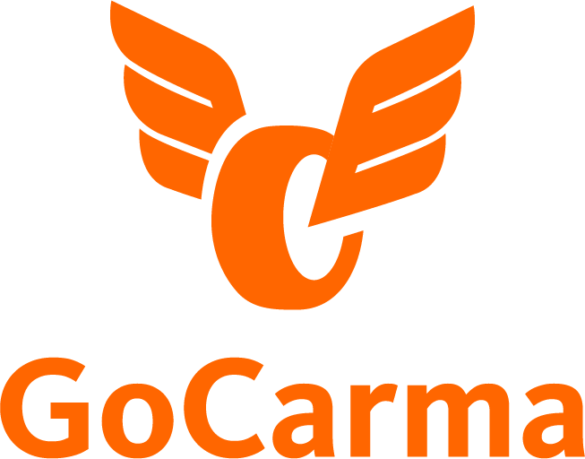

AUTOMATED OCCUPANCY
DETECTION AND VERIFICATION TECHNOLOGY

MARKETING COMMUNICATIONS PLAN

Co-Developed by:
North Central Texas Council of Governments (NCTCOG) and Carma Technology Corporation

INTRODUCTION

Background
The Regional Transportation Council (RTC) has established policies (RTC Policies), which provide for a toll discount for high-occupancy vehicles. The requirement for the discount is a motorcycle or two-axle vehicle with two or more occupants (2+) and could have gone to three or more occupants (3+) in a two-axle vehicle on or before June 1, 2018, as stated in the RTC Policies. A 50% discount is available during the weekday peak periods for HOV users on Tolled Managed Lanes.
The HOV discount during the weekday peak period was originally implemented through an app-based pre-declaration method and enforced manually through officers in the field. The RTC Policies provided that, over time, more advanced technology verification equipment would be phased in to replace manual enforcement.
This document outlines goals, target audiences, tactics and branding for integrated marketing and outreach to encourage metroplex commuters to download and use the GoCarma app for HOV discounts on all DFW TEXpress Lanes.
Marketing tactics include testing the effectiveness of various communication channels to identify the most effective at driving downloads/registration and usage of the GoCarma app. GoCarma is responsible for hosting the website used for downloads, FAQs, customer support information, as well as customer service, as defined in the Customer Service Scenarios document.

This Document
This communications plan addresses public information, participant recruitment, and ongoing communication efforts with GoCarma app users. Public information includes communication with the general public, the press, and potential project partners including: TxDOT, NTTA, Transcore, Cintra, transit authorities, and local governments.
This document outlines the continued use of a brand strategy and communications tactics that aim to attract and retain a broad user base throughout the project. This plan addresses how the project team communicates back and forth with program participants, including types of communication channels.
This is a “working plan” which will be updated as the program progresses based upon the effectiveness of outreach activities.

Project Goals and Objectives
Previously, the goal was to educate the public about the transition from Drive On TEXpress to GoCarma. New goals for the “maintenance phase” of the communications plan are detailed below.
- Gain new users by targeting people who have never carpooled; promote the HOV discount GoCarma provides
- Gain new users by targeting carpoolers who are not using GoCarma
- Maintain existing GoCarma users
- Encourage relevant businesses/stakeholders to promote and support GoCarma

Tactics
- Design, edit, and produce an informational flyer and business card to be distributed at homeowner association events and during professional presentations. (Carma) Complete

- Coordinate with at least four homeowner associations near a managed lane corridor to host a barbeque event for residents and present GoCarma app information. (Carma) Ongoing

- Update instructional GoCarma video with the latest information. This video can be used throughout various advertising platforms including social media (Facebook/YouTube), websites, and even embedded within the GoCarma app. (Carma) Complete

- Include GoCarma app and information in at least four presentations given to professional organizations and regional chambers of commerce. (NCTCOG, Project Partners) Ongoing

- Post GoCarma content at least four times a month (once a week) on all social media platforms. (NCTCOG, Project Partners) Ongoing

- Include updated news article about GoCarma app in March eblasts and newsletters. (NCTCOG, Project Partners) Planned

- Post and/or highlight GoCarma banner on agency and partner websites February - May 2023. (NCTCOG, Project Partners) Planned

- Run dynamic message signs (DMS) to promote GoCarma along the Manage Lane Corridors (Project Partners) Planned
Draft Schedule
*The following draft schedule will start at the same time as integration. The timelines reflect the amount of time needed to update marketing materials prior to the launch date and are contingent on integration being completed by the time the campaign is scheduled to launch.
Campaign evaluation will be continuous and changes will be made as needed.
Draft Communications Plan | Feb 11, 2022
Communications Plan Committee Brainstorm | Week of March 7, 2022
Final Communications Plan | March 25, 2022
Content Updates/Development | April 29, 2022
Implement Outreach/Distribution of Materials | Fiscal Year 2022: June - Sept. 2022  Fiscal Year 2023: Feb. - May, 2023

STRATEGIC COMMUNICATIONS

Communications Approach
NCTCOG is the lead on public relations and media engagement for the project to ensure consistent messaging. Messaging and collateral materials continue to be shared with project partners for review and comment to ensure consistent messaging, particularly when education is being provided related to any partner information (the role of transponders, how to use the TEXpress Lanes, etc.) as well as determine if partner logos are appropriate on materials.

Key Messaging
Marketing communications should focus on the following key messages about the program:
- Mobile smartphone and toll transponder are necessary to receive the discount
- Download GoCarma to get your HOV discount
- Easy to use
- Mobile phone based
- GoCarma users pay the correct toll every time
- Carpooling is easy and gas is expensive; save money when you ride together

Tone
Guidelines for establishing communication pieces are below.
- Written tone - simple sentence structures in a “voice” tone (write like you are speaking to the reader. Short and direct sentences.) No full stops in headlines or subheads.
- American English spelling - since we are communicating with end-users who are using this service in a business environment, we will use the full spelling of words, rather than “text” or “slang” words. Example: through (yes) vs. thru (no)
- Visual - we will use images of people in various attire in or around the vehicles. They will be smiling, talking with one another, or working on portable devices, and of mixed ages, races, and genders. For the maintenance phase, we will show groups of friends and/or families going to events and outings together (see “Theme” for details).
- Terminology relating back to the key benefits should be used throughout all messaging. Key terms include: when riding together, riding together, getting there together, download to discount, easy to use, mobile phone based. To explain HOV, we will use the phrase, “HOV means getting there together.”
  - Phase out the world “carpool.”
  - Do not include the following in any promotional or outreach collateral: “set it and forget it,” “rebate,” and “free tolls.”
- Collect and use testimonials from happy customers. Messaging is most successful when it reflects the thoughts and words of service users, as well as signage that exists on the roadway to avoid confusion. By promoting the benefits that they experience on their commute, it will be easier to attract the next commuter to try the app.
- Tagline (where applicable): Get there together
Theme
The proposed theme for the maintenance phase revolves around shared experiences with friends and family. Messaging could include phrasing such as, “Ride with your ______ family,” where the blank space is interchangeable (work family, gym family, knitting family, etc.). In addition to carpooling images, images of people attending events and participating in activities together could be shown with copy indicating they rode together and used GoCarma. Ideally, testimonials could be incorporated into the visuals.

Outreach

GoCarma Website
The domain www.gocarma.com/dfw is the primary webpage and the one-stop location for program-related content. The webpage plays a role in user communications, giving users of the program answers to frequently asked questions.
This same FAQ section of the site will provide contact information for technical support (see separate Customer Service Scenarios document). The DFW section of the site also provides a link to the NCTCOG carpool incentive program (TryParkingIt) - https://support.gocarma.com/en/articles/4101087-earn-more-for-your-green-travel. A link to www.TEXpressLanes.com should be featured on the GoCarma website educating individuals about which roadways have an HOV discount.
Selected information hosted on the site will be available in Spanish or users can copy/paste text and use the translate feature in the Google browser. Additional translation would be provided if requested. Users can also receive more personalized and in-depth support by emailing, chatting, or calling a Carma Customer Care Agent.

Partner Websites
A banner and web page creative/content was designed that appears on relevant partner websites including;
- NCTCOG | Complete https://www.nctcog.org/trans/manage/tdm/gocarma Air North Texas | Complete https://www.airnorthtexas.org/links
- TxDOT
- NTTA
- Cintra (all associated TEXpress Lanes websites including My TEXpress microsite)
- LBJExpress |Complete https://www.lbjtexpress.com/discounts/hov-qualifications-and-activation
- Try Parking It
- Local governments
  - City of Dallas
  - City of Ft. Worth
  - City of Richardson
Website copy should be written by Carma/NCTCOG and provided to partners to redirect partner websites to the GoCarma.com/DFW website. This ensures all website updates are maintained in a single location. Content on the GoCarma website is provided in advance to project partners for review and comment.

Media Relations
NCTCOG staff is the primary media relations contact, and a robust media database exists that is being used to send out press releases. Media relations could include a press release and/or more-targeted outreach to reporters or outlets who have done stories before. Podcasts are another option to explore because they allow messaging to be extremely targeted. Potential types of podcasts include transportation, technology and “extreme couponing.” If it is determined that an insufficient number of participants are recruited for the program, additional media support may be necessary and could include direct pitches to reporters and booking appearances on media programs in targeted communities.

Print and Electronic Newsletters
The NCTCOG Transportation Department periodically publishes print and electronic newsletters. NCTCOG publications that could highlight the campaign in either feature or sidebar articles include:
- Local Motion (monthly publication)
- Mobility Matters (bi-annual publication)
- NCTCOG Agency Publications such as What’s New at NCTCOG (monthly publication)
- NCTCOG Transportation Update e-newsletter (monthly publication)
- Try Parking It e-newsletter (once a quarter publication)
- Air North Texas Clean Air Corner (monthly blog)
Campaign promotion in these newsletters will be enhanced by reaching out to partner transportation organizations, such as TxDOT, NTTA, NTE/LBJ, TTI, local governments along the corridor, and the transit authorities and asking these organizations to include information in their own newsletters. Articles could also be shared with chambers of commerce, homeowner associations, and related blogs. NTTA will not be able to send direct email to TollTag customers due to a prohibition on sending email marketing but will do an article for its newsletter. Articles are written by NCTCOG staff to make the process simple for others to incorporate this information.
Co-Branding
Co-branding opportunities may arise with NCTCOG programs that have overlapping goals/messages.
Program | Message | Outreach Tactic/Co-Branding Opportunity
Try Parking It | Carpool/Log your alternative commute
Air North Texas | Choose clean air actions (including carpooling)

Social Media
The NCTCOG Transportation Department maintains a presence on Facebook, Twitter, Instagram, Vimeo, and YouTube, but the individuals following these accounts may not be the target audience for this campaign. However, it is still important to inform our audience of the GoCarma program and its benefits.
General messaging about GoCarma is posted periodically. Photos or graphics, whenever possible, will accompany content. Additionally, hashtags can be incorporated into the website, newsletter articles, and other information to promote GoCarma and to leverage additional followers. A social media kit can be provided to partner organizations in a messaging package with template newsletter articles. As an example, TxDOT will use social media channels as well as construction project social media accounts to publicize GoCarma. Content can also be shared with relevant social media influencers, such as extreme couponers.

Community Outreach & Business Relations
Community outreach and business relations provide opportunities to connect with target audiences to spread word about the GoCarma app. Many events are held throughout the year, such as homeowner and neighborhood association meetings. When the target demographic of the meeting or event matches with the demographics/geography of interest to GoCarma, participation, whether that means hosting a booth/meeting or providing a presentation, should be considered.
Should additional direct outreach be needed to increase recruitment in targeted communities, community leaders or groups in the impacted areas should be identified to receive more information on the GoCarma program. Groups or organizations are listed in priority order below, starting with highest priorities.
- Neighborhood and homeowner associations, Nextdoor app/website
- Apartment complexes
- Major businesses along the corridor, including hospitals
- Libraries, community centers, and senior centers
While NCTCOG will leverage their local connections and established business relationships, GoCarma will assist with any collateral creation and staffing needs for these efforts.

TxDOT/Cintra Digital Message Signs
Information regarding GoCarma can be displayed on digital message signs (DMS) along roadways with TEXpress Lanes indicating the app must be used to get HOV discounts.

ADVERTISING PLAN

Branding
The purpose of this advertising plan is to create awareness of the GoCarma program and to recruit participants into the program. Branding guidelines are outlined below and may be expanded upon as the campaign progresses.
See appendix for style guide.

Advertising Tactics

Paid advertising
Paid media timeframe includes GoCarma HOA events planned for Saturday, March 18 and Saturday, April 1. Media will focus on new and current users who live and commute along gantries and would be interested in utilizing the HOV discount GoCarma provides. The budget is up to $200,000. General paid advertising information is below:
- Digital Billboards - Procure placements in high traffic areas like shopping malls and grocery stores around TEXpress lanes but also concentrate an extra board near HOA event locations. If billboards, static preferred.
- Traditional Radio Spots - English and Spanish radio, preferred demographics of families and early adopters
- Print Publications: Community News, Major Newspapers, Local Magazines - Community papers service homes and businesses near or around TEXpress lanes (Keller, Roanoke, N. Fort Worth and Garland, Richardson circulations). With a potential HOA event in Garland, there are higher African American and Vietnamese populations so perhaps put a high visibility placement in those publications.
- Facebook - Organic posts and advertising that have co-branding will need approval from all parties. Social Media placements to support OOH and publications.

User Adoption

Incentives
Incentives should be offered to encourage potential, new, and existing users to take more trips and do activities through the app. Incentives may vary depending on the time of year and other marketing initiatives occurring simultaneously. Incentives and associated timeframes will be determined between GoCarma and NCTCOG staff with support of partners as the campaign progresses.
- Holiday Giveaway - December 2022 All GoCarma users will be encouraged to participate by completing a quick form asking what the HOV discount means to them. Users who complete the form will be eligible to win a $250 Amazon gift card. Five lucky winners will be randomly selected and notified by Jan. 3, 2023.

Collateral
While physical collateral is not critical for this campaign, we will create a few collateral pieces to be used for various purposes. To reach key audiences and generate new participants, the project team will develop and distribute the following materials based on the key messaging described above.

Digital Flyer, Business Card Info Piece, and Other Needs
These collateral pieces will inform audiences on what the GoCarma app does while also communicating key benefits, statistics, and details about the program.
This flyer should contain the following information:
- Key Benefits - Described in a previous section of this document.
- How to download GoCarma app - Simply go to the Apple app store or Google Play to download the GoCarma app.
- Requesting a GoCarma pass - After you download the app, you will receive an email with information on how to register. Other occupants with a smartphone can also download the app so that a discount will be applied. Passengers don’t have a smartphone? Don’t worry! You can request an Occupant Pass to travel with that person.
- Where to get support - Will direct you to the GoCarma customer support center.
- FAQs - Have a question? Visit our in-app FAQ page for the most commonly asked questions. You can also message us from within the GoCarma app if you need further assistance. GoCarma Support & FAQs-https://support.gocarma.com/en/

Banner Pen
Procured in 2019, a GoCarma branded banner pen is available to distribute.

Other Promotional Items

Educational items will be considered and potentially procured to provide to potential users during outreach events, public meetings, partner support, etc. These items include but are not limited to branded socks, car-shaped mint tins, chip clips, etc. and should go along with the theme of GoCarma's branding.

Video Production
GoCarma produced an instructional video explaining the GoCarma app, as well as how to sign-up and start earning discounts and incentives. GoCarma updated the video with the latest information in 2022. This video can be used throughout various advertising platforms including social media (Facebook/YouTube), websites, and even embedded within the GoCarma app. GoCarma may also edit the instructional video to answer specific customer related FAQs in a video format (i.e.: how to enter your transponder number, how to update your account information, etc.). Staff will review other opportunities for Carma video testimonials. Also, staff would like to propose a side-by-side video of TEXpress Lanes vs. Standard lanes to show the time advantage.

Photography
Photography that highlights the benefits and ease of the GoCarma app will be needed for press kits, advertising creative, collateral pieces, websites, social media, etc. Images need to be of people in various attire in or around the vehicles. Images should include North Texas landmarks and evoke the feeling the user is in the DFW region and near or on corridors with HOV TEXpress Lanes. Images should be high resolution. During the maintenance phase, images of friends and/or families attending outings and events together should be featured.

APPENDIX
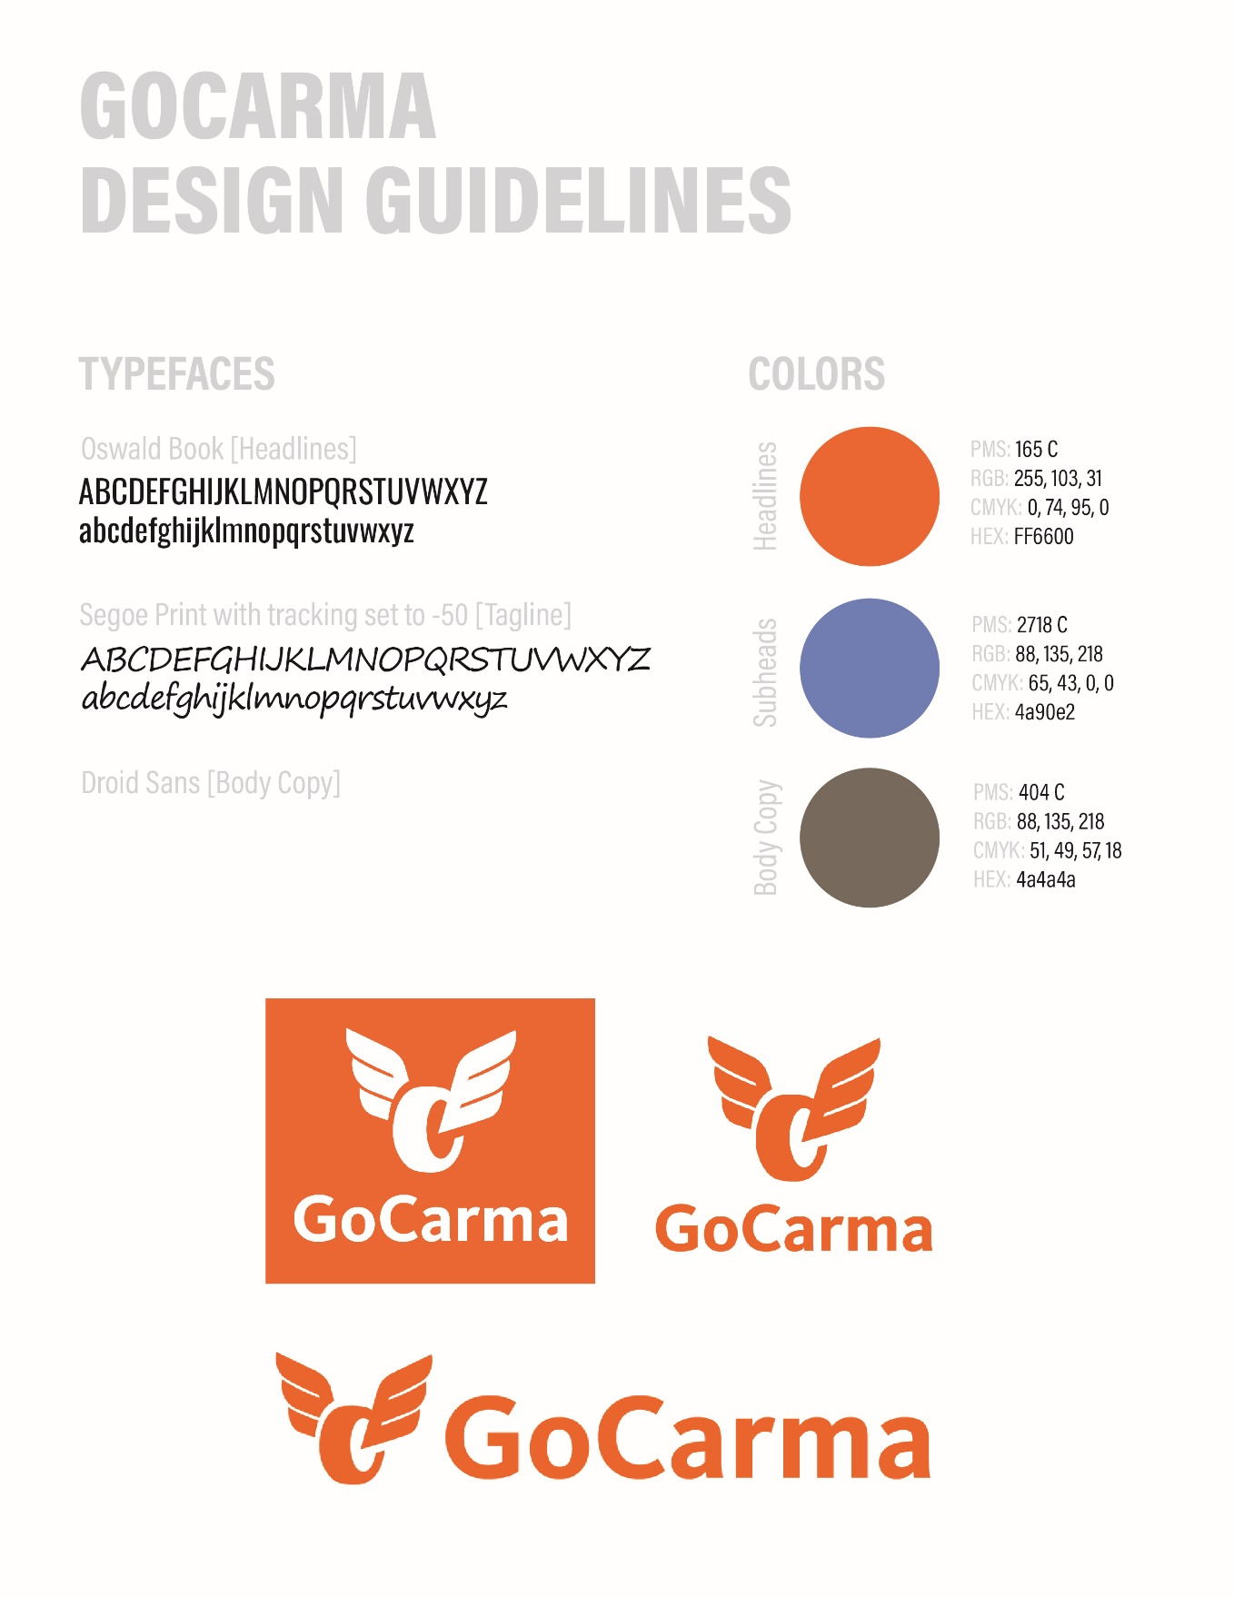

KEY PERFORMANCE METRICS
Performance for this campaign will include measurements for all key goals and objectives as defined above. In addition, GoCarma will track key conversion metrics to assist with marketing campaign measurements and executive communications. Some of the Key Performance Metrics include:
- Conversion rates
  - Average number of days from download to registration
  - Average number days from registration until first HOV trip
- User statistics
  - Total number of registered GoCarma users
  - Total number of trips (SOV, HOV2+, HOV3+)
  - Total HOV trips per month
- Advertising
  - Impression, reach, and clicks by mode, where available
  - App downloads, where available
  - Demographics and platforms, where available
Information used for analysis will be provided by GoCarma, NCTCOG, and partners and will be monitored monthly. Metrics will be reviewed frequently, and types of metrics tracked may be updated.
Earned Media Stories
Date | Title | Link | Publication
GOCARMA FUNCTIONALITY AND OPERATIONS
Basic who, what, where, when, why, how = “the story”
Qualitative analysis of feedback from the GoCarma pilot testers clearly confirms great ease of use in both setting up and using the GoCarma product, even amongst drivers with self-described low levels of comfort with technology. In every case, drivers commented positively on the fact that they never needed to use the app after the initial setup process.
Ease-of-Use / Set-Up
With GoCarma, each user is asked to install the iOS or Android app. This setup process is designed to be speedy and to ensure drivers never need to interact with the app again. All marketing collateral should highlight the simplicity of the setup process.
Feedback from pilot testers confirmed that the process was considered easy by all drivers, regardless of their comfort level with technology. Quotes on their experience are below:
Quotes from Pilot Testers on Ease-of-Use/Set-Up
Really easy. The longest part was setting it up the first time and then it's easy because you don't have to do anything more.

The questions to set it up were simple. I even got the guy I carpooled with to set his up and he did it on the way home. It only took him a few minutes. Everything is straightforward.
Easy, quick, fast, wasn't hard.
It was quick and easy! It wasn't overly difficult.
Extremely easy! Being my age, I'm not that savvy on today's technology and I didn't need any assistance.
I'm not a technology person and I was able to do it without any problems. It was easy, very easy!
Little to No Maintenance / Easy Daily Use
Another major benefit we highlight throughout our communications and marketing strategies should be the fact that, with GoCarma, a user never has to open the app after the initial setup process. As long as the user keeps Bluetooth enabled on their phone, their occupancy in a car will always be detected and reported in the background. No human interaction is required to declare (or even pre-declare) vehicle occupancy; making it easy and simple to use. There is no longer a 15-minute wait period to activate HOV status or a 10-minute wait period to deactivate HOV status, it is simply based on the number of Bluetooth enabled devices with the GoCarma app.
As evidenced by the comments below, drivers clearly loved how simple it was to use – as they didn’t have to do anything.

Quotes from Pilot Testers on Maintenance/Daily Usage
I didn't have to do anything.

It was just an initial set-up and then the guy I carpool with just jumps in the car and we never had to look at it again.
I don't have to use it on a daily basis. It's been great! Once you do the initial set up, that's it.

I think we've probably checked it a couple times to make sure it says I'm detected in the car, but that's it. There is little to no maintenance.
It was extremely easy; there was nothing I had to do, but to drive.

All I had to do was drive my car. And that's what everyone wants, something easy. This was very easy.
It was easy, very easy!
Didn't have to do anything to declare how many people were in the car.
Mobile Smartphone and Toll Transponder are Necessary to Receive Discount
There must be at least one mobile smart phone in the vehicle with the GoCarma app installed. Your carpool buddy should possess either a second smartphone or an occupant pass. The smartphone(s) transmit information to GoCarma's system to confirm discount qualification. There is no pre-registration and all communication with the system is done in real-time on the roadway. You must have a toll transponder (toll tag) in order to receive the HOV discount and that information is entered into the GoCarma app at the time of account registration. Remember to update your transponder information with GoCarma when you get a new vehicle.
Messaging for Motorcycle Operators
The GoCarma app enables operators of motorcycles to register their motorcycles to qualify for discounted tolls in TEXpress Lanes. Upon adding a vehicle in the app, the user will be asked to denote if they drive a motorcycle. They are then directed to a motorcycle registration form. Vehicles that are marked as a motorcycle within the GoCarma system will always be reported as HOV so that the toll operator can apply the discount in the same way it applies a discount for a verified HOV transaction.
GoCarma Users Pay the Correct Toll Every Time
GoCarma users don’t have to do anything once they have registered. No need to open the app or pre-register before using the TEXpress lanes… just drive and the correct toll based upon the vehicle’s occupancy will be reported every time. The GoCarma app activates when you are in a TEXpress Lane during weekday peak periods and shares the data with the toll operator. Carma only verifies GPS location during weekday peak hours and only if carpoolers are in, or next to, a TEXpress Lane. All GPS data is deleted after 60 days, and personal data is protected by the GoCarma privacy policy.
Customer Service
NTTA will be the front line for customer support as they will handle billing for a majority of GoCarma users. Yet, GoCarma will handle customer inquiries that are technical in nature or related specifically to the GoCarma app. GoCarma closely coordinates with NTTA, TxDOT, Cintra, and NCTCOG staff regarding other customer service issues related to the HOV discount per the Customer Service Business Rules. GoCarma also provides customer support. Solutions to most customer questions and user related topics will be available for review within the GoCarma app. However, there is a chat within the GoCarma app that will direct customers to live support, as needed.
GoCarma Website
The GoCarma.com/DFW website is the go-to source for all information about the new program in DFW, links to pre-register, download the GoCarma app (Android & iOS only), FAQs, and customer support.
In-App Support
The GoCarma app is designed with in-app help for the most common tasks, including registration of people, registration of vehicles, inviting passengers to download the app, trip history, HOV status, and checking the app to ensure the occupancy is working properly. Most tasks include in-app help and links to the GoCarma website for more information including the FAQs.
Live Chat
Carma uses an in-app service (Intercom) that supports “live chat” with customer service representatives that will be available during local hours Monday - Saturday 9 a.m. to 5 p.m. The staff will help users with everything from registration to resolving user questions.
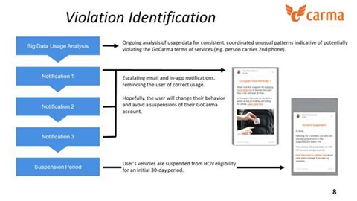
An education process was developed to educate users on how to properly use the service during the initial 90 day startup period. More information is provided in the (separate) GoCarma Tolling App HOV Discount Violation and Account Suspension Policy.
Warnings and suspensions of GoCarma accounts should be tied to the number violation DAYS and not individual OCCURRENCES. Example; someone violates the GoCarma Terms Of Service on three (3) trips on Monday, but that only increments the violation counter one (1). It will be made clear that the warnings and suspensions do not apply to toll tag accounts.
Per the separate GoCarma Tolling App HOV Discount Violation and Account Suspension Policy, if an account is suspended, that individual will continue to be included in occupancy reports as a passenger. The individual will not receive HOV discounts when they are a driver, but if they are a passenger in a carpool, the other driver will continue to receive discounts.
- Educational info within the app - Your first 90 days will be the time to become acquainted with GoCarma, and violations will be overlooked. However, after the 90-day grace period, these violations will be addressed with the user.
New User Education
NCTCOG has also requested a violation leniency period of ninety (90) days from the date of app registration. During this initial period, GoCarma should not penalize users for improper usage of the app, but rather educate them when issues are identified with relevant communications. See (separate) Violation Reporting documentation for violation triggers and user communications. During this mentioned “leniency” period, users should receive a series of educational messages to encourage them to get a “real” carpool, warn them that SOV trips discounted during this period are just to show them the benefits of the managed lanes, etc.
When someone downloaded the GoCarma app prior to the transition date, users received a message saying something such as, “Thank you for downloading GoCarma, you will need to use Drive On App to receive HOV discounts up to 1/24/2020”. Then another message at the transition date saying “Drive On app will no longer work, but you are all set up for GoCarma…”
