North Central Texas Council of Governments

NCTCOG TECHNOLOGY PROJECT IDENTIFICATION (TPI) FRAMEWORK

Application Information Packet
Applications Due: April 10, 2026



This Technology Project Identification (TPI) Framework Information Packet contains information on the type of program, background, funding structure, eligible recipients, eligible activities, evaluation criteria, application process, and schedule.
INTRODUCTION
The North Central Texas Council of Governments (NCTCOG) Technology and Innovation Program is implementing a new Technology Project Identification (TPI) Framework that provides approximately $8,700,000 in Surface Transportation Block Grant Program (STBG) funding to support connected, automated, and emerging transportation technologies within the North Central Texas region. This framework establishes a criteria-based process for agencies to submit, evaluate, and advance innovative technology concepts.
To be considered for funding, the submitting agency must be a regional public-sector partner agency in the 12 counties MPO nonattainment area: Collin, Dallas, Denton, Ellis, Hood, Hunt, Johnson, Kaufman, Parker, Rockwall, Tarrant, and Wise Counties (See map below).
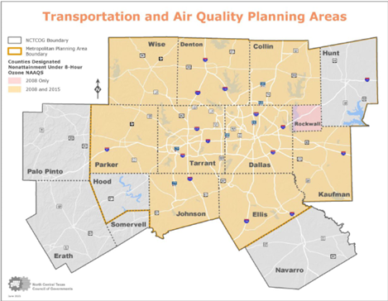

BACKGROUND
The Technology and Innovation Program supports the regional deployment of emerging transportation technologies that enhance safety, efficiency, connectivity, and overall mobility. Lessons learned from past and ongoing efforts (e.g. automated shuttles, connected vehicle corridors, broadband as transportation initiatives, and smart freight systems) helped inform and guide the development of the new Technology Project Identification Framework.
The TPI Framework streamlines the way technology projects are identified and advanced by introducing a three-step process:
- Idea Submission: Agencies submit project concepts that outline the purpose, scope, timing, and anticipated cost (how, what, when, and how much).
- Evaluation & Readiness Review: Staff review each concept for eligibility, alignment with program goals, technical readiness, and overall feasibility.
- Regional Procurement: NCTCOG leads procurement for selected technologies to ensure consistency and achieve regional benefits.
This process ensures that regional funding is directed toward projects with measurable community benefits, strong readiness, and potential for regional scalability.
EMPHASIS AREAS
Project concepts submitted through the TPI Framework must align with one or more of the following emphasis areas:
- Roadway Safety Technologies: Deploying advanced tools that help protect pedestrians, cyclists, and other road users such as connected warnings, speed management, and automated incident detection.
- Food Desert Elimination: Expanding access to fresh food through innovative mobility solutions.
- Delivery Bots & Drones: Using small-scale autonomous delivery devices and unmanned aerial systems (UAS) to improve last-mile freight movement and reduce congestion.
- Next-Gen Traffic Signals: Smart signal control, transit priority, and connected intersection systems to enhance traffic flow and safety.
- Autonomous Shuttles: Providing low-speed automated shuttle services for first/last-mile connections and circulation within campuses and neighborhoods. Higher-speed automated shuttles are eligible but will require additional safety review.
GENERAL GUIDELINES
- There is no limitation on the number of project proposals submitted by an eligible agency. However, agencies submitting more than one project must rank the projects by priority and specify the fiscal year in which each project will occur.
- Maximum award amount per project is $3 Million.
- The NCTCOG Technology Project Identification (TPI) Call for Ideas is a cost reimbursement program (not a grant). Applicants must have sufficient cash flow to accommodate the payment of 100 percent of project costs. Reimbursement will occur after appropriate documentation is submitted to NCTCOG.
- Project activities must be completed by December 31, 2028 or risk the loss of funding.
- The agency receiving the award is responsible for all cost overruns.
- To comply with the federal and state regulations, as well as internal agency policy, NCTCOG will need a Risk Assessment on file prior to making any subrecipient agreements. Has your agency completed a Risk Assessment with NCTCOG within the past calendar year? If you are unsure, you may contact Nancy Luong at 817-704-5697 or nluong@nctcog.org to verify. If not, applicants must complete the online form at https://www.surveymonkey.com/r/InnovationCFP (TBD).
As part of this process, Applicants will be required to provide a Unique Entity Identifier (UEI), and proof of a current registration with the System for Award Management (SAM). Applicants can receive a UEI and start the registration process in SAM at no cost at www.SAM.gov. If a UEI has not yet been assigned or the SAM registration has not been approved by the time the application is submitted, please include the date the applicant requested the UEI and/or the date the SAM registration was submitted.
- The Regional Transportation Council will approve all final projects and funding levels. Itemized budgets will be reviewed by NCTCOG for eligibility and reasonableness. Based on available funds, some projects may not be fully funded.

FUNDING AVAILABILITY

The NCTCOG Technology Project Identification framework (TPI) is funded through the Category 7 – Surface Transportation Block Grant Program (STBG) and covers multiple jurisdictions throughout the NCT Metropolitan Planning Area. The East/West equity split for the allocation of STBG funds is 69 percent east and 31 percent west. The total approved project budget is $8,700,000. Agencies selected to receive funding are responsible for procurement and reimbursement requests.

Eastern Subregion Dallas District Share (69%) | Western Subregion Fort Worth District Share (31%) | NCTCOG TPI Projects Funding Available
$6,003,000 | $2,697,000 | $8,700,000
Total Budget: $8,700,000. No local match is required as Transportation Development Credits (TDCs) will be used to satisfy the local match requirement.

ELIGIBLE RECIPIENTS AND REQUIREMENTS
- Maximum award amount per project is $3 Million.
- Public partner agencies within the 12 county MPO boundaries.
- Projects must address a transportation need, clearly identify the emphasis area(s) they support and include documentation verifying the project’s Technology Readiness Level (Minimum required level 6), such as test results, pilot outcomes, or research validation. For additional reference, see NASA’s Technology Readiness Level descriptions:
https://www.nasa.gov/wp-content/uploads/2017/12/458490main_trl_definitions.pdf
- Commitment to open-data sharing with NCTCOG.
- Follow Connected Vehicle Systems Interface Guidelines.
- Include a plan for maintenance and operations after project completion.
- Personnel costs for project implementation are not eligible for reimbursement.
BUILD AMERICA, BUY AMERICA REQUIREMENTS
The PERFORMING PARTY agrees to comply with all Build America, Buy America (BABA) requirements under 23 USC 313, 2 CFR 200.184 and 2 CFR 200.322 for the purchase, acquisition, or use of goods, products, or materials (including but not limited to iron, aluminum, steel, cement, and other manufactured products). Consistent with 2 CFR §200.322, “Produced in the United States” means, for iron and steel products, that all manufacturing processes, from the initial melting stage through the application of coatings, occurred in the United States. “Manufactured products” means items and construction materials composed in whole or in part of non-ferrous metals such as aluminum; plastics and polymer-based products such as polyvinyl chloride pipe; aggregates such as concrete; glass, including optical fiber; and lumber. The PERFORMING PARTY must provide a Certification completed by the manufacturer or demonstrate that the Federal Highway Administration has granted a waiver of the BABA requirements.
PROPERTY MANAGEMENT REQUIREMENTS
Agencies must maintain grant-funded equipment, including information technology systems such as computing devices, ancillary equipment, software, firmware, and similar procedures, services (including support services), and related resources, in accordance with federal property management requirements and will be subject to monitoring by NCTCOG. This means that an Agency must maintain grant-funded equipment in good working order, operate it in a manner consistent with the grant until the fair market value is $5,000 or less, and provide information concerning the use and condition of the equipment upon request. When the equipment acquired is no longer needed, the Agency must contact NCTCOG for further instructions regarding disposition. Equipment may not be sold, scrapped or otherwise disposed of until written approval is received from NCTCOG. Sale, scrap or other disposal without NCTCOG approval or when fair market value exceeds $5,000, may result in a partial return of funding.

MATCHING REQUIREMENTS
Agencies receiving funds through the NCTCOG Technology Project Identification (TPI) Framework will not be required to provide a local match as a part of this call for ideas.
EVALUATION CRITERIA
Scoring Component |  | Available Points
Innovative approach to solve a transportation need | Innovative solution that supports listed emphasis areas, engages the community, improves job access, and drives economic growth | 50%
Strong case for regional investment | Clearly articulates why regional funds are needed and how the project can be transferable across regions | 40%
Public/Private Collaboration | Involves coordinating between public/private partner to enhance regional value | 10%
Total Points |  | 100%

APPLICATION PROCESS
- Applications and supplemental materials may be obtained online or by contacting NCTCOG staff.
- Three (3) signed copies and supporting materials submitted “in hand” to NCTCOG offices, and one (1) electronic copy.
- Electronic documents must be submitted in PDF format.
- Graphics (maps, diagrams, renderings): PDF, JPEG, or bitmap format.
- No supplemental information (other than administrative clarifications) will be accepted after the application deadline.
- Deadline: Applications must be received in hand by 5:00 pm CST on April 10, 2026. A postmark does not constitute an on-time submission.
Submittal Addresses:
Mail:
North Central Texas Council of Governments
Transportation Department – Technology and Innovation
Attn: Braulio Bessa
P.O. Box 5888
Arlington, Texas 76005-5888
Physical Location:
North Central Texas Council of Governments
Transportation Department – Technology and Innovation
616 Six Flags Drive
Arlington, Texas 76011
FUNDING ADMINISTRATION AND REIMBURSEMENT OF EXPENSES
- Selected applicants will be notified in writing of their selection and the funding amount awarded.
- Agencies must enter into an interlocal agreement with NCTCOG.
- Project activities may not begin until the agreement with NCTCOG is executed.
- Reimbursement requests must include itemized expenses and supporting documentation.
- Costs must be reasonable, necessary, actual, and eligible under the program guidelines.
SCHEDULE
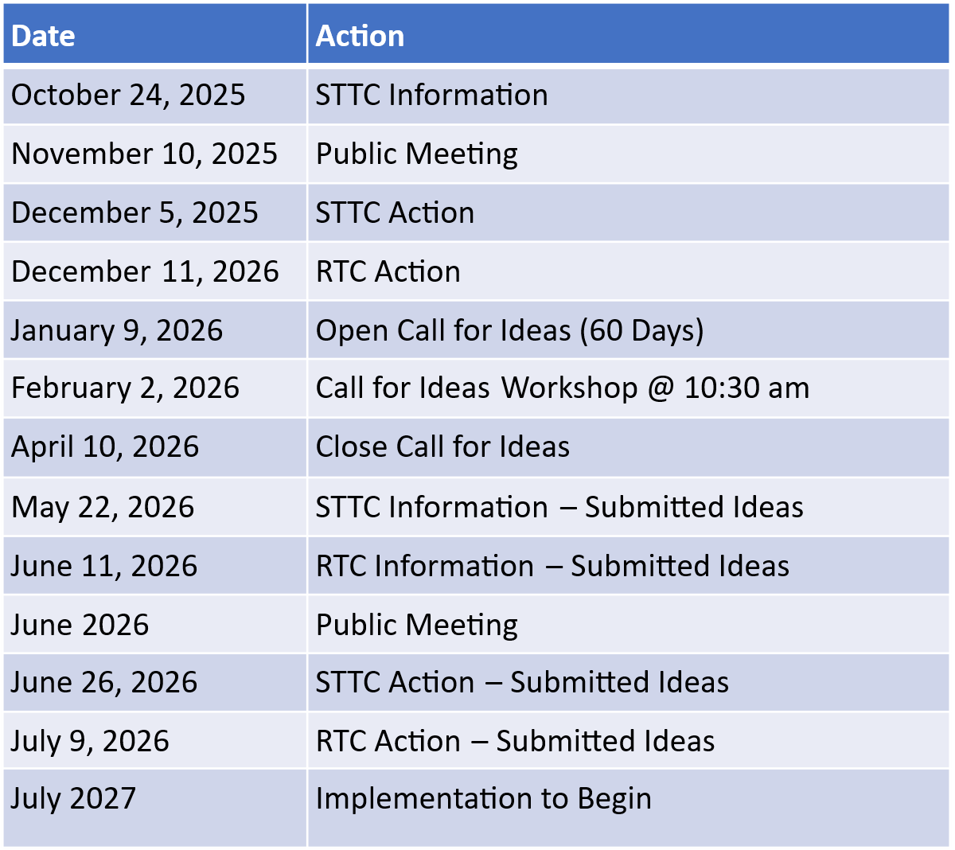

CONTACT INFORMATION
NCTCOG PROJECT STAFF:
Natalie Bettger
Senior Program Manager
Transportation Department
Email: nbettger@nctcog.org
Phone: (817) 695-9280
Braulio Bessa
Transportation Planner II
Transportation Department
Technology and Innovation
Email: bbessa@nctcog.org
Phone: (817) 640-7806
For additional information or questions, contact the NCTCOG Transportation Department.

End of Document

