Planning for Sustainable Materials Management in North Central Texas
FY 2022 to 2023 Solid Waste
Implementation Grant Application Guidelines
A program funded through a grant from the Texas Commission on Environmental Quality (TCEQ)
February 2021
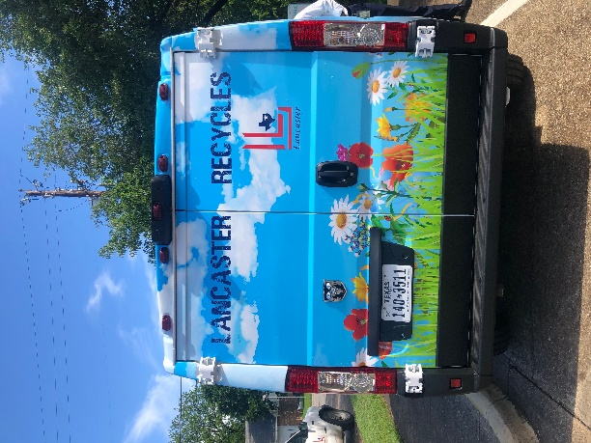
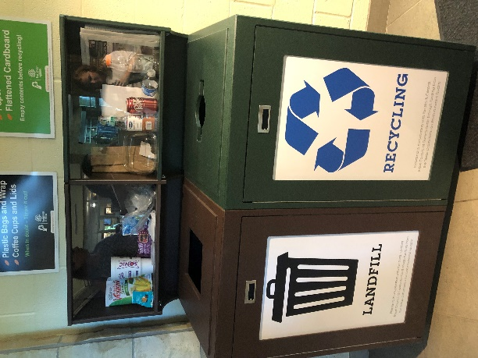
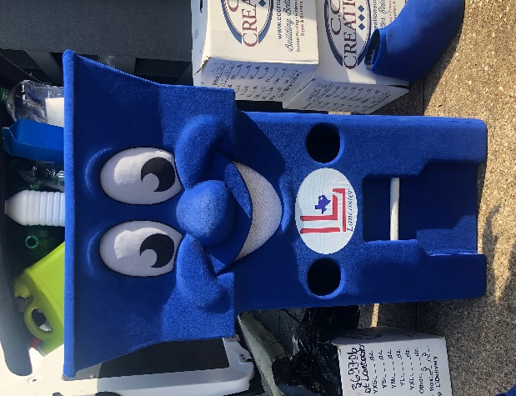

North Central Texas Council of Governments
616 Six Flags Drive
Arlington, Texas 76011
(817) 695-9210
eandd@nctcog.org

www.nctcog.org/solidwastegrants

Table of Contents
Introduction 3
FY 2022-2023 Call for Projects Anticipated Timeline 3
Eligible Entities 3
Eligible Project Types 4
Eligible Project Categories 5
Eligible Expense Categories 5
Applicable Standards 6
Application Requirements 6
Application Process 8
Application Checklist: 9
Private Industry Considerations 9
Grant Administration, Reimbursement of Expenses, and Reporting Requirements 10
Applicant Appeals 11
Appendix 1: Eligible Projects and Expenses with Examples 12
Appendix 2: Regional Plan Goals and Objectives 15
Appendix 3. Applicable Funding Standards 16
Appendix 4: Grant Scoring Criteria 18

Introduction
The North Central Texas Council of Governments (NCTCOG) is issuing a Call for Projects (CFP) for the FY2022-2023 Solid Waste Implementation Grant Program. This CFP will fund a variety of municipal solid waste (MSW) projects for local governments in the NCTCOG 16-county region (Figure 1). These projects help advance efforts that support the regional goals and objectives outlined in the Planning for Sustainable Materials Management in North Central Texas 2015 - 2040 (Regional Plan). This program is funded by the Texas Commission on Environmental Quality (TCEQ) through MSW tipping fees collected by the state.
Projects funded through this program must be consistent with the Regional Plan, must promote cooperation between public and private entities, and may not create a competitive advantage over a private industry that provides recycling or solid waste services that are readily available.
Applicants must comply with these Implementation Grant Application Guidelines in order to be eligible for funding. Additional information on the Implementation Grants Program can be found here: https://www.nctcog.org/envir/materials-management/grants.
NCTCOG anticipates that approximately $1,300,000 will be available for distribution for local and regional projects for the FY22-23 biennium. However, the source of the funds provided by TCEQ is the Solid Waste Disposal and Transportation Fees, as stated in Texas Health and Safety Code 361.013. Due to demands upon that source for funds necessary to protect the health and safety of the public, it is possible that the funds contained in the Municipal Solid Waste Disposal Account, as proscribed in Texas Health and Safety Code 361.014(d), may be depleted or reduced. As such, all funding for these projects is subject to sufficient funds in the Municipal Solid Waste Disposal Account and to the receipt and availability of funds appropriated by the Texas Legislature for the purposes of this call for projects. In the event funding is not available, NCTCOG has no obligation to provide funding to any projects that may be selected in association with this call for projects.

FY 2022-2023 Call for Projects Anticipated Timeline
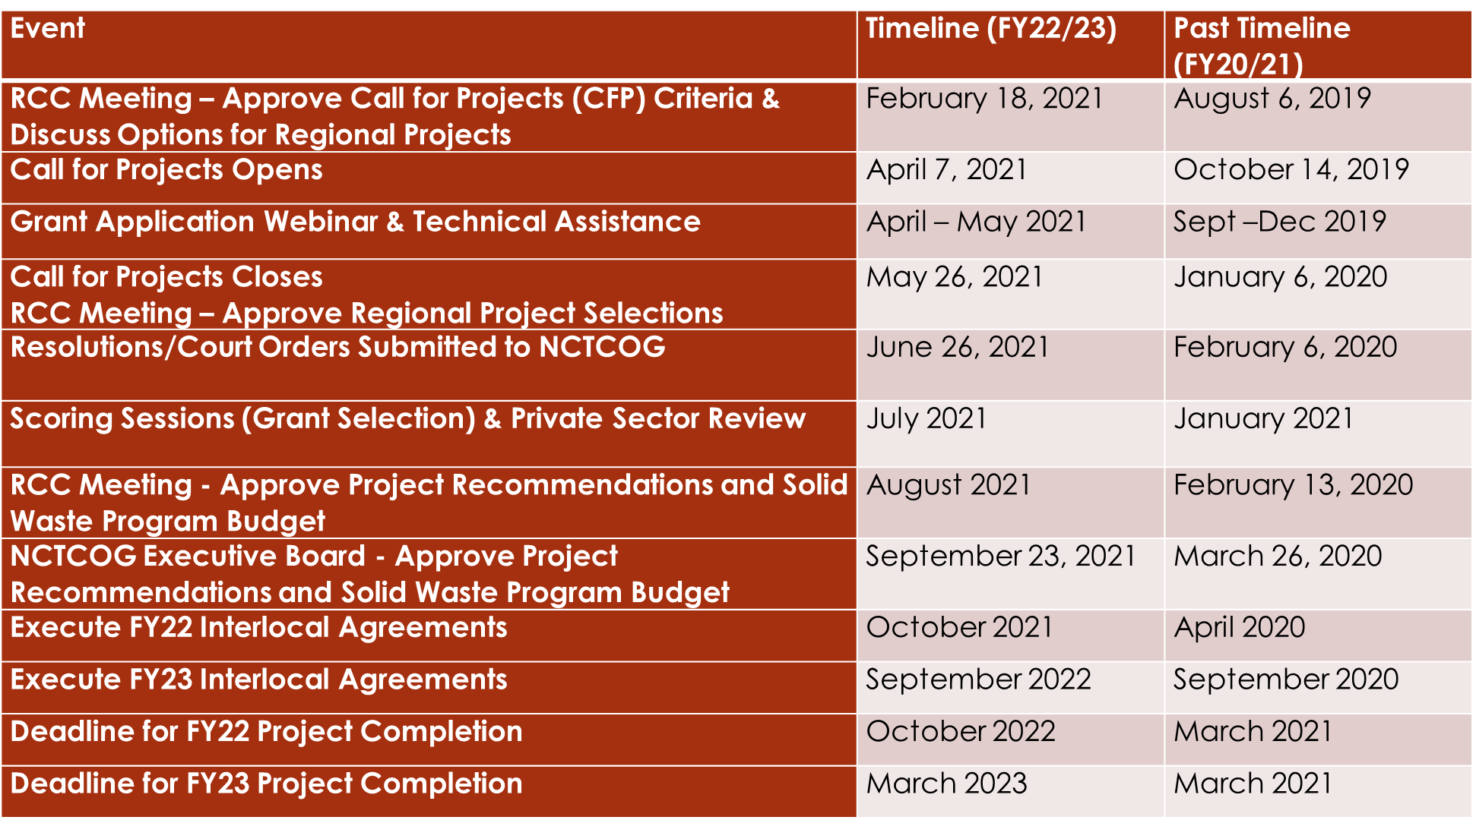

Eligible Entities
To be eligible for funding, entities must be located within NCTCOG’s 16-county region (Figure 1) which includes the following counties: Collin, Dallas, Denton, Ellis, Erath, Hood, Hunt, Johnson, Kaufman, Navarro, Palo Pinto, Parker, Rockwall, Somervell, Tarrant, and Wise.

The following entities are eligible to receive funding:
- Cities
- Counties
- Public schools and school districts (excluding Universities or post-secondary education institution)
- General and special law districts created in accordance with state law, and with authority and responsibility for water quality protection or municipal solid waste management, to include river authorities
- Councils of Governments – NCTCOG may propose to conduct a regional project

Private sector and non-profit organizations are not eligible for grant funding; however, they can partner or contract with an eligible entity to provide specific project-funded services and support project activities.
Please note: each entity is limited to two applications and only one per department.

Figure 1. NCTCOG 16-County Region

Eligible Project Types

- Local Government Project: An individual application from any eligible entity:
  - Minimum Funding Request: $15,000
  - Maximum Funding Request: $200,000
- Regional Collaborative Project: An application submitted by a partnership of at least 3 eligible entities:
  - Minimum Funding Request: $125,000
  - Maximum Funding Request: $500,000

Eligible Project Categories
Project categories eligible for funding include:
- Local Enforcement
- Source Reduction and Recycling
- Household Hazardous Waste
- Litter and Illegal Dumping Programs
- Citizens’ Collection Stations and “Small” Transfer Stations
- Local Solid Waste Management Plans
- Technical Studies with a regional scope/impact
- Educational and Training Projects
Eligible project categories are listed with example activities, example expenses, and funding limitations in Appendix 1. Additionally, applicants will be required to identify at least one regional plan goal and objective that a project intends to address. The Regional Plan goals and objectives can be found in Appendix 2.

Eligible Expense Categories

NOTE: Each line item must meet or exceed $500 to be deemed eligible for funding. All expenses must be itemized with a per unit cost and a total line-item cost. Failure to provide the number of units requested and unit cost may result in your project being deemed ineligible. Applicants are encouraged to submit information on matching and/or in-kind expenses in the application. However, in the event that grant funds are left over at the end of the biennium, any redistributed funds will not be applied to in-kind expenses (only matching expenses).

The following categories of expenses may be eligible for funding under this CFP. All expenses must be directly related to implementing the proposed project. Description of how the proposed expenses will support the proposed project will need to be provided in the application.
- Equipment. Equipment necessary and appropriate for the proposed project may be authorized. Expenses included under the “Equipment” expense category should be for non-construction related, tangible, and personal property having a unit acquisition cost of $5,000 or more (including freight and set up costs) with an estimated useful life of over one year. Any equipment that will be used for other projects or activities, in addition to the funded project, may only be funded at an amount reflecting the appropriate percentage of time that the equipment will be directly used for the funded project. The special conditions and requirements set forth in the grant program (relating to Title to and Management of Equipment and Constructed Facilities) also apply to equipment purchased with pass-through grant funding. In the application, grantees must inform NCTCOG of the physical location where equipment will be stored.
- Construction. Appropriate construction costs may be authorized. Expenses budgeted under this category should be for costs related to the enhancement or building of permanent facilities. No construction costs may be incurred by a grant recipient unless the construction details are approved in advance by NCTCOG. Appropriate costs that may be included are:
a. The cost of planning the project;
b. The cost of materials and labor connected to the construction project;
c. The cost of equipment attached to the permanent structure; and
d. Any subcontracts, including contracts for services, performed as part of the construction.
- Contractual Expenses. Professional services or appropriate tasks provided by a firm or individual not employed by the grant recipient for conducting the funded project may be authorized for subcontracting by the recipient. No contractual costs should be incurred by a grant recipient unless the subcontract is approved in advance by NCTCOG. Applicable laws and regulations concerning bidding and contracting for services must be followed. Any amendment to a subcontract which will result in or require substantive changes to any of the tasks required to be performed must be approved in writing by NCTCOG.
- Other Expenses. Other expenses, not falling under the main expense categories, may be included, if connected with the tasks and activities of the proposed project. Some expenses that may be appropriate include:
- Postage/delivery
- Printing/reproduction
- Advertising/public notices
- Signs
- Training
- Computer Hardware (under $5,000 and not listed under the “Equipment” category)
- Computer Software
- Miscellaneous Other (includes anything not listed anywhere else in the budget)

Applicable Standards
The administration of projects funded by this program must meet all applicable state and local statutes, rules and regulations, and guidelines. The main governing standards include, but may not be limited to:
- Section 361.014(b) of the Texas Health and Safety Code.
- Title 30 Texas Administrative Code (30 TAC) Chapter 330, Subchapter O, TCEQ Rules.
- 30 TAC Chapter 14, TCEQ Rules.
- The Grant Agreement between NCTCOG and TCEQ.
- The Uniform Grant and Contract Management Act, Texas Government Code §§783.001 et seq., and the Uniformed Grant Management Standards, 1 TAC §§5.141 et seq. (collectively called “UGMS”).

Appendix 3 provides further information regarding applicable statutes and regulations.

Application Requirements
Identify Applicable Goals and Objectives: All applicants will be required to identify a minimum of one or more applicable goals and objectives from the Planning for Sustainable Materials Management in North Central Texas 2015 - 2040 that the applicant’s project intends to address. The goals and objectives are included in Appendix 2.
Identify Project Category and Type: Each project will need to identify the project type (Local Government or Regional Collaborative Project) and the project category (one of eight eligible project categories).
Resolution or Court Order: Submittal of a resolution or court-order from the governing body of the project lead entity, or applicant, authorizing the application submittal as well as receipt of funding if awarded is required within thirty (30) days of the application close date. Resolutions and court orders must be received by NCTCOG via email to ccampbell@nctcog.org no later than June 26, 2021.
Private Sector Notification: According to state law (Section 341.014 (b) TX Health and Safety Code), a project or service funded under this program must promote cooperation between public and private entities, and the grant-funded project or service may not be otherwise readily available or create a competitive advantage over a private industry that provides recycling or solid waste services. In accordance with grant requirements established by the TCEQ, an applicant for funding under one of the listed project categories below must adhere to the notification requirements. For a Regional Collaborative Project, all eligible entities included in the application must adhere to the notification requirements. Failure to notify private sector service providers will result in immediate disqualification from the grant process.
Applicable Categories
- Source Reduction and Recycling
- Citizens’ Collection Stations and “Small” Registered Transfer Stations
- A demonstration project under the Educational and Training Projects category

Applicant Notification Requirements
Contact in person or in writing the known private service providers of similar services which, at the time of the application development, are providing services within the geographic service area that the project intends to serve, prior to making the application. A list of service providers within the region is available from NCTCOG at www.timetorecycle.com/locator/recycler_list.asp.

Letters of Support: For applicants under the Regional Collaborative Project category, each participating entity is required to submit a letter of support. The letters of support should identify the applicant role, level of participation, and any other support, including financial, that the partner will provide to the lead applicant entity. The lead entity, or the applicant, will only be required to submit a court order or resolution in support of the project.
Project Timeline: For each task, describe as concisely as possible the major steps or activities involved, identify the responsible entities and establish a specific timeline to accomplish each task. The Scope of Work must include:
- detailed purpose and goal of the project (must be consistent with implementing the Regional Plan’s goals and objectives);
- specific task statements with responsible entity identified;
- list of deliverables/products/activities under each task; and,
- schedule of deliverables which will begin with the execution of Interlocal Agreement with NCTCOG

Selection Subcommittee Presentation by Grant Application: All grant applicants will be required to have a representative available to present a brief presentation and to answer questions at the Grant Selection Subcommittee Meeting. Applicants will be notified of their presentation time after the close of the Call for Projects.
Required Supporting Documentation: Additional supporting documentation such as maps, drawings, plans, photos, quotes, or other materials are required and must be submitted in the online application submittal. Applicants are strongly encouraged to supply adequate supporting documentation to assist the Grant Selection Subcommittee in evaluating the application.
All applicants will need to consider and include information in the grant application concerning the ability of the applicant to cover ongoing maintenance costs of grant funded equipment, if additional equipment will be needed in order to utilize grant funded items (i.e. if applying for a trailer, is a tractor needed to pull the trailer), and will staff need to be trained and licensed in order to use equipment (i.e. forklifts, vehicles that require special driver’s licenses).
Risk Assessment Requirements: NCTCOG policy requires that all grant applicants undergo an applicable risk assessment in order to receive grant funds. After the projects have been selected for award, NCTCOG will reach out to each entity to initiate the risk assessment process, as necessary. Please note that this process will not be necessary if an entity already has a completed up-to-date risk assessment evaluation on file with any NCTCOG department. Information regarding the documentation that will be required and the evaluation criteria of the assessment is included below:
Evaluation Criteria:
- Qualitative Analysis: Subrecipient Risk & Oversight
  - In accordance with provisions under the Office of Management and Budget’s Uniform Administrative Requirements, Cost Principles, and Audit Requirements for Federal Awards (2 CFR 200)⁴, NCTCOG will conduct a risk assessment of all anticipated subrecipients prior to final selection. This assessment includes the following elements:
    - Financial/organizational capacity
    - History of performance for federal funds
    - Experience in carrying out a federally compliant procurements, and the proposed procurement approach for this project
    - Results of previous audits
    - Past performance on NCTCOG-related grants
  - NCTCOG is not obligated to fund a proposal from an applicant that has demonstrated marginal or unsatisfactory performance on previous grants or contracts with NCTCOG and/or other state or federal agencies.
  - NCTCOG is not obligated to fund a proposal from an applicant based on a determination of the risks, including the financial condition of the applicant and other risk factors as may be determined by NCTCOG.
NCTCOG may base funding decisions on factors associated with best achieving the purpose of the CFP and is not obligated to select a project for funding. Additionally, NCTCOG may select parts of an application for funding or offer to fund less than the amount requested in an application.
Procurement Requirements. The subrecipient’s contractual costs must comply with allowable cost requirements. Subrecipients who are governmental entities must engage in contractor selection on a competitive basis in accordance with their established policies or NCTCOG’s procurement guidelines. All subcontracts awarded by the subrecipient shall be in accordance with the (UGMS) and other applicable procurement laws. The subrecipient shall be responsible for the management and fiscal monitoring of all subcontractors. The subrecipient shall ensure that all subcontractors comply with all provisions required by the interlocal agreement signed between NCTCOG and the subrecipient. NCTCOG reserves the right to perform an independent audit of all subcontractors.
All subrecipients will be required to submit documentation of procurement activities along with a statement of certification to NCTCOG and receive explicit notice to proceed prior to making any purchases that require proper procurement procedures.

Application Process
Applications will be submitted through a web-based application portal available at www.nctcog.org/solidwastegrants or http://solidwastegrants.nctcog.org. Applicants will be required to register in the system with a Username and Password. It is recommended that applicants register prior to the application deadline to ensure they can access the system and avoid delays caused by technical difficulties.
Applications for the 2022-2023 Call for Projects must be received in the web-based application system by 5:00 p.m. CST on May 26, 2021 to be scored. Deadline extensions will not be considered.
Applicants are encouraged to submit their applications in advance of the submission deadline to allow time to work through any technical difficulties.

Application Checklist:
All of the items below are required to have occurred or be uploaded into the web-based system and submitted by the submission deadline for an application to be deemed complete and reach the evaluation stage:
- Completed Application Form submitted via http://solidwastegrants.nctcog.org
- Private sector notification, if applicable
- Support Letters from participating entities for Regional Collaborative Projects
- Signed Certification and Assurances
Supplemental information which is material to the application will not be accepted after the application deadline. Non-material omissions will not constitute an incomplete application. Additional supporting documentation such as maps, drawings, plans, photos, quotes, or other materials submissions are required and failure to provide sufficient material may result in disqualification.
Signed Resolution or Court Order is required within thirty (30) days of the application close date; must be received by NCTCOG via email to ccampbell@nctcog.org no later than June 26, 2021.
NCTCOG will be performing a preliminary review of all applications and disqualify those not meeting minimum requirements.
Evaluation Criteria: All applications will be evaluated based on several criteria for a total of 100 points for each project. These criteria apply to both project types (Local Government and Regional Collaborative Project). The scoring criteria is included in Appendix 4.

Private Industry Considerations
NCTCOG maintains a contact list of private service providers in North Central Texas. These private entities are invited to submit comments and attend public meetings to discuss their concerns and issues. The list of providers is made available to all project applicants.
The following process will be followed in order to alleviate private industry concerns with TCEQ funded projects:
- During the Call for Projects:
- NCTCOG will inform all known private service providers of the following:
- Availability of project funds;
- Timeframe allowed for eligible organizations that submit applications to NCTCOG
- Date of the scoring meeting at which those applications are to be reviewed and approved by NCTCOG’s solid waste advisory committee, the Resource Conservation Council (RCC).
- Project applicants must contact in person or in writing the known private service providers of similar services which, at the time of the application development, are providing services within the geographic service area that the project intends to serve, prior to submitting the application. A list of service providers within the region is available from NCTCOG at www.timetorecycle.com/locator/recycler_list.asp. On the grant application, provide complete documentation that service providers were notified of the project prior to submission of the application and submit written comments provided by any private service provider.
Once the Project Applications are Received:
  - NCTCOG staff will review applications to verify that they meet all required procedures, including the information regarding the notification of the private service providers.
  - A list of all applications will be posted online at https://www.nctcog.org/envir/materials-management/grants outlining the project applicant and the title of the project.
  - NCTCOG will inform these private service providers that they may obtain a full copy of an application with which they have concerns.
Protested Applications:
- All private service providers’ comments will be submitted to the RCC’s Grant Selection Subcommittee for consideration during project selection.
- The RCC and subsequently, the NCTCOG Executive Board will approve or reject the recommended projects. Private service providers are allowed to make oral comments regarding concerns related to a project(s) at the NCTCOG Executive Board meeting.
- The Executive Board shall then notify the private sector provider, in writing, of the determination and inform them that they have ten (10) days to appeal the determination on any of the following grounds:
  - The project does not promote cooperation between public and private entities;
  - The service is readily available in the proposed project service area; and/or,
  - The project creates a competitive advantage over that private service provider in the provision of recycling or solid waste services.
- The TCEQ makes the final determination of the appeal and the eligibility of projects.

Grant Administration, Reimbursement of Expenses, and Reporting Requirements
  - Grant Administration
Entities selected to receive grant funding will be required to execute an interlocal agreement with NCTCOG in order to receive grant funding. Projects must be completed within the scope of work, timeframe, and funding limitations specified by the interlocal agreement. A Notice to Proceed will be provided to awarded applicants. Under no circumstances will reimbursement be made for costs incurred prior to the date of the Notice to Proceed.
  - Reimbursement of Expenses
Grant funding will be made on a reimbursement basis for eligible expenses incurred and paid by the grant recipient. A cost may not be considered incurred until the grant-funded item has been paid for by the grant recipient. Requests for reimbursement shall include documentation to show all grant funded expenses and eligible expenses have been received and expenses paid by the grant recipient. Grant recipients must submit a Request for Reimbursement at least quarterly, but not more frequently than once a month, for reimbursement of actual allowable costs. If no funds were spent within a quarterly period, grant recipients are required to submit an explanation for why no funds have been spent and when they are expected to be spent. A Final Report, Final Reimbursement Request, and Release of All Claims will be due to NCTCOG at the end of the grant.

  - Reporting Requirements
Grant recipients are obligated to fulfill agreement requirements including, but not limited to, completing the quarterly grant summary and results reports.
- Quarterly Progress Reports: All recipients must submit reports detailing progress toward project completion on a quarterly basis until final reimbursement is issued. A template will be provided by NCTCOG.
- TCEQ Results Report: Grant recipients will submit cumulative results from the start of the project to August 31, 2023. A template will be provided by NCTCOG.
- TCEQ Results Report (aka: Year Later Report): Grant recipients will be required to submit a report documenting results one year after the project completion date. A template will be provided by NCTCOG.
Grant recipients agree to provide data related to the results of the project to NCTCOG and/or TCEQ. The grant recipient will also commit to monitoring the results of the project beyond the project funding term, and periodically provide NCTCOG and/or TCEQ with additional reports on the status of the project. Grant recipients also agree to allow NCTCOG and/or TCEQ staff to perform on-site visits to monitor progress of projects and document purchases as needed.

Applicant Appeals
NCTCOG may base funding decisions on factors associated with best achieving the purpose of the CFP and is not obligated to select a project for funding. Additionally, NCTCOG may select parts of an application for funding or offer to fund less than the amount requested in an application.
Applicants may appeal the funding recommendations to the RCC, after the results of the scoring process have been announced. All appeals must be based on a specific, identified error of the Grant Scoring Subcommittee and not on factors that allow discretion by the Grant Scoring Subcommittee members.

Applicants must submit the appeal to NCTCOG no later than 5:00 p.m., August 30, 2021. Notification must be in writing via email. The written notification must include a justification of the grounds for the appeal.

The RCC will meet to hear appeals if needed. If any appeals are upheld, NCTCOG will send out a notice with the revised project rankings, funding amount recommendations, and comments.

Appendix 1: Eligible Projects and Expenses with Examples
Eligible project categories are listed with example activities, example expenses, and funding limitations below. This is not an exhaustive list of all possible items.
- Local Enforcement: Projects that contribute to the prevention of illegal dumping of municipal solid waste, including liquid wastes.
- Funded activities may include: Investigating illegal dumping problems; Enforcing laws and regulations; Establishing a program to monitor collection and transport of municipal liquid wastes; Public Education on illegal dumping laws and regulations.
- Example Expenses: Equipment (vehicles, communications, surveillance); Protective gear and supplies; Educational materials.
- Funded activities may not include:
  - Funds may not be expended to any law enforcement agency regulated by Chapter 1701, Texas Occupations Code, unless: 1) the law enforcement agency is in compliance with all rules on Law Enforcement Standards and Education; or 2) the Commission on Law Enforcement Officer Standards and Education certifies that the requesting agency is in the process of achieving compliance with such rules.
  - Funds may not be used for investigation and enforcement activities related to the illegal dumping of industrial and/or hazardous waste. Instances where industrial or hazardous waste is discovered at a site do not preclude the investigation of that site, so long as the intent and focus of the investigation and enforcement activities are on the illegal dumping of MSW.
  - Funds may not be used for purchase of weapons, ammunitions, and/or hazardous materials gear.

- Source Reduction and Recycling: Projects that provide a direct and measurable effect on reducing the amount of MSW going into landfills by diverting various materials from the MSW stream for reuse or recycling, or by reducing waste generation at the source.
- Funded activities may include: Diversion from the waste stream and/or collection, processing for transport, and transportation of materials for reuse and/or recycling; Implementation of efficiency improvements in order to increase source reduction and recycling; Education and promotional activities to increase source reduction and recycling.
- Example Expenses: Facility design and construction; Equipment (chippers, balers, crushers, recycling and composting containers, trailers, forklifts, and trucks); Educational materials; Printing and advertising expenses.
- Funding activities may not include:
  - Any program or project funded under this category with the intent of demonstrating the use of products made from recycled/or reused materials shall have as its primary purpose the education and training of residents, governmental officials, private entities, and others to encourage a market for using these materials.
  - Big Belly Solar Trash Cans/Recycle Bins

- Household Hazardous Waste (HHW): Projects that provide a means for the collection, recycling or reuse, and/or proper disposal of HHW, including household chemicals, electronic wastes, and other materials. All HHW collection, recycling, and/or disposal activities must be coordinated with TCEQ, and all applicable laws, regulations, guidelines, and reporting requirements must be followed.
- Funded activities may include: Collection events; Consolidation and transportation costs associated with collection activities; Recycling or reuse of materials; Proper disposal of materials; Permanent collection facilities; Education and public awareness programs; and, Support Texas County Cleanup events.
- Example Expenses: Equipment (recycling containers, trailers, forklifts, and crushers); Design and construction of permanent collection facilities; Protective gear; Contractual services for special collection events; Education materials; Printing and advertising expenses; Appreciation items for volunteers (t-shirts, caps, etc.).

- Litter and Illegal Dumping Cleanups: Projects that support the ongoing or periodic cleanup of litter and illegal dumping of MSW.
- Funded activities may include: Waste removal, disposal or recycling of removed materials, lake and waterway cleanup, fencing and barriers, and signage; placement of trash collection receptacles in public areas; periodic community collection events; provision of facilities for collection of residential waste materials for which there is no readily available collection alternative.
- Example Expenses: Equipment (e.g. vehicles and trailers); Subcontract expenses; Protective gear and supplies; Fencing, barriers, signage; Educational materials; Appreciation items for volunteers (t-shirts, caps, etc.).
- Funding activities may not include:
  - One-day clean-up events
  - Projects funded to clean up litter or illegal dumping on private property must be conducted through a local government sponsor or the NCTCOG. Funds may not be provided directly to a private landowner or other private responsible party for cleanup expenses.
  - The local government sponsor or the NCTCOG must either contract for and oversee the cleanup work or conduct the work with its own employees and equipment.
  - Big Belly Solar Trash Cans/Recycle Bins

- Citizen Collection Stations and “Small’ Transfer Stations: Projects to construct and equip citizen collection stations, as defined by 30 TAC 330.3.
- Example Expenses: Facility design and construction; Equipment (dumpsters/roll-off containers; trailers, compactors; crushers; scales, and recycling containers); Protective gear; Educational materials; Printing and advertising expenses
- Funding Limitations:
  - The costs associated with operating a transfer station once construction is completed may not be funded.

- Local Solid Waste Management Plans: Projects to develop or amend local and sub-regional solid waste management plans, in accordance with Subchapter D, Chapter 363, Texas Health and Safety Code, and 30 TAC Chapter 330, Subchapter O, TCEQ Regulations.
- Example Expenses: Consultant services; Printing and advertisement expenses.
- Funding limitations:
  - All funded local solid waste management plans must be consistent with the Regional Plan, and prepared in accordance with 30 TAC Subchapter O, Chapter 330, TCEQ Regulations, and the Content and Format Guidelines provided by TCEQ.

- Technical Studies: Projects that result in a technical study report which assist in making MSW management decisions.
- Funded activities may include: Collection of data, analysis of issues and needs, cost-benefit analyses, feasibility analysis, technology awareness, evaluation of alternative solutions, public input (as appropriate), recommended actions, plans, or other report documentation.
- Example Expenses: Consultant services; Printing and advertising expenses.
- Funding Limitations:
  - All technical studies funded must be consistent with the Regional Plan and prepared in accordance with the Administrative Procedures provided by TCEQ.

- Educational and Training Projects: Projects to fund information-exchange, training, workshops, education campaigns, or other educational activities related to MSW management topics.
- Example Expenses: Educational materials; Printing and advertising expenses; Contractual services.
- Funding Limitations:
  - Funding may not be used for certification training such as the LEED Green Building Rating System.
Funds applied to a broader education program may only be used for those portions pertaining to municipal solid waste.

Appendix 2: Regional Plan Goals and Objectives
Applicants will be required to identify at least one regional plan goal and objective that a project intends to address.
Regional Plan Goals:
1) Support Materials Management Education and Training
2) Promote Creation and Expansion of Waste Management Programs
3) Measure Regional Waste Reduction Efforts
4) Support and Encourage Innovative Technologies for Other Waste
5) Promote Public and Private Sector Partnerships
Regional Goal: Support Materials Management Education and Training
- Objective: Support outreach and education programs to facilitate long-term increases in source reduction, reuse, and recycling
- Objective: Educate the public about proper waste management opportunities and alternatives to reduce illegal dumping
- Objective: Educate the public about proper management and alternative options for Household Hazardous Waste (HHW)
Regional Goal: Promote Creation and Expansion of Materials Management Programs
- Objective: Encourage establishment, maintenance, and expansion of government, single and multi-family residential, and commercial waste source reduction, reuse, and recycling programs
- Objective: Expand reuse and recycling of construction and demolition materials
- Objective: Expand existing collection and management alternatives for other wastes and establish and expand new product markets
- Objective: Facilitate the development and implementation of integrated solid waste management plans
- Objective: Promote integrated waste management practices and provide ample, convenient collection, and disposal options in rural and underserved areas
Regional Goal: Measure Regional Waste Reduction Efforts
- Objective Encourage survey and evaluation techniques to establish baseline and effectively track waste reduction
- Objective: Encourage the maintenance of disposal and processing capacity to meet the needs of the region
Regional Goal: Support and Encourage Innovative Technologies for Other Waste
- Objective: Encourage innovative technologies to reduce, manage, and process emerging waste streams
Regional Goal: Promote Public and Private Sector Partnerships
- Objective: Increase coordination between cities’ and counties’ organizational entities to reduce illegal dumping
- Objective: Assure that applicants for state permits demonstrate compliance with the adopted regional solid waste plan
- Objective: Maintain and update the Closed and Abandoned Landfill inventory

Appendix 3. Applicable Funding Standards
In addition to the standards set forth in applicable laws and regulations, as well as the category-specific funding limitations, the standards outlined below apply to all uses of the CFP.
1. Uniform Grant Management Standards. The provisions of the Uniform Grant Management standards (UGMS) issued by the Office of the Governor apply to the use of these funds, as well as the supplement financial administration provided in the program Administrative Procedures.
2. Procurement of Goods and Services. Pass-through grant recipients, and subcontractors shall comply with all applicable state and local laws and regulations pertaining to the use of state funds, including laws concerning the procurement of goods and services and competitive purchasing requirements.
3. Payment of Fees. Local and regional political subdivisions subject to the payment of state solid waste disposal fees and whose payments are in arrears are not eligible to receive grant funding.
4. Land Acquisition Costs. Funds may not be used to acquire land or an interest in land.
5. Municipal Solid Waste-Related Programs Only. Funds may not be used for programs dealing with wastes that are not considered MSW, including programs dealing with industrial or non-residential hazardous wastes.
6. Activities Related to the Disposal of Municipal Solid Waste. Except as may be specifically authorized under an eligible project category, funds may not be used for activities related to the disposal of MSW. This restriction includes: solid waste collection and transportation to a disposal facility; waste combustion (incineration or waste-to-energy); processing for reducing the volume of solid waste which is to be disposed of; any landfill-related facilities or activities, including the closure and post-closure care of a landfill; or other activities and facilities associated with the ultimate disposal of MSW. This provision does not apply to activities specifically included under an authorized project category.
7. Projects Requiring a TCEQ Permit. Funds may not be used for expenses related to projects or facilities that require a permit from the TCEQ and/or that are located within the boundaries of a permitted facility, including landfills, wastewater treatment plants, and other facilities. This provision, however, may be waived by the TCEQ, at its discretion, for otherwise eligible activities to be located at a closed permitted facility and/or for recycling activities that will take place within the boundaries of an open facility. Recycling activities that may qualify for such a waiver may include recyclables collection, composting, and land application of bio-solids for beneficial use. The applicant and/or NCTCOG will request a preliminary determination from the TCEQ as to the eligibility of the project prior to consideration for funding.
8. Projects Requiring TCEQ Registration. Projects or facilities that require registration from the TCEQ, and which are otherwise eligible for funding, may be funded. However, the registration for the facility must be finally received before that project can be selected for funding.
9. Projects that Create a Competitive Advantage over Private Industry. In accordance with §361.014(b) of the Texas Health and Safety Code, a project or service funded under this program must promote cooperation between public and private entities and may not be otherwise readily available or create a competitive advantage over a private industry that provides recycling or solid waste services. Under this definition, the term “private industry” includes non-profit entities.
10. Supplanting Existing Funds. Funds may not be used to supplant existing funds. In particular, staff positions where the functions assigned to that position will remain the same, were active at the time of the grant application and were funded from a source other than a previous solid waste grant, are not eligible for grant funding.
11. Food/Entertainment Expenses. Funds may not be used for food or entertainment expenses, including refreshments at meetings and other functions.
12. Use of Alcoholic Beverages. Funds may not be used for payment of salaries to any employee who uses alcoholic beverages on active duty. None of these funds may be used for the purchase of alcoholic beverages, including travel expenses reimbursed with these funds.
13. State Contracts. Funds may not be provided through a pass-through grant or subcontract to any public or private entity that is barred from participating in state contracts by the Texas Building and Procurement Commission, under the provisions of §2155.077, Government Code, and 1 TAC §113.02, GSC Regulations.
14. Intended Purpose. All equipment and facilities purchased or constructed with funds provided under this program shall be used for the purposes intended in the funding agreement.
15. Consistency with Regional Plan. A project or service funded under this program must be consistent with NCTCOG‘s Regional Plan, and must be intended to implement the goals and objectives established in the Regional Plan.
16. Lobbyists. Funds may not be used for employment or contracts for services of a lobbyist or for dues to an organization that employs or otherwise contracts for the services of a lobbyist.
17. Enforcement Actions. Funds may not be used to assist an entity or individual to comply with an existing or pending federal, state, or local judgment or enforcement action. This restriction includes assistance to an entity to comply with an order to clean up and/or remediate problems at an illegal dumpsite. However, the TCEQ may waive this restriction, at its discretion and on a limited case-by-case basis, to address immediate threats to humans.
19. Penalties. Funds may not be used to pay penalties imposed on an entity for violation of federal, state, or local laws and regulations. This restriction includes expenses for conducting a supplemental environmental project (SEP) under a federal or state order or penalty. Funds may be used in conjunction with SEP funds to support the same project.

Appendix 4: Grant Scoring Criteria

