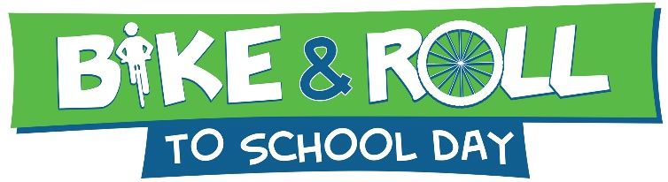
May xx, 20xx
Event Reminder Email Text

Use this email script 1-2 weeks from the event date to remind parents about the event and solicit any remaining volunteers:

Dear Parents,
Bike & Roll to School Day 20xx at [insert your school name here] is only [two weeks] away! You and your students are invited to participate on [insert date]. Bike & Roll to School Day is an annual nationwide celebration.
- To teach traffic safety skills to our children.
- To promote the benefits of physical activity.
- To enjoy being with the school community.
- To reinforce the importance of traffic safety.

If you live too far to bike, walk, or roll safely to school, please consider parking a few blocks from school and walking with your child the rest of the way. This will give more students a chance to participate. Remember, children who bike safely to school arrive prepared to learn.
For more information or to help with this event, please contact me at [insert contact information here] or visit nctcog.org/walkbikeroll. Let’s work together to make our community a safer and friendlier place to walk.
[Your name here]
Bike & Roll to School Day Organizer, [insert your school name here]

