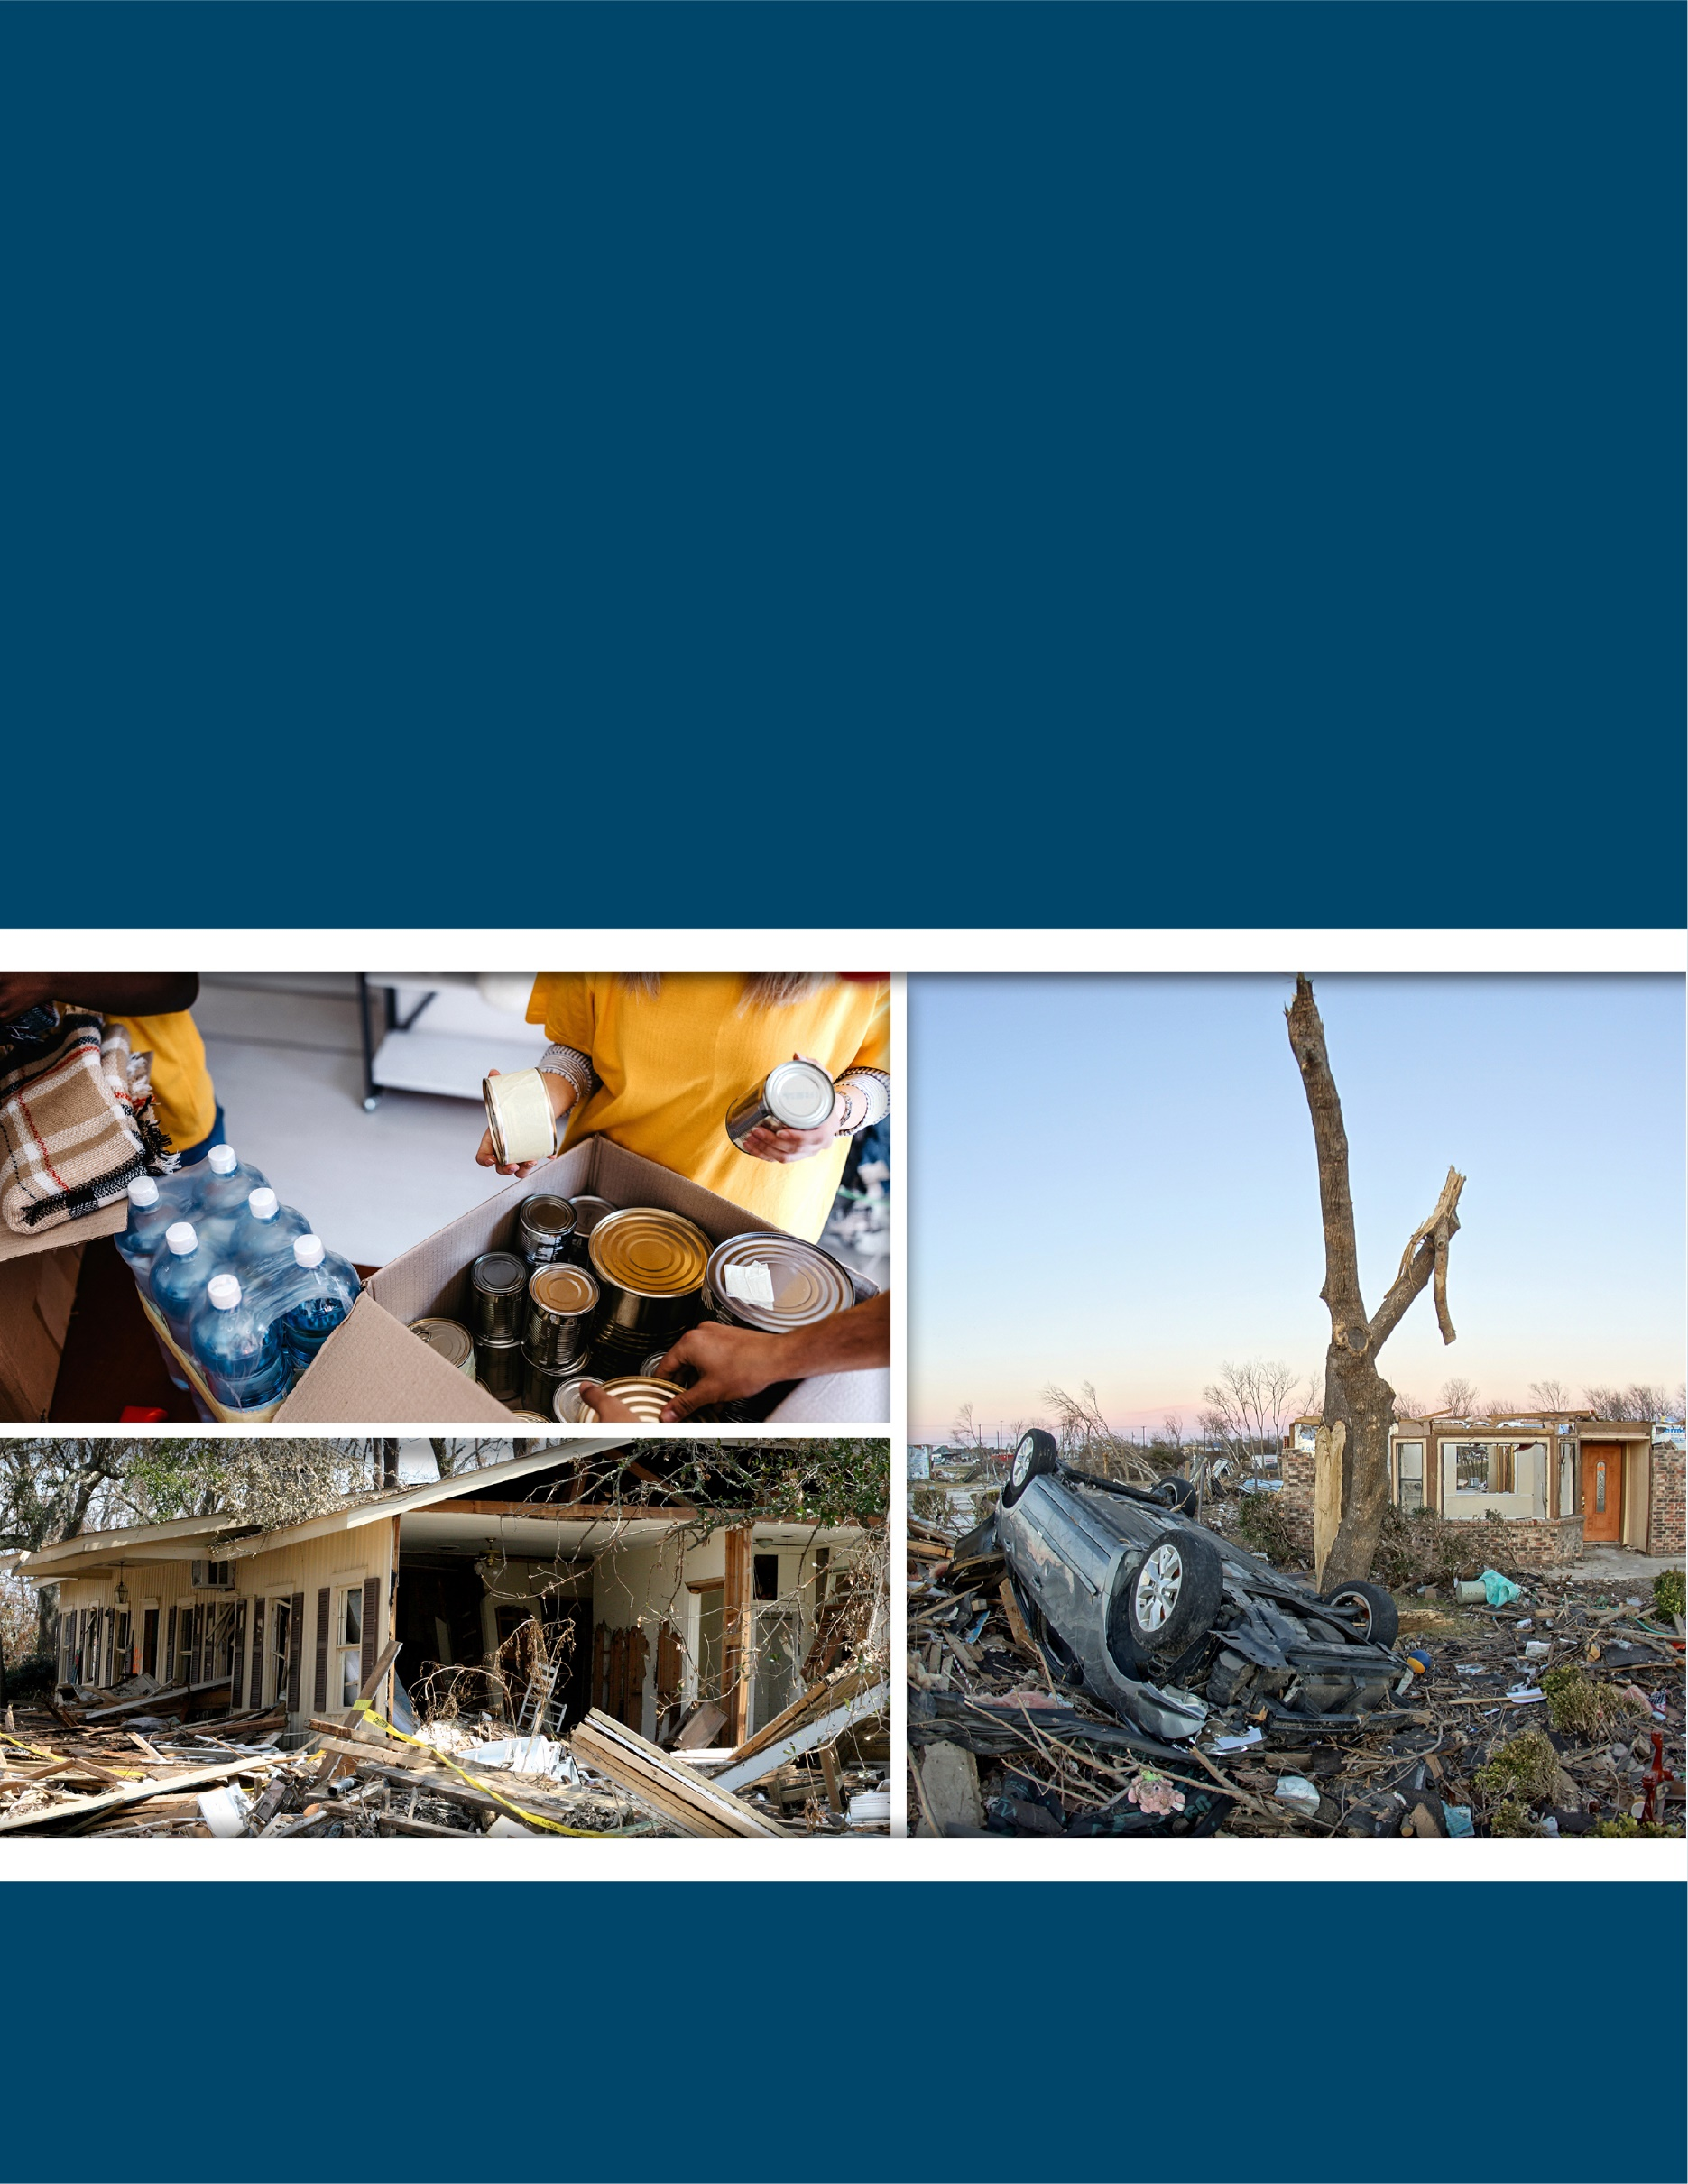
NAME OF
JURISDICTION
PRE-DISASTER
RECOVERY PLAN

DATE

This page intentionally left blank.

Promulgation Statement

(NAME OF CHIEF ELECTED OFFICIAL)

(NAME OF JURISDICTION)

(NAME OF JURISDICTION) RECOVERY PLAN

The primary role of the government is to provide for the welfare of its citizens. The welfare and safety of citizens is never more threatened than during disasters. The goal of emergency management is to ensure mitigation, preparedness, response, and recovery actions exist so that public welfare and safety is preserved.
The (Name of Jurisdiction) Recovery Plan provides a comprehensive framework for disaster recovery. It addresses the roles and responsibilities of government organizations and provides a link to government and private organizations and resources that may be activated to address disasters in (Name of Jurisdiction).
The (Name of Jurisdiction) Recovery Plan ensures consistency with current policy guidance and describes the interrelationship with other levels of government. The plan will continue to evolve, responding to lessons learned from actual disaster and emergency experiences, ongoing planning efforts, training and exercise activities, and Federal guidance.
Therefore, in recognition of the emergency management responsibilities and with the authority vested in me as the (Title) of (Name of Jurisdiction), I hereby promulgate the (Name of Jurisdiction) Recovery Plan.

(Name)

(Title), (Name of Jurisdiction)

This page intentionally left blank.

Approval and Implementation

The transfer of management authority for actions during recovery is done through the execution of a written delegation of authority.
The (Name of Jurisdiction) Recovery Plan delegates the (Chief Elected Official)’s authority to specific individuals in the event that he or she is unavailable. The chain of succession in a major emergency or disaster is as follows:
- (Position Title)
- (Position Title)
- (Position Title)

_____________________________________________________
(Name)

_____________________________________________________
(Senior Official Title), (Name of Jurisdiction)

This page intentionally left blank.

Signature Page

(Name), (Title) (Name), (Title)
(Name of Organization) (Name of Organization)

(Name), (Title) (Name), (Title)
(Name of Organization) (Name of Organization)

(Name), (Title) (Name), (Title)
(Name of Organization) (Name of Organization)

(Name), (Title) (Name), (Title)
(Name of Organization) (Name of Organization)

This page intentionally left blank.

Record of Changes
Date | Plan Section | Change | Who Posted

This page intentionally left blank.

Record of Distribution
Date | Office/Department | Representative | Signature

This page intentionally left blank.

Table of Contents

I. Purpose, Scope, Situation Overview, and Assumptions 1
II. Concept of Operations 7
III. Organization and Assignment of Responsibilities 10
IV. Direction, Control, and Coordination 22
V. Information Collection, Analysis, and Dissemination 23
VI. Communications 25
VII. Administration, Finance, and Logistics 26
VIII. Plan Development and Maintenance 27
IX. Authorities and References 28
X. Recovery Committee Annexes 29

This page intentionally left blank.

Purpose, Scope, Situation Overview, and Assumptions

Purpose
This Pre-Disaster Recovery Plan aims to facilitate and expedite (Name of Jurisdiction)’s local disaster recovery operations and help the community establish a “new normal” following a natural or human-caused disaster. The Plan outlines the (Name of Jurisdiction)’s approach to coordination, organization, and collaboration to leverage the collective capabilities, expertise, and resources of public, private, and nongovernmental organization (NGO) recovery partners to support a comprehensive, community-wide recovery.

Scope
This Plan applies to all government agencies within (Name of Jurisdiction), along with the private sector, volunteer organizations, and its residents. Furthermore, it applies to response (where appropriate) and recovery operations during state- and Presidentially declared emergencies or major disasters. This Plan will be applied following a disaster after the initial response phase has passed and immediate threats to life and property have been stabilized.
This Plan supports and integrates state and federal plans that aid in recovery operations, including the Federal Emergency Management Agency’s (FEMA) National Disaster Recovery Framework (NDRF) and the National Response Framework, 4th Edition. The Plan template adheres to planning development guidance set forth in FEMA’s Developing and Maintaining Emergency Operations Plans: Comprehensive Preparedness Guide 101, Version 2.0 and Pre-Disaster Recovery Planning Guide for Local Governments.

Situation Overview
Geographic, Demographic, and Socioeconomic Overview
(Name of Jurisdiction) aims to anticipate community recovery needs, prevent or mitigate the effects of a disaster, and provide services and resources necessary to return the community to daily life. This section describes the (Name of Jurisdiction)’s geography and demographics; hazards that may threaten the community; and the potential impacts to people, property, the environment, and the economy.
    - (Name of Jurisdiction) has an approximate population of (XX) and an area of (XX) square miles.
    - Among the (Name of Jurisdiction) population, (XX), or (XX) percent, have limited English-language proficiency.
    - An estimated (XX) people, or (XX) percent of the population, are people with disabilities and others with access and functional needs. All plans must be compliant with the Americans with Disabilities Act (ADA). People with disabilities and others with access and functional needs must have access to all government-provided services.
    - (XX) percent of the population are children under the age of 18, and (XX) percent are seniors over the age of 65. (XX) percent of the senior population is home-bound.
    - Among the (Name of Jurisdiction) population, (XX), or (XX) percent, are living at or below the poverty line.
    - The (Name of Jurisdiction) housing stock comprises (XX) percent renters, (XX) percent mobile homes, and (XX) percent homeowners. Approximately (XX) of homeowners are under-insured.
    - (XX) percent of the (Name of Jurisdiction) population has household pets; there are an estimated (XX) total household pets. (Include information on livestock populations if applicable).
    - (Name of Jurisdiction) has (XX) miles of roads, including (names of major highways/throughways), (XX) bridges, (XX) water/wastewater treatment plants, and (names of other major infrastructure).
    - There are (XX) small businesses operating in the jurisdiction. Major employers include (names of employers and approximate number of locally-employed persons).
    - There are more than (XX) historic structures in (Name of Jurisdiction), including (name(s) of most prominent and their location within the jurisdiction).
    - (Name of Jurisdiction) contains sensitive natural areas, including (name most prominent parks, waterways, estuaries, protected areas, etc.).
    - (Add additional statistics to provide a picture of the current situation related to economic, health and social services, housing, infrastructure, land use planning and development, and natural and cultural resources.)
Hazards and Vulnerability Analysis
(Name of Jurisdiction) is vulnerable to a wide range of hazards that threaten residents, businesses, government, and the environment, including those listed in Table 1. (Modify table as necessary.) (Include information about previous risk assessment activities and relevant findings).
Table 1: Hazards for (Name of Jurisdiction)
Earthquake | Hazardous material emergency
Flood | Energy disruption
Fire | Food and agricultural emergency
Landslide | Civil unrest
Dam and levee failure | Pandemic and epidemic
Severe weather | Terrorist attack
Tsunami | Failure of critical infrastructure

Recovery Timeline
Figure 1 shows the timeline for a disaster divided into its primary phases: preparedness, response, transition, short-term recovery, and long-term recovery. The goals and outcomes of each phase are summarized in Table 2.
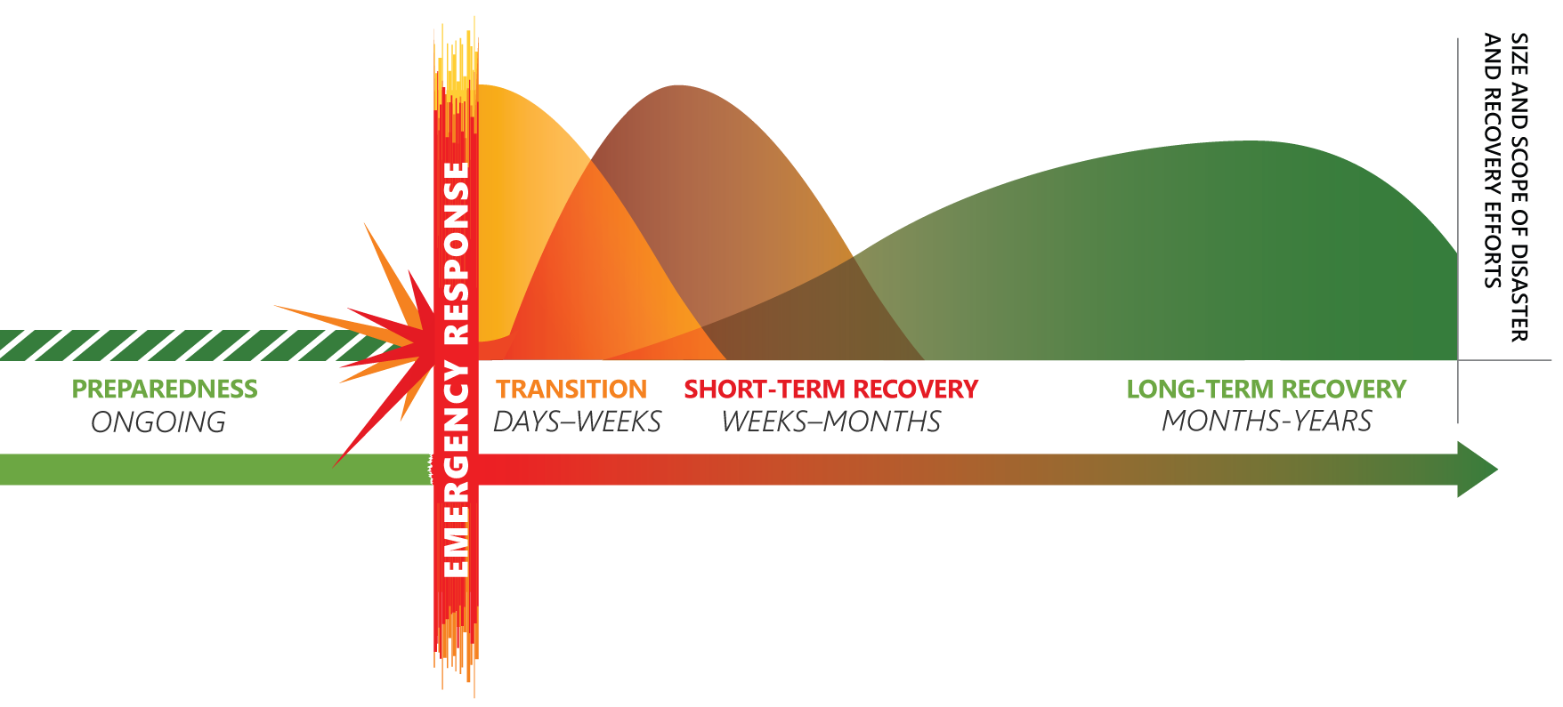
Figure 1: Timeline for Recovery
    - The pre-disaster preparedness phase is ongoing. Plans are created to address disaster response, recovery, and mitigation. Once those plans are developed, individuals responsible for plan implementation are trained. Exercises are developed to test plans and identify areas for improvement. Plans are then updated, trained, and exercised as part of an ongoing, continual preparedness cycle.
    - The response phase occurs while an emergency is imminent, during the incident, and immediately following the initial incident impact. First responders work to ensure life safety and, to the extent possible, reduce the risk of damage to buildings and infrastructure. Emergency response activities may last hours or days.
    - The transition phase focuses on completing response operations and putting the mechanisms in place to transition to a recovery organization. During this phase, the emergency operations center (EOC) directs damage assessment operations and coordinates the restoration of essential infrastructure and lifelines to make the affected area safe for re-entry. As the EOC deactivates, the Recovery Organization is activated and begins the recovery action planning process. Depending on the situation, this transition phase can last days or weeks.
    - The short-term recovery phase is generally the first 8 weeks post-disaster. The goal of the short-term recovery phase is to provide support to community residents and businesses to begin the initial stages of recovery. This may include clearing debris, identifying temporary housing options, providing information on governmental disaster relief (e.g., FEMA and Small Business Administration [SBA] programs), and providing information on insurance claim processing for homeowners.
    - The long-term recovery phase begins as short-term recovery issues are resolved and may span years. Long-term recovery involves rebuilding homes and businesses and developing community-based plans to restore neighborhoods and rebuild damaged infrastructure. The primary objective of long-term recovery is to establish a new and improved “normal” for the community.
Table 2: Key Attributes of Incident Phases
Phase | Overall Goals | Outcomes
Pre-disaster (Preparedness) | - Complete recovery plans and test plans through training and exercise  - Establish relationships among recovery partners, including government, nongovernmental, and private partners  - Outline potential recovery roles and responsibilities of community organizations | - Effective plans are in place to facilitate recovery  - Increased coordination developed among community recovery partners for expediting recovery operations
Response | - Protect life safety  - Prevent and/or reduce damage to the built environment  - Contain the incident  - Gather initial impact information  - Identify critical recovery priorities | - Completion of most, if not all, life-safety measures  - Containment of the threat/hazard  - Initial assessment of impacts  - Identification of immediate recovery objectives
Transition | - Complete all life-safety operations  - Conduct damage assessments  - Reestablish lifelines and make repairs to critical infrastructure to allow for safe re-entry to the affected area  - Activate Recovery Organization and begin the recovery action planning process | - Damage assessments are largely complete  - Lifelines are partially or fully reestablished (e.g., power, water, gas)  - Critical infrastructure (e.g., roads and bridges) repaired/in the process of being repaired  - Key recovery staff positions activated
Short-term Recovery | - Support immediate recovery needs of survivors (e.g., reunification, food, shelter)  - To the extent possible, repair and rebuild infrastructure, homes, businesses, and other facilities  - Direct recovery activities under an operational Recovery Organization | - Displaced residents are transitioned out of emergency shelters  - Property owners and businesses are in the process of repairing and rebuilding  - Critical infrastructure is repaired/in the process of being repaired  - Operations have been fully transitioned to Recovery Organization
Long-term Recovery | - Satisfy the recovery needs of survivors  - Continue repair and rebuilding of damaged structures and infrastructure  - Develop a long-term Recovery Strategy to build back better | - Residents are back in their homes and businesses are reopened  - Community is healthy and more resilient

Planning Assumptions
    - Damage assessment team composition and thoroughness in the field will be crucial to appropriately address recovery issues.
    - Various recovery activities will occur concurrently at different rates, creating tension and a competitive demand for resources. This dynamic will be exacerbated when there are secondary hazards and/or inadequate processes for prioritizing needs.
    - Critical resources and services such as water, electrical power, natural gas, oil, sewer, communications, and transportation may be damaged, compromised, and in limited operation.
    - Homeowners, rental property owners, and renters with and without insurance will likely require additional recovery assistance for the repair of their homes or in finding alternative housing.
    - Past disasters have shown that the longer an affected population is displaced or removed, the less likely to return to that community. The economic loss of prolonged population displacement, including lost tax revenue, compounds the problems incurred during the recovery process.
    - People with disabilities and others with access and functional needs will require special considerations during recovery. According to FEMA, access and functional needs populations includes populations whose members may have additional needs before, during, and after an incident in functional areas, including maintaining independence, communication, transportation, supervision, and medical care.
    - Recovery progress and assistance activities will be of high interest to local and national media. Media management will be challenging.
    - The influx of unaffiliated volunteers, unsolicited donations, and out-of-state contractors will need to be managed to ensure protection of potential fraud or scams on those affected and made vulnerable by the disaster.
    - Volunteers will be necessary for successful recovery operations. Affiliated volunteers will be available via ongoing coordination with members of (Name of Jurisdiction) organizations with expertise in recruiting, coordinating, and managing unaffiliated volunteers. (Reference the local VOAD or long-term recovery group (LTRG) if applicable).
    - Small businesses are particularly vulnerable post-disaster; many may not be able to reopen.
    - Low-income communities may suffer disproportionately due to lack of available and affordable housing.
    - Often, the residents’ and property owners’ vision is to rebuild the community to its pre-disaster form and condition as quickly as possible. (Name of Jurisdiction) will actively identify opportunities to build resiliency to future disasters and improve quality of life for its residents throughout the recovery process.

Plan Integration
This plan aligns with the (Name of Jurisdiction) Emergency Operations Plan and other agency-specific plans listed in Table 3. (Modify table as necessary).
Table 3: Planning Crosswalk
Recovery Element | Applicable Documents
Disaster Cost Recovery | - Annex J: Recovery  - (Disaster finance policies or protocols)
Public Information | - Annex I: Public Information
Disaster Declaration Process | - Annex J: Recovery  - Annex U: Legal
Economic Recovery | - (Economic development plans)  - (Continuity of Operations [COOP] plans)  - (Private-sector Business Continuity Plans)  - (Supply chain recovery plan)
Health and Social Services | - Annex C: Shelter and Mass Care  - Annex H: Health and Medical  - Annex O: Human Services  - Annex T: Donations Management  - (Point of Distribution (POD) plan/commodities plan)  - (LTRG or VOAD plans)  - (Healthcare provider plans)
Housing Recovery | - (Development ordinances/zoning regulations/comprehensive plan)  - (HUD Community Development Block Grant plans)  - VOAD/LTRG plans)  - (Affordable housing initiatives/plans)
Infrastructure (including damage assessment and debris management) | - Annex J: Recovery  - Annex K: Public Infrastructure and Engineering  - Annex L: Utilities  - (Private utility provider plans)  - (Continuity of Government [COG] plans)  - (Local debris-management plans or standby contracts)
Land Use Planning and Development | - Annex P: Hazard Mitigation  - (Local/state hazard mitigation plan)  - (Development ordinances/zoning) regulations/comprehensive plan)  - (Inspections and permitting policies/procedures)  - (Building codes)
Natural And Cultural Resources | - (Development ordinances/zoning regulations/comprehensive plan)  - (Historic preservation guidelines)  - (Parks and open space plans)

Concept of Operations

Activation and Notification
The (EOC Manager/EM Director/City or County Manager) in consultation with Incident Command makes the determination to activate the Recovery Plan. During a major incident, plan activation should happen early in the response to ensure sufficient time to spin up recovery operations. Considerations for activating recovery operations include:
    - Size, scope, and complexity of incident impacts, including loss of life and damage to property;
    - Anticipated duration for repairs of critical infrastructure, residential, or major commercial areas; and
    - Accessibility of the affected area and anticipated timeline for re-entry.
Once the plan is activated, the Local Disaster Recovery Manager (LDRM) reports to the EOC to monitor situational awareness and support transition activities. The LDRM, in consultation with EOC staff, determines the committees to be activated. The LDRM is responsible for notifying each committee lead organization of activation. Each committee lead organization is responsible for notifying support organizations via phone, email, and other available means. The committee lead organization convenes relevant support organizations and initiates the recovery action planning process.

Transition from Response to Recovery
The following activities will take place in the days to weeks following the incident, and may overlap with response operations.
    - Complete all life-safety operations initiated during the response phase.
    - Activate the Recovery Plan and imbed the LDRM in the EOC (e.g., positioned within the Policy Group or Planning Section).
    - Continue to track incident-related costs and document decision-making from the EOC.
    - Continue to coordinate with critical infrastructure operators for timely restoration of critical lifelines.
    - Conduct damage assessments of property, systems, and infrastructure.
- Manage teams tasked with neighborhood and site assessments of public and private property, critical infrastructure, and cultural and/or historic sites.
- Develop disaster summary outlines to estimate damages and Public Assistance thresholds.
    - Liaise with state and federal officials to initiate the Preliminary Damage Assessment (PDA) process and eligibility for federal assistance.
    - Aggregate, document, and confirm information gathered in the EOC:
- Damage assessment and impact data
- GIS maps
- Contact names and numbers of EOC staff
    - Initiate debris management operations.
- Activate debris management plan and/or standby debris management contract.
- Determine long-term debris removal needs.
    - Plan for re-entry to the affected area.
- Identify which areas are safe to return.
- Establish detours, roadblocks, etc.
- Staff and manage checkpoints.
    - Initiate a comprehensive and streamlined public information and outreach campaign to residents and businesses focused on community recovery.
- Establish an incident-specific webpage to serve as a central repository of information.
- Develop public outreach and messaging related to available recovery assistance (e.g., donations, volunteer services, etc.) and push out through all available channels.
- Evaluate the need to establish a local information or resource center.
    - Activate the Recovery Organization, begin the recovery action planning process, and identify short-term recovery objectives.

Short-term Recovery
The following activities will generally take place within the first 8 weeks following the incident and may overlap with transition phase activities.
    - Begin deactivation of the EOC and stand up the Recovery Organization.
    - Conduct an after-action review of the emergency response.
    - Implement continuity of government and business continuity and restoration plans.
    - Continue a comprehensive public outreach campaign to share recovery information with the public.
    - Continue to ensure proper, timely, and accurate financial and administrative management.
    - Continue collaborating with infrastructure operators for restoration of critical services.
    - Continue collecting information on severity and impacts of the disaster.
    - Support the needs of disaster survivors.
- Continue mass care operations until no longer necessary.
- Transition shelter clients to temporary housing.
- Support deployment of Voluntary Organizations Active in Disaster (VOAD) relief services.
- Provide information and referrals for disaster assistance.
- Ensure recovery information and resources reach vulnerable populations, including people with disabilities and others with access and functional needs.
    - Initiate the repair and reconstruction process.
- Consider prioritizing permitting processes, waiving plan review requirements, or reducing fees, where possible.
- Consider the need for permitting field offices.
- Manage inspector staffing and activate mutual aid for additional support, if necessary.
    - Coordinate with the State and/or FEMA for assistance programs, as necessary.
    - Continually evaluate recovery needs and activate committees and subcommittees as needed.
- Economic
- Health and Social Services
- Housing
- Infrastructure
- Land Use Planning and Development
- Natural and Cultural Resources
    - Conduct recovery action planning.
- Establish short-term recovery objectives for each planning cycle.
- Identify actions and assignments for each objective.
- Compile into a Recovery Action Plan.
- Evaluate progress and update status and objectives.

Long-term Recovery
The following activities will take place in the months to years following the incident and may overlap with short-term recovery phase activities.
    - Continue the comprehensive public outreach campaign.
    - Continue to ensure proper, timely, and accurate financial and administrative management.
    - Continue to implement strategies for expeditious reconstruction of the built environment.
    - Continue to provide recovery assistance, information, referrals, and services to disaster survivors.
    - Develop a Long-term Recovery Strategy through collaboration with committees and subcommittees comprising government, nongovernment, and private recovery partners.
- Identify projects and programs that fulfill long-term recovery objectives.
- Identify funding sources, subtasks and milestones, and timelines for implementation.
- Conduct public engagement process to ensure community buy-in.
- Monitor and evaluate implementation progress of the Recovery Strategy.

Organization and Assignment of Responsibilities

Recovery Organization
(Name of Responsible Jurisdiction Entity) has overall responsibility for (Name of Jurisdiction) recovery operations. (Name of Jurisdiction) recovery operations will be carried out by the organizational structure shown in Figure 2 based on principles of the National Incident Management System (NIMS) and the Incident Command Structure (ICS) and in alignment with the NDRF. The structure is flexible and adaptable to the incident and facilitates the transition from EOC operations.

Hazard Mitigation
Policy Group
Local Disaster
Recovery Manager
Legal
Public Information
Government and Community Affairs
Financial/Grants Management
Recovery Coordination Task Force
Planning Unit
Economic
Health and
Social Services

Housing

Infrastructure
Land Use Planning and Development

Natural and
Cultural
Resources

Business Restoration, Retention, and Recruitment
Employment and Workforce Support
Business Recovery Centers
Donations and Volunteers
Individual and Family Services
Public Health and Medical
Schools and Academic Institutions
Housing Availability and Needs Assessment
Short-term Housing
Long-term Housing
Damage Assessment
Debris Management
Utility Restoration
Transportation Restoration
Public Facility Repair
Damage Assessment
Inspections and Permitting
Community Engagement and Long-term Planning
Historic Preservation
Environmental Remediation and Restoration
Community Arts and Recreation
Figure 2: Recovery Organization
Local Disaster Recovery Manager
The (Emergency Management Coordinator or designee) should serve as the LDRM unless otherwise designated by the (Name of Official, e.g., City/County Manager).
    - Has the authority to execute operational decisions within the recovery organization.
    - Assigns (City/County) staff to serve full- or part-time in specific recovery positions and may assign recovery tasks to (City/County) staff.
    - Liaises directly with the State Disaster Recovery Coordinator, the State Disaster Recovery Task Force, and the Federal Disaster Recovery Coordinator.
    - Provides leadership and direction to prioritize recovery efforts and balance expeditious recovery with thoughtful consideration of post-disaster capabilities.
Policy Group
    - Maintains full authority to direct recovery objectives.
    - Oversees policy changes to facilitate recovery operations.
    - Oversees the Recovery Organization and works directly with the LDRM to monitor recovery progress.
Public Information
    - Develops and deploys a coordinated public outreach and information strategy.
    - Responds to media inquiries and proactively provides information to the media.
    - Manages information channels including web, print, radio, television, email, social media, etc.
    - Works in conjunction with the Joint Information System/Joint Information Center, if active.
Financial and Grants Management
    - Manages proper recovery cost documentation for reimbursement eligibility.
    - Manages contracting, procurement, and accounting for recovery-related services, supplies, equipment, and staff time.
    - Manages grants administration and work with FEMA and other federal agencies throughout the recovery process.
Legal
    - Provides legal advice to the LDRM and the Policy Group.
    - Assists in drafting and reviewing any policy changes, contracts, and other documentation as requested.
Government and Community Affairs
    - Provides consultation to the LDRM and members of the Recovery Coordination Task Force regarding local, state, and federal policy issues related to recovery
    - Facilitates information exchange between the Recovery Organization and community groups to better understand the needs and concerns of the community.
    - Coordinates public forums and public surveys.
    - Oversees local recovery information centers.
Recovery Coordination Task Force
    - Oversees recovery activities and provides guidance and subject-matter expertise to the LDRM.
    - Meets with the LDRM and committees on a regular basis to share information, coordinate efforts, track progress, and evaluate priorities.
Planning Unit
    - Documents Recovery Task Force meetings.
    - Compiles Recovery Action Plans.
    - Gathers information for the development of the long-term Recovery Strategy.

Recovery Committees
Recovery committees are responsible for carrying out recovery activities. Committees carry out recovery activities through collaboration among (City/County) departments, the private sector, and nongovernmental organizations.
Economic Committee
The Economic Committee coordinates the efforts of government, nonprofit, and private-sector partners to support restoration and revitalization of the local economy following a disaster.
    - Lead Agency: (Insert applicable committee lead)
    - Support Organizations:
- (Insert applicable committee support organizations)
- (Insert applicable committee support organizations)
- (Insert applicable committee support organizations)
- (Insert applicable committee support organizations)
    - Subcommittees
- Business restoration, retention, and recruitment
- Employment and workforce support
- Business Recovery Centers
Health and Social Services Committee
The Health and Social Services Committee coordinates with government, private, and nonprofit providers to pool resources that meet the recovery needs of individuals, families, and children, including people with disabilities and others with access and functional needs.
    - Lead Agency: (Insert applicable committee lead)
    - Support Organizations:
- (Insert applicable committee support organizations)
- (Insert applicable committee support organizations)
- (Insert applicable committee support organizations)
- (Insert applicable committee support organizations)
    - Subcommittees
- Donations and volunteers
- Individual and family services
- Public health and medical services
- Schools and academic institutions
Housing Committee
The Housing Committee coordinates the efforts of government, nonprofit, and private-sector partners to provide displaced residents with housing information and assistance.
    - Lead Agency: (Insert applicable committee lead)
    - Support Organizations:
- (Insert applicable committee support organizations)
- (Insert applicable committee support organizations)
- (Insert applicable committee support organizations)
- (Insert applicable committee support organizations)
    - Subcommittees
- Housing availability and needs assessment
- Short-term housing
- Long-term housing
Infrastructure Committee
The Infrastructure Committee coordinates repairs and restoration of essential systems and structures.
    - Lead Agency: (Insert applicable committee lead)
    - Support Organizations:
- (Insert applicable committee support organizations)
- (Insert applicable committee support organizations)
- (Insert applicable committee support organizations)
- (Insert applicable committee support organizations)
    - Subcommittees
- Damage assessment
- Debris management
- Utility restoration
- Transportation restoration
- Public facility repair
Land Use Planning and Development Committee
The Land Use Planning and Development Committee coordinates efforts to facilitate repair and reconstruction in an orderly, safe, and timely manner.
    - Lead Agency: (Insert applicable committee lead)
    - Support Organizations:
- (Insert applicable committee support organizations)
- (Insert applicable committee support organizations)
- (Insert applicable committee support organizations)
- (Insert applicable committee support organizations)
    - Subcommittees
- Damage assessment
- Inspections and permitting
- Community engagement and long-term recovery
- Hazard mitigation
Natural and Cultural Resources Committee
The National and Cultural Resources Committee coordinates efforts to remediate disaster impacts to ecosystems and culturally significant places in compliance with applicable state and federal regulations.
    - Lead Agency: (Insert applicable committee lead)
    - Support Organizations:
- (Insert applicable committee support organizations)
- (Insert applicable committee support organizations)
- (Insert applicable committee support organizations)
- (Insert applicable committee support organizations)
- Subcommittees
- Environmental remediation and restoration
- Community arts and recreation
- Historic preservation

Roles and Responsibilities
Table 4 presents the recovery roles of (Name of Jurisdiction)’s government, private-sector, and nongovernmental recovery partners. (Modify table below as necessary)
Table 4: Recovery Roles and Responsibilities
Agency/ Organization | Role in Disaster Recovery
Name of local organization(s)  Affordable Housing Advocacy Groups | - Help identify safe, accessible, and affordable temporary and long-term housing options for affected households, including lowest-income seniors, people with disabilities, families with children, veterans, people experiencing homelessness, and other at-risk populations.  - Ensure transparency and accountability for recovery programs and compliance with civil rights laws and the Fair Housing Act.  - Assist renters and those experiencing homelessness before the disaster in obtaining quality, affordable, and accessible rental property.
Name of local organization(s)  Chamber of Commerce | - Provide a link between businesses and local officials.  - Identify available resources and needs from various local businesses.  - Provide public information from local officials to businesses via established methods of communication including email listservs, websites, and newsletters.
Community Development Department | - Work with developers and community housing development organizations to support safe and efficient housing and neighborhood recovery.  - Support programs to retain residents.  - Support identification of affordable temporary and long-term housing options.  - Propose affordable housing investments and grant funding allocations for recovery.  - Provide programs and services to support people experiencing homelessness.
Name of local organization(s)  Community Foundations | - Reach out to local nonprofit partners to gather information on recovery needs (e.g., need for volunteers, supplies, donations).  - Connect local organizations with potential donors by posting affected organizations’ recovery needs on the foundation’s website.  - If possible, establish and administer a local disaster relief fund.
Name of local organization(s)  Community Outreach Organizations | - Provide information on available recovery assistance and services to target populations (e.g., low-income residents, people with disabilities and others with access and functional needs, seniors, children, home-bound populations, those with limited English proficiency, etc.).  - Use websites, social media, community events, and other engagement channels to amplify recovery messaging to the community.  - Solicit input and feedback from community members to ensure their voices are heard and build trust and confidence in the recovery process.  - Help improve accessibility to recovery information and services by providing foreign-language translation and sign-language interpreters.  - Identify recovery services that are compatible with the target audience’s value system and relevant to that audience’s problems.  - Refer individuals to mental health counseling services, employment support, childcare, financial assistance, and other support.
Name of local organization(s)  Donations Management NGOs | - Support management of solicited and unsolicited donations from private entities and nonprofit organizations.  - Work with case managers, construction and warehouse coordinators, and fundraisers to determine donation needs and solicit, catalog, and distribute donated materials and resources.  - Develop press releases and donations requests to be sent to the media.  - Serve as the main point of contact for donors.
Economic Development Department | - Provide information and referrals for financial resources and technical assistance providers (e.g., SBA disaster resources, small business development centers, university entrepreneur services, etc.).  - Provide services and information to job seekers (e.g., career development and counseling, specialized employment services, re-employment services, unemployment insurance benefits guidance, training programs, hiring and recruitment, resume assistance).  - Disseminate recovery information to local businesses through available channels.  - Ensure local economic development plans are considered during recovery.
Elected Officials and (City/County) Management | - Set recovery priorities.  - Approve changes to policies to expedite recovery.  - Make decisions on recovery funding allocations.  - Serve as the “face” of the recovery effort by communicating directly with residents and businesses to reassure them and keep up morale.
Emergency Management Department | - Manage EOC operations and oversee the transition to the Recovery Organization.  - Staff key Recovery Organization positions (e.g., LDRM, Planning Unit in the Recovery Task Force).  - Coordinate and support damage assessment teams.  - Provide situational reports and damage assessments to the Texas Division of Emergency Management (TDEM) and the Texas A&M University System.  - Coordinate and maintain files of all initial assessment reports.  - Collaborate with state and federal recovery partners to coordinate resources.  - Support content development for public outreach via websites, social media, publications, and events.  - Contribute to development of long-term Recovery Strategy.  - Coordinate development of after-action reports.
Engineering Department | - Support damage assessments of local infrastructure (e.g., roadways, drainage and flood-control facilities, water and wastewater facilities, etc.).  - Support repairs to damaged infrastructure (e.g., roadways, drainage and flood-control facilities, water and wastewater facilities, etc.).
Name of local organization(s)  Faith-based Organizations | - Provide emotional and spiritual care to survivors and provide information for self-care, coping mechanisms, and how to find help.  - Initiate worship services and commemorative events to promote healing.  - Organize volunteer efforts to help individuals and families, such as muck cleanup, feeding, housing, child care, transportation, etc.
Finance Department | - Distribute information to government departments on proper disaster cost-documentation procedures.  - Accept, review, manage, and file all disaster cost documentation to ensure eligibility for reimbursement.  - Coordinate purchasing and procurement for recovery projects.  - Ensure all contract solicitation processes adhere to federal and state rules during disaster declarations.  - Manage administration of post-disaster grants and financing.  - When requested, generate and provide copies of all financial documents or reports (pay sheets, checks, etc.) regarding damage and expenditures.  - Assist with any state or federal audits.
Government Facilities Management Department | - Assess damage to public facilities.  - Coordinate repairs and reconstruction of damaged public facilities.  - Maintain repair and maintenance vendor lists.  - Execute pre-disaster contracts as needed.
Name of local organization(s)  Healthcare Providers | - Coordinate mutual aid, evacuation, and repopulation support for healthcare services.  - Ensure safe, efficient continuity of operations and resumption of services.  - For mass casualty or mass fatality incidents, provide key information regarding victims to local officials and assist in public information messaging and media releases.  - Provide subject-matter expertise for disaster-related health issues.
Name of local organization(s)  Historic Preservation Organizations | - Provide subject-matter expertise and information for repair and restoration of historical facilities.  - Provide information to local officials related to recovery needs of various historical facilities, artifacts, and landmarks following a disaster.
Name of local organization(s)  Hospitality Sector | - Provide temporary housing to displaced populations (e.g., hotels, motels, Airbnb, Vacation Rentals By Owner [VRBO], etc.).  - Provide occupancy data to support housing needs assessments.
Human Resources Department | - Provide information to government employees on available sponsored counseling, financial information and resources, and legal support that may be helpful for their personal recovery.
Media Relations Department | - Respond to media inquiries and conduct press briefings.  - Gather, develop, and disseminate information on recovery progress and activities.  - Support website, social media, and other available public information outlets.  - Liaise with local, regional, state, and federal recovery partners to coordinate messaging and provide additional methods of outreach to disaster survivors.
Parks and Recreation Department | - Assess damage to parks and recreation spaces and facilities.  - Coordinate cleanup, repair, and reopening of local parks, trails, athletic fields, and community recreation centers.  - Leverage department resources (e.g., facilities and programs) to provide recovery information and outreach to the community.  - Explore options to provide use of park space and community centers for recovery activities (e.g., temporary sheltering for displaced animals, donation storage and distribution, public meetings, etc.).
Permitting and Inspections Department | - Support damage assessment activities.  - Prioritize and expedite permitting.  - Ensure compliance with applicable building codes and zoning ordinances.  - Provide certified building inspectors.  - Request contract inspectors or hire additional staff if the situation warrants.  - Conduct inspections of rebuilding and new construction projects.  - Issue Certificates of Compliance.  - Provide information to homeowners regarding contractor licensing requirements and proper permitting processes.
Planning and Zoning Department | - Make recommendations regarding land use policy decisions, including:  - Moratoria related to development, construction, and permits;  - Policy changes to allow for repairs to reconstitute existing structures;  - Policy changes to allow placement of temporary modular or manufactured housing on homeowner property; and  - Coordination of conservation easements, fee-simple purchases, and other voluntary land-protection methods.  - Ensure existing land use plans are considered during recovery, including strategic and comprehensive plans, neighborhood and special district plans, transportation plans, economic development plans, and capital improvement plans.  - Provide information regarding development and/or permitting processes to homeowners and developers.  - Support integration of hazard-mitigation measures into rebuilding efforts.  - Direct long-range planning processes and community engagement for recovery.
Name of local organization(s)  Private-sector Builders/ Developers | - Provide information to support housing needs assessments.  - Work with urban designers and landscape architectural firms to propose sustainable design opportunities for rebuilding efforts.  - Secure investments and financing for redevelopment projects.
Public Health Department | - Develop public information and outreach materials for disaster-related health impacts.  - Conduct Health Department inspections of affected restaurants.  - Conduct community health and injury education.  - Conduct community needs assessments to determine populations at risk for injury, illness, and death during the recovery phase.  - Support access to mental health services and crisis counseling by providing information and referrals.
Public Works Department | - Assess damage to local government-owned infrastructure (e.g., roadways, drainage and flood control facilities, water/wastewater facilities, etc.).  - Open and close roads in coordination with law enforcement.  - Coordinate and oversee repairs to damaged infrastructure (e.g., roadways, drainage and flood control facilities, water/wastewater facilities, etc.).  - Activate pre-disaster debris-management contract(s) or procure debris management services.  - Oversee debris removal, storage, recycling, and disposal.  - Oversee debris management cost documentation for reimbursement.
Social Services Department | - Ensure continued operations of state- and federal-mandated programs.  - Refer survivors to available mental and behavioral health services.  - Provide support services (e.g., transportation, medication assistance) and referral services to vulnerable populations, including low-income residents and people with disabilities and others with access and functional needs.  - Provide information on financial support available to assist with personal recovery, including childcare, food and nutrition services, and Medicaid.  - Administer crisis funds received from federal and state benefits as a result of a disaster declaration.
Solid Waste Department | - Assess, characterize, and manage collection of waste.  - Establish temporary storage sites for large volumes of household waste, such as e-waste and furniture.  - Provide guidance and advice to local authorities on interim solutions to minimize environmental and health impacts of disaster waste.  - Provide information to residents on the proper means of disposal for damaged items (e.g., electronics, furniture, construction materials, etc.).
Transportation Department | - Assess damage and oversee repairs of public transit assets.  - Oversee resumption of public transit operations.  - Modify service routes or schedules, as needed.  - Communicate status of services to the public.  - Ensure regional and local transportation plans are considered during recovery.
Name of local organization(s)  University | - Provide subject-matter experts and technical assistance for recovery activities.  - Support research efforts related to local needs assessments.
Name of local organization(s)  Utilities | - Coordinate internal response plans to restore services as quickly as possible.  - Communicate scope and expected duration of an outage to the public.  - Communicate and coordinate with government officials on the status of recovery operations.
Voluntary Organizations Active in Disaster (VOAD) | - Coordinate faith-based and nonprofit member organizations to support recovery activities.  - Gather information on the needs of the community and provide information to local, state, and federal government partners.  - Use past experiences with disasters to develop strategies to address recovery issues.  - Offer member organization resources and volunteers that cover a wide variety of service areas.  - Serve leadership roles in recovery committees and subcommittees to continue to match member resources with ongoing recovery needs.
Water Department | - Conduct assessments of water and wastewater treatment infrastructure and service.  - Carry out existing emergency response plans.  - Coordinate necessary repairs to water and wastewater systems, which may include the use of contractors and vendors.  - Monitor the potential contamination of water supply.  - Provide notification and information to the public regarding actions that need to be taken, such as boiling water before drinking or drinking bottled water.

Direction, Control, and Coordination
This recovery plan is the official source for (Name of Jurisdiction) pertaining to all emergencies and disasters when coordinated disaster recovery is required.
The LDRM is the lead for recovery and reconstruction of (Name of Jurisdiction) and is responsible for overall direction and control of the effort. The decision to activate recovery committees or subcommittees is determined by the LDRM with input from the Recovery Coordination Task Force. The LDRM will report to the Policy Group.
Direction, control, coordination, and management of recovery operations will be conducted from the recovery office, if established. Otherwise, recovery operations will be managed remotely through the home offices of activated organizations.
The LDRM, Recovery Coordination Task Force, and committees will coordinate directly with community organizations, VOAD, LTRG, and other stakeholders, as needed. Non-governmental recovery partners will operate under the direction of their organizational management.

Information Collection, Analysis, and Dissemination

Incident Information
Updated information will need to be collected, analyzed, and disseminated repeatedly throughout recovery as often as necessary.
Recovery information will build on the information gathered and disseminated during the response phase. The information noted below is likely known by those coordinating the response phase and will be helpful during the transition and short-term recovery phases.
    - Overall scope and degree of damage
    - Affected population demographics
    - Damage to and repair status of the following:
- Roads and bridges
- Dams and reservoirs
- Airfields
- Government buildings
- Hospitals
- Residential property
- Businesses
    - Requests and/or need for state and federal assistance
    - Shelter populations, displaced populations, and/or temporary housing populations
    - Needed mass care and social services for impacted communities
    - Status of structures without power; damaged natural gas, sewer and/or water lines; and restoration timelines
Throughout the short-term and long-term recovery phases, active committees will be responsible for providing relevant data, information, and status updates to the LDRM and the Recovery Coordination Task Force.
During short-term recovery, incident information will be compiled into a Recovery Action Plan by the Planning Unit at the end of each planning period. During long-term recovery, committees will be responsible for providing updates on implementation progress of the Recovery Strategy. Implementation progress will be documented, tracked, and managed by the Planning Unit.

Public Information
The Public Information Group will take the lead role for coordination and dissemination of recovery information to the public. The Public Information Group will maintain an updated list of recovery information and resources for the affected population to be housed on the (Name of Jurisdiction) website.
The Public Information Group will provide timely updates on topics of concern to the community such as the following:
    - Abandoned homes and properties
    - Building codes
    - Business assistance
    - Contractor fraud
    - Curfew
    - Debris removal
    - Emergency sanitation issues
    - Housing assistance
    - Individual assistance and how to access disaster relief program assistance
    - Insurance issues
    - Locations for food, water, and medical attention
    - Mail delivery
    - Permits and inspections
    - Post-disaster relocation/evacuation
    - Pets (sheltering, homeless, and lost)
    - Redevelopment policies
    - Reentry policies
    - Traffic and roadway issues
Public education and outreach will be conducted using a variety of accessible formats to ensure that the entire affected population is reached. To the extent possible, information will be accessible to people with disabilities and others with access and functional needs as well as those with limited English proficiency and will be shared in a clear, consistent, and culturally sensitive manner.

Communications

Internal Communications
The LDRM and Recovery Coordination Task Force are responsible for ensuring there are processes and procedures in place to facilitate interoperable communications among local recovery stakeholders, including:
    - Establishing and managing official communication channels and processes for sharing information across recovery committees and subcommittees.
    - Establishing policies for management of sensitive issues and information.
    - Developing and implementing a formal process for requesting and tracking resources.
    - Setting policies for communicating with elected officials.
Internal communications methods will include the following:
    - (Insert applicable internal communications method)
    - (Insert applicable internal communications method)

External Communications
The LDRM and Recovery Coordination Task Force are responsible for ensuring there are processes and procedures in place to facilitate interoperable communications with outside agencies, including:
    - Establishing processes for communicating with state and federal recovery agencies.
External communications methods will include the following:
    - (Insert applicable external communication method)
    - (Insert applicable external communication method)

Administration, Finance, and Logistics

Mutual Aid
Requests for assistance may be made from other governmental entities in accordance with existing or emergency negotiated mutual aid agreements and understandings. Such assistance may take the form of equipment, supplies, personnel, or other available capabilities. Duly authorized officials enter into all agreements and understandings. Copies of existing agreements are on file at (insert location).

Procurement and Cost Documentation
(Name of Responsible Department) will maintain detailed records tracking personnel hours, supplies, materials, equipment, and other disaster-related costs to ensure eligibility for obtaining federal disaster declarations and receiving reimbursements and payments for staff and projects during recovery. Qualifying for and obtaining assistance from the federal government relates directly to the approach and details of cost tracking. Responsibility for submitting financial reports to the (Name of Responsible Department) rests with (Name of Responsible Department).
Agencies may consider employing their own internal process for recording and documenting expenditures and should maintain all recovery-related records for a minimum of 5 years after the last action on the disaster application. This process for recording and documenting expenditures by agencies must be consistent with other disaster recovery policy and procedures.

Plan Development and Maintenance
The (Name of Responsible Department) is responsible for maintenance of this plan. Organizations listed in this plan may recommend changes at any time and provide information periodically pertaining to changes in personnel and available resources. The (Name of Responsible Department) will coordinate an annual review and revise the plan as necessary.
This recovery plan provides an overall approach to disaster recovery. As part of ongoing preparedness efforts, recovery committees should develop supplemental processes, policies, and plans, including the following: (Modify bullets as necessary)
    - Standby disaster contracts and mutual aid agreements
    - Risk assessments and capability assessments
    - Continuity of government/continuity of operations plans
    - Hazard mitigation plans
    - Debris management plans
    - Damage assessment plans
    - Donations management plans
    - Disaster housing plans
Organizations with a role in disaster recovery should train staff to develop skills and expertise to carry out recovery responsibilities included in this plan. Training may include the following:
    - Damage assessment procedures
    - Expedited permitting procedures
    - Public information and outreach and crisis communications
    - Processes for federal assistance programs such as Public Assistance, Individual Assistance, SBA, Community Development Block Grant (CDBG), etc.
This plan should be activated at least once a year in the form of an exercise, real-life event, or training to provide practical operations experience to those who have recovery responsibilities. Recovery operations outlined in this plan should be incorporated into response exercises when possible. Stakeholders included in this plan—particularly nongovernmental recovery partners—should be invited to participate in recovery-related exercises. Following each exercise, relevant feedback identified in the after-action report and improvement plan should be incorporated as an update to this plan.

Authorities and References

Legal Authority
The Robert T. Stafford Disaster Relief and Emergency Assistance, Public Law 93-288, as amended
Title 44, Code of Federal Regulations, parts 9, 10, 13, 59, 204, and 206
(Insert applicable authorities)

References
Comprehensive Preparedness Guide (CPG) 101, Federal Emergency Management Agency, November 2010.
Homeland Security Exercise and Evaluation Program (HSEEP), U.S. Department of Homeland Security. April 2013.
National Incident Management System (NIMS), U.S. Department of Homeland Security, October 2017.
National Disaster Recovery Framework (NDRF), Federal Emergency Management Agency, June 2016.
National Response Framework (NRF), U.S. Department of Homeland Security, October 2019.
Texas Division of Emergency Management, Emergency Operations Plan, 2019
State of Texas Hazard Mitigation Plan. 2013.
(Name of Jurisdiction) Emergency Operations Plan, (Month, Year).
(Name of Jurisdiction) Hazard Mitigation Plan, (Month, Year).

Recovery Committee Annexes
A Economic 31
Business Restoration, Retention, and Recruitment 34
Employment and Workforce Support 36
Business Recovery Centers 38
B: Health and Social Services 39
Donations and Volunteers 42
Individual and Family Services 44
Public Health and Medical Services 46
Schools and Academic Institutions 48
C: Housing 51
Housing Availability and Needs Assessment 54
Short-term Housing 56
Long-term Housing 58
D: Infrastructure 61
Damage Assessment 65
Debris Management 67
Utility Restoration 68
Transportation Restoration 71
Public Facility Repair 74
E: Land Use Planning and Development 77
Damage Assessment 80
Inspections and Permitting 82
Community Engagement and Long-term Planning 84
Hazard Mitigation 86
F: Natural and Cultural Resources 89
Environmental Remediation and Restoration 92
Community Arts and Recreation 94
Historic Preservation 96

This page intentionally left blank.

Economic Committee Annex

Mission
The Economic Committee coordinates the efforts of government, nonprofit, and private-sector partners to support restoration and revitalization of the local economy following a disaster. The Committee supports the repair efforts of local businesses and encourages the reinvestment and private-sector lending necessary to restart the local economy. The Committee also supports local workforce development, including job-placement services and training opportunities.
Note: NCTCOG has conducted extensive research related to the challenges of economic recovery following a disaster and compiled a suite of guidance and resources for both local governments and businesses to build resilience and support economic recovery. These resources can be found on the NCTCOG website.

Recovery Objectives
- Provide support to local businesses to repair, reconstruct, and resume operations so that they can remain in the area.
- Develop public–private partnerships to encourage reinvestment in the local economy and recruit new businesses to the area.
- Help local residents return to work by providing referrals and resources.
- Collaborate with the private sector to develop economic recovery strategies that leverage existing economic development plans and increase economic resiliency to future disasters.

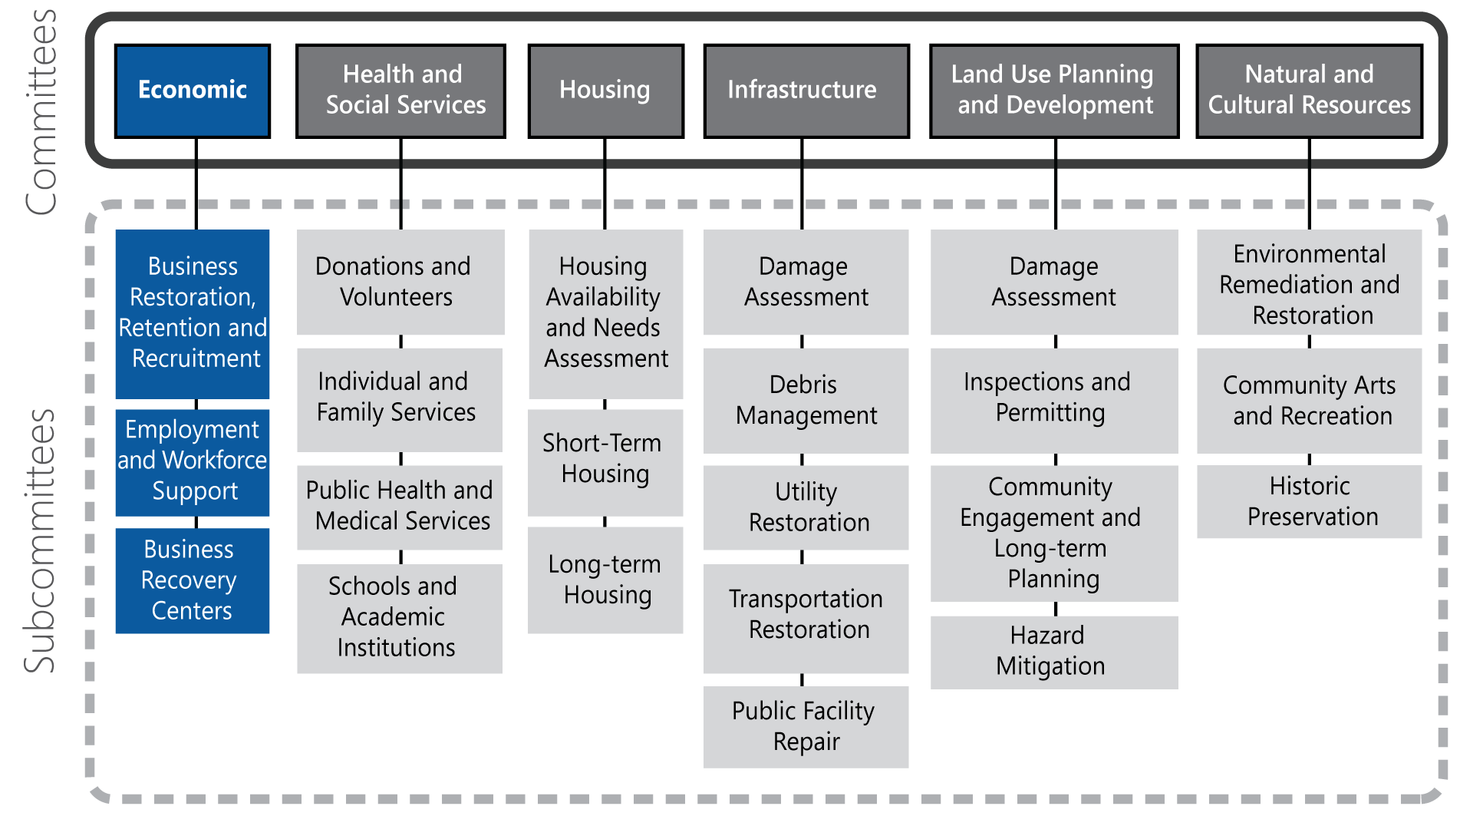

Local Recovery Partners

Local Organization | Business Restoration, Retention, and Recruitment | Employment and Workforce Support | Business Recovery Centers
Department of Economic and Workforce Development | Lead | Lead | Support
North Central Texas Economic Development District | Support | Support | Support
Chamber of Commerce | Support | Support | Support
North Central Texas Small Business Development Center | Support | Support | Support
Local Business Owners | Support | Support | Support
Office of Emergency Management |  |  | Support
Planning Department | Support

State and Federal Recovery Partners
The table below lists state and federal recovery partners that may coordinate efforts with the Economic Committee. The federal agencies listed have committed to these roles per the NDRF.
Effective September 1, 2019, House Bill 6 (HB6) enacts the Disaster Recovery Task Force through TDEM to help local communities throughout the long-term recovery period. The Task Force may use the resources of the Texas A&M University System, including the Texas A&M AgriLife Extension Service, the Texas A&M Engineering Extension Service, and the Texas A&M Forest Service, and other state agencies and organized volunteer groups. As this Task Force is in the initial stages of development, the table below lists state agencies that could potentially be called upon by the Task Force to provide resources to support these critical functions.

Texas (Potential Recovery Partners) | Federal Recovery Partners
Primary Agencies  - Texas A&M University System – Texas Division of Emergency Management  - Economic Development and Tourism Division of the Governor’s Office | Coordinating Agency  - U.S. Department of Commerce  Primary Agencies  - Federal Emergency Management Agency  - Small Business Administration  - U.S. Department of Agriculture  - U.S. Department of Homeland Security  - U.S. Department of Labor  - U.S. Department of the Treasury
Supporting Organizations  - Texas Economic Development Corporation  - Texas Economic Development Council  - Insurance Council of Texas | Supporting Organizations  - Delta Regional Authority  - Environmental Protection Agency  - General Services Administration  - U.S. Department of Health and Human Services  - U.S. Department of Housing and Urban Development  - U.S. Department of State  - U.S. Department of the Interior

Business Restoration, Retention, and Recruitment

Objective
Provide resources, programs, and strategies to help affected business owners quickly resume operations and develop strategies to attract new businesses to the area.

Overview
The Business Restoration, Retention, and Recruitment Subcommittee should include participation from government departments that develop and implement economic plans and programs; local associations that promote local economic development; and local business owners and employers. Local, state, and national chambers of commerce and the federal SBA should provide information on programs and assistance (such as recovery business loan programs) to help business owners during recovery.

Pre-disaster Preparedness Activities
- Develop long-term economic development plans and strategic priorities to direct economic investment during disaster recovery.
- Identify and foster development of resources to promote economic resilience, such as small business support services and employment and job-placement programs.
- Encourage private-sector entities to create business continuity plans (BCPs).
- Identify essential businesses that should receive priority for reopening because they are necessary for other businesses to open (e.g., the banking system to ensure cash flow and availability, local home improvement stores to provide supplies for repairs, grocers to provide food to the affected population).
- Support and encourage incorporation of private sector partners into emergency management planning, training, and exercises.
- Collaborate among private companies, insurers, and lenders that may be crucial to disaster recovery. Create a working group to participate in recovery planning efforts.
- Develop an outreach campaign to help local businesses understand the limitations of insurance for disasters.

Transition Phase Activities
- Review damage assessments to understand the operational status of current businesses to determine which are still operating, which had to close, and which can reopen with available resources and support.
- Prioritize support to reestablish essential commercial services (e.g., food, fuel, pharmaceuticals, banks) in locations near population concentrations.

Short-term Recovery Activities (initiated within 8 weeks post-disaster)
- Work with commercial property management companies to identify available facilities that could be used for the temporary relocation of essential businesses.
- Support local businesses to leverage nontraditional resources that may provide recovery capabilities (i.e., flower-delivery trucks used to distribute small amounts of commodities over short distances).
- Establish, staff, and provide resources to service centers and information centers to distribute information on available SBA programs and financial assistance.
- Work with the Land Use Planning and Development Committee to facilitate amendment of regulations, codes, and permitting requirements to remove or lessen challenges of reopening disaster affected businesses.
- Coordinate with insurance providers to disseminate information about insurance benefits and limitations and proper documentation for insurance claims.

Long-term Recovery Activities
- Work with private insurers to monitor insurance premiums and coverage to facilitate timely repair and restoration of damaged businesses.
- Coordinate with insurance companies to expedite claim settlements and payouts.
- Identify public–private partnerships and sources of funding to support local business recovery.
- Work with the SBA and lenders to monitor commercial credit availability and identify and address credit and lending gaps that may delay business repair and resumption efforts.
- Work with commercial real estate brokers to match displaced businesses with available commercial space.
- Coordinate with businesses to determine what services and sectors are at risk of leaving and what resources would be needed to ensure they remain in the area.
- Develop public outreach campaigns encouraging people to shop at local businesses when possible.
- Identify opportunities to provide incentives to businesses for remaining in the area.
- Collaborate with lending institutions to facilitate lending and investment to local businesses.
- Identify strategies for recruiting companies that will provide job opportunities to the community.

Information Collection
Proposed measures of recovery progress in this area include:
- Total disaster-affected businesses;
- Number of businesses with minor or major damage or that are closed (i.e., condemned);
- Number of businesses reopened within the central business district;
- Number of insured and uninsured businesses;
- Number of commercial bankruptcies; and
- Tax revenues.

Employment and Workforce Support

Objective
Provide job placement and job training resources for workers who are displaced by the disaster.

Overview
The Employment and Workforce Support Subcommittee involves coordination between local government departments that run programs that support local employees and local nonprofit and private-sector organizations that provide services such as reviewing resumes, job training, job placement, and career counseling services. This Subcommittee should incorporate organizations that provide these services to low-income residents and residents with limited English proficiency.

Pre-disaster Preparedness Activities
- Facilitate business outreach campaign to highlight the importance of employee preparedness both at home and at work.
- Identify local nonprofit and private organizations that provide job placement and training services, particularly for low-income and limited-English proficiency populations.
- Establish and maintain strong relationships between local government economic development departments and major employers.

Transition Phase Activities
- Assess the impact to the local workforce, including staffing levels for key sectors.

Short-term Recovery Activities (initiated within 8 weeks post-disaster)
- Continue to assess the impact to the available workforce.
- Establish, staff, and provide resources to service centers and information centers to distribute employment resources and referrals.
- Coordinate with community organizations and social service providers to promote public awareness of available resources and services for employee health and wellness, childcare, and dependent care.
- Coordinate with major employers to provide workforce transportation services if normal transportation and public transit options are limited.
- Coordinate with major employers to provide temporary workforce housing to locate employees closer to employer facilities.
- Identify opportunities for displaced workforce to participate in recovery efforts.

Long-term Recovery Activities
- Coordinate with major employers, placement companies, and job-training companies to provide training, resources, information, and placement services for area residents.
- Coordinate with community organizations and social service providers to disseminate information on available resources and services for employee health and wellness, childcare, and dependent care.
- Promote hiring of area workers and local contractors for recovery activities (e.g., construction and related fields).

Information Collection
Proposed measures of recovery progress in this area include:
- Unemployment statistics.

Business Recovery Centers

Objective
Offer a single coordinating place to provide businesses with local, state, and federal resources and services.

Overview
The Business Recovery Centers Subcommittee supports business recovery centers (BRCs), which are often established by a local economic development organization in cooperation with local, state, and federal partners. The BRC should include representatives from the SBA, local business leaders, bank officers, chambers of commerce, workforce-development entities, specialized technical assistance counselors, and other local organizations that provide financial or technical assistance to small businesses.

Pre-disaster Preparedness Activities
- Pre-identify organizations and resources that can support BRCs.

Transition Phase Activities
- Assess the need to establish a local BRC(s) and identify possible locations.

Short-term Recovery Activities (initiated within 8 weeks post-disaster)
- Continue to monitor and assess the need to establish a local BRC(s) to serve affected populations.
- Coordinate logistical needs for establishment and operation of BRCs and coordinate with state and federal partners to staff it.
- Identify organizations and resources available to support operations and coordinate with state and federal partners operate the BRC.
- Identify and/or provide local subject-matter experts.

Long-term Recovery Activities
- Continue to operate BRCs until they are no longer needed.

Information Collection
Proposed measures of recovery progress in this area include:
- Number of BRCs opened; and
- Attendance at BRCs.

Health and Social Services Committee Annex

Mission
The Health and Social Services Committee coordinates with government, private, and nonprofit providers to pool resources to support individuals, families, and children, including those with disabilities and others with access and functional needs. In addition to reestablishing pre-disaster services, this Committee also works to identify community recovery needs and provide additional services to meet those needs.

Recovery Objectives
- Manage donations and volunteers effectively.
- Coordinate individual and family services that support recovery.
- Ensure the needs of vulnerable populations are addressed.
- Provide health information and medical services to disaster survivors.
- Support education institutions as they recover.
- Provide easily-accessible recovery information and resources to the public.

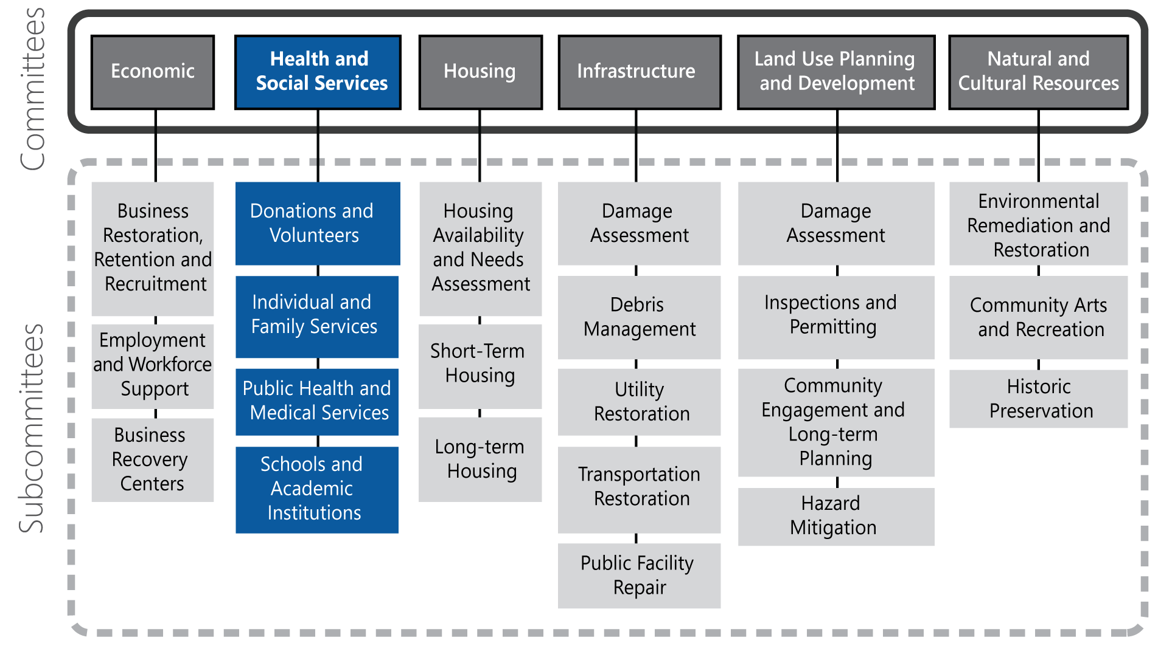

Local Recovery Partners

Local Organization | Donations and Volunteers | Individual and Family Services | Public Health and Medical Services | Schools and Academic Institutions
Social Services Department | Support | Lead | Support | Support
Public Health Department |  | Support | Lead
Environmental Health Department |  |  | Support
Parks and Recreation | Support | Support | Support | Support
Office of Emergency Management | Lead | Support | Support | Support
Voluntary Organizations Active in Disaster | Support | Support | Support | Support
American Red Cross | Support | Support | Support | Support
Salvation Army | Support | Support | Support | Support
Community Advocacy Organizations | Support | Support | Support | Support
NGOs and Faith-based Organizations | Support | Support | Support | Support
Libraries | Support | Support |  | Support
School District |  | Support |  | Lead
Universities | Support | Support |  | Lead

State and Federal Recovery Partners
The table below lists state and federal recovery partners that may coordinate efforts with the Health and Social Services Committee. The federal agencies listed have committed to these roles per the NDRF. Note that the State of Texas has not identified lead or supporting organizations for recovery functions, and thus this table lists potential state partners.
Effective September 1, 2019, House Bill 6 (HB6) enacts the Disaster Recovery Task Force through TDEM to help local communities throughout the long-term recovery period. The Task Force may use the resources of the Texas A&M University System, including the Texas A&M AgriLife Extension Service, the Texas A&M Engineering Extension Service, the Texas A&M Forest Service, and other state agencies and organized volunteer groups. As this Task Force is in the initial stages of development, the table below lists state agencies that could potentially be called upon by the Task Force to provide resources to support these critical functions.
Texas (Potential Recovery Partners) | Federal Recovery Partners
Primary Agencies  - Texas A&M University System – Texas Division of Emergency Management  - Texas Health and Human Services Commission | Coordinating Agency  - U.S. Department of Health and Human Services  Primary Agencies  - Corporation for National and Community Service  - Federal Emergency Management Agency  - U.S. Department of Agriculture  - U.S. Department of Commerce  - U.S. Department of Education  - U.S. Department of Homeland Security/Cybersecurity and Infrastructure Security Agency  - U.S. Department of Homeland Security/Office for Civil Rights and Civil Liberties  - U.S. Department of Housing and Urban Development  - U.S. Department of the Interior  - U.S. Department of Labor  - U.S. Environmental Protection Agency
Supporting Organizations  - Texas Department of Public Safety, Emergency Management  - Texas Department of State Health Services  - Texas Education Agency  - Texas Hospital Association  - Texas Public Health Association  - Texas Public Health Coalition  - Texas Voluntary Organizations Active in Disaster | Supporting Organizations  - American Red Cross  - National Voluntary Organizations Active in Disaster  - Office of Foreign Missions  - Small Business Administration  - U.S. Department of Education  - U.S. Department of the Treasury  - U.S. Department of Transportation  - U.S. Department of Veterans Affairs

Donations and Volunteers

Objective
Effectively manage solicited and unsolicited donations and volunteers to help with recovery efforts.

Overview
The Donations and Volunteers Subcommittee plans and coordinates among local NGOs, local VOAD, the faith-based community, and local volunteer organizations to develop strategies to effectively manage volunteers and both financial and commodity donations following a disaster. This group should work closely with the Public Information Officer to provide messaging that discourages unsolicited or unneeded items, as well as directing donors to legitimate organizations. The effective management of donations and volunteers requires heavy involvement from local VOADs and other organizations that coordinate donations and volunteers as part of their organizational mission.

Pre-disaster Preparedness Activities
- Identify local NGOs’ missions, services, and resources available and incorporate NGO partners in response and recovery training and exercise activities.
- Involve local VOAD in planning, training, and exercises related to recovery.
- Develop community-wide donations and volunteer management plans and develop pre-scripted messaging to discourage unsolicited donations.
- Pre-identify potential volunteer staging areas and donation storage and distribution locations.

Transition Phase Activities
- Disseminate information to the public on emergency commodities distribution areas including water, ice, food, hygiene and sanitation products, etc.
- Disseminate frequent and consistent donations management public messaging to discourage unsolicited commodities donations and redirect donors to cash donations or needed items.
- Collaborate with local NGOs, VOAD, and faith-based communities to assist with donations management, volunteer management, and public messaging.
- Evaluate the need for a local disaster fund to receive financial donations and coordinate with a local community foundation or other nongovernmental partner with the capability to serve as a central point to collect cash donations.

Short-term Recovery Activities (initiated within 8 weeks post-disaster)
- Continue donations and volunteer messaging.
- Identify issues with unsolicited donations and volunteers and identify strategies to redirect potential donors to cash contributions
- Establish a local disaster fund to receive financial donations if necessary.
- Coordinate with local VOAD for assistance with donations management, available resources, volunteer management, and public messaging.
- Engage local NGOs and faith-based organizations that can help with collecting, sorting, storing, transporting, and distributing unsolicited donations.
- Coordinate with local nonprofits and VOAD members with volunteers to combine activities like training, deployment, and management.

Long-term Recovery Activities
- Continue donations and volunteer messaging, identify issues with unsolicited donations and volunteers, and identify strategies to redirect potential donors to cash contributions.
- Coordinate with local VOAD for assistance with donations management, available resources, volunteer management, and public messaging.
- Engage local NGOs and faith-based communities that can help with collecting, sorting, storing, transporting, and distributing unsolicited donations.
- Support operation of a local disaster fund to receive financial donations, if established.
- Collaborate with local nonprofits that routinely work with volunteers to identify potential recovery activity volunteer opportunities.

Information Collection
Proposed measures of recovery progress in this area include:
- Types and/or amount of donations received and distributed;
- Financial donations received (and whether a local disaster fund is established);
- Volunteer participation; and
- Volunteer program and project achievements.

Individual and Family Services

Objective
Provide support to disaster survivors through personal welfare and care services, referrals, and outreach.

Overview
The Individual and Family Services Subcommittee can have diverse participation. Often, Social Services entities and local VOAD assume leadership roles within the Subcommittee. These groups must work closely to understand both the needs of the affected community and the services provided by recovery partners. This Subcommittee should ensure that any service delivery areas or information and assistance centers are inclusive and provide pertinent resources and information.

Pre-disaster Preparedness Activities
- Create a matrix of resources available to those affected by disaster through community NGOs and VOAD members, including thresholds to activate resources and limits that may be present (dollar amount, family size, etc.).
- Coordinate planning, training, and exercises with community NGOs through the local VOAD.
- Support and participate in coordinated efforts by nongovernmental agencies to develop a Long-term Recovery Group or Unmet Needs Committee.
- Support development of a process to coordinate long-term disaster case management that is compliant with state and federal regulations and client confidentiality standards.

Transition Phase Activities
- Continue mass care operations initiated during the response phase until they are no longer needed.
- Identify active VOAD partners, share information about relief operations, and develop consistent public messaging about available support.

Short-term Recovery Activities (initiated within 8 weeks post-disaster)
- Support demobilization of emergency shelters, including gathering information on recovery needs of families and individuals leaving the shelter.
- Stand up and manage local resource and information centers and/or support FEMA Disaster Recovery Centers (DRCs) if a federal declaration is received. Provide information to the public about the location and services located at the information center(s).
- Provide public information on available disaster assistance programs and who may qualify through all communication channels (city/county website, social media, tv/radio, etc.).
- Coordinate with local social service agencies and organizations to provide mental health services and referrals to disaster survivors.
- Coordinate with local organizations that provide services to vulnerable populations (e.g., those with disabilities and access and functional needs, seniors, children, and those with limited-English proficiency) to provide relief services and disseminate information.
- Ensure all service delivery areas are accessible for people with disabilities and others with access and functional needs, including information and assistance centers. Consider language issues when crafting public messaging or printed information.
- Coordinate available animal care, temporary animal sheltering, and animal reunification resources through both nonprofit organizations and local governmental animal services entities.
- Coordinate community door-to-door needs assessments, if necessary.
- Support FEMA DRCs (if disaster receives federal declaration). Provide information to the public about the location and operations of the DRC; the information that will be available; and that they may qualify for federal individual assistance from FEMA, SBA, and other federal programs.
- Coordinate with local community NGOs and VOAD to ensure available resources are communicated with affected communities.
- Ensure continuity of social services programs and coordinate with Texas Health and Human Services for additional resources.

Long-term Recovery Activities
- Continue to support staffing, resources, and logistical support for local information centers and/or DRCs for social and human services, such as assistance for those with disabilities, case management, crisis counseling, family-recovery assistance, childcare services, and nutrition services. Service and information centers may also provide information on housing, employment, important document recovery, and other disaster recovery resources.
- Maintain ongoing relationships with VOADs, nonprofits, and faith-based organizations to coordinate recovery assistance efforts.
- Work with VOAD partners to gather information on unmet needs of the community and identify strategies, programs, and resources to address them.
- Provide information and referrals about available community resources and assistance to the public.

Information Collection
Proposed measures of recovery progress in this area include:
- List of VOAD members actively providing services;
- Information and assistance centers established;
- Number of individuals visiting information and assistance centers; and
- Identified unmet needs.

Public Health and Medical Services

Objective
Support local healthcare providers, provide information on disaster-related health issues, and support community health advocacy organizations.

Overview
The Public Health and Medical Services Subcommittee supports local healthcare providers in reestablishing services, support the provision of community health services, and develop and disseminate disaster-related health information and resources. This Subcommittee should involve participation from local healthcare providers and hospital networks, local public health and health departments, the Texas Department of State Health Services, and the Texas Hospital Association to ensure all resources are available and used to facilitate recovery.

Pre-disaster Preparedness Activities
- Work with local healthcare providers to ensure there are up-to-date Continuity of Operations (COOP) Plans as well as emergency response plans in place. Involve healthcare providers and hospitals in exercises and training activities organized by local Emergency Management Agencies.
- Continue to build relationships between government organizations and community NGOs providing health and medical services, work to better understand those organizations’ missions and services, and incorporate NGO partners in response and recovery training and exercise activities.
- If one does not already exist, Emergency Management and Public Health departments should work to establish a public health emergency planning working group to conduct ongoing emergency preparedness.

Transition Phase Activities
- Disseminate public health directives related to disaster impacts (e.g., boil water).
- Support local healthcare providers with patient tracking and reunification efforts, if requested.
- Support points of distribution operations initiated during the response phase and disseminate information to the public on emergency commodities distribution areas.
- Work with local healthcare networks and providers to disseminate public messaging on the status of operations.
- Coordinate with healthcare providers to establish mobile locations for providing medical assistance, if requested.

Short-term Recovery Activities (initiated within 8 weeks post-disaster)
- Continue to disseminate disaster-related public health information.
- Identify potential alternate or mobile locations for providing medical assistance, if requested.

Long-term Recovery Activities
- Support local organizations to provide community health services, including mental health services.
- Maintain effective public health outreach and communications related to recovery impacts (e.g., mold, drinking water contamination).
- Monitor and maintain human and animal disease surveillance.
- Identify and advocate for public–private funding to meet the physical and behavioral health needs of vulnerable populations.

Information Collection
Proposed measures of recovery progress in this area include:
- Percentage of affected healthcare providers returned to normal operations; and
- Public health outreach campaigns and information resources.

Schools and Academic Institutions

Objective
Provide recovery support to local school districts, private schools, and higher education institutions.

Overview
The Schools and Academic Institutions Subcommittee coordinates with local school districts and universities to ensure students receive access to available recovery resources. This Subcommittee also supports the demobilization of emergency shelter locations at school sites and the return to normal school operations.

Pre-disaster Preparedness Activities
- If one does not exist, establish an education emergency working group that includes local emergency management and public health departments, school districts, and universities to conduct ongoing preparedness efforts.
- Include schools in disaster trainings and exercises. Provide a variety of scenarios so school administrators and school systems at all levels can explore ways in which they might prepare for, respond to, and recover from a disaster.
- Maintain a current list of all public and private primary, secondary, and high school emergency contact information and emergency alert systems and procedures.
- Conduct preparedness planning for the use of temporary, portable, or modular buildings to continue school while school facilities are inhabitable.
- Conduct preparedness planning for virtual or remote learning as an alternative to in-person instruction.
- Promote individual and family preparedness in schools and universities and encourage students to participate in community emergency preparedness activities.
- Encourage local community colleges, public and private colleges, and universities to plan and train together to become more disaster resilient.
- Develop university continuity plans to continue classes during recovery, which may include transitioning classroom courses to virtual courses.

Transition Phase Activities
- Establish communication with childcare centers, schools, and universities in the affected area to understand extent of physical damages and anticipated impact on operations.
- Coordinate the consolidation and/or deactivation of schools used as emergency shelters.

Short-term Recovery Activities (initiated within 8 weeks post-disaster)
- Provide support to local school districts to maintain continuity of services, reestablish operations, and disseminate public messaging related to closures.
- Coordinate with local and state education entities to identify temporary, alternative, and/or supplemental locations for schools and tools and resources required for virtual or remote instruction, as needed.

Long-term Recovery Activities
- Support local school districts’ efforts to reestablish full operations.

Information Collection
Proposed measures of recovery progress in this area include:
- Number of schools used as emergency shelters;
- Number of schools with heavy damage or destroyed;
- Number of school-aged children in affected area;
- Number of affected schools returned to normal operations; and
- Number of students resuming school.

This page intentionally left blank.

Housing Committee Annex

Mission
The Housing Committee coordinates the efforts of government, nonprofit, and private sector partners to provide displaced residents with housing information and assistance. The Committee implements programs and policies to support temporary and permanent housing solutions.

Recovery Objectives
- Identify impacts to housing stock, short-term and long-term housing needs, and displacement and relocation data.
- If the disaster receives a federal declaration, coordinate with FEMA to implement sensible short- and long-term housing solutions.
- Collaborate with private-sector entities to identify solutions for short-term and long-term housing.
- Collaborate with the nonprofit community to identify housing solutions and address the needs of those displaced.

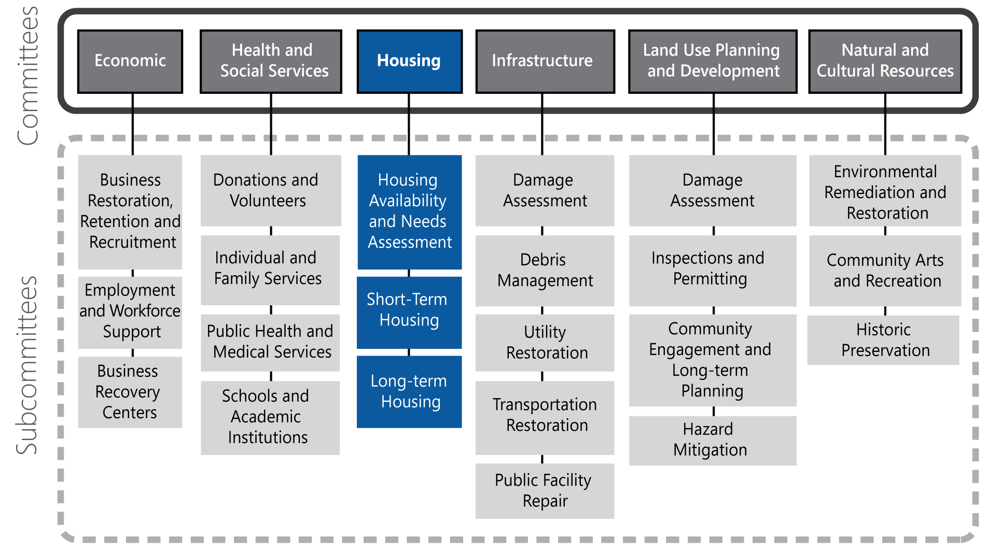

Local Recovery Partners

Local Organization | Housing Availability and Needs Assessment | Short-term Housing | Long-term Housing
Department of Housing | Lead | Lead | Lead
Community Development | Support | Lead | Lead
Neighborhood Improvement | Support | Lead | Lead
Planning Department | Support | Support | Support
Economic Development Department | Support | Support | Support
Office of Emergency Management | Support | Support | Support
Apartment Association | Support | Support | Support
Home Builders Association | Support | Support | Support
Housing Authority | Support | Support | Support
Housing Affordability Advocacy Organizations |  | Support | Support
North Texas Community Development Association |  | Support | Support
Local Real Estate Developers |  |  | Support

State and Federal Recovery Partners
The table below lists state and federal recovery partners that may coordinate efforts with the Housing Committee. The federal agencies listed have committed to these roles per the NDRF.
Effective September 1, 2019, House Bill 6 (HB6) enacts the Disaster Recovery Task Force through TDEM to help local communities throughout the long-term recovery period. The Task Force may use the resources of the Texas A&M University System, including the Texas A&M AgriLife Extension Service, the Texas A&M Engineering Extension Service, and the Texas A&M Forest Service, and other state agencies and organized volunteer groups. As this Task Force is in the initial stages of development, the table below lists state agencies that could potentially be called upon by the Task Force to provide resources to support these critical functions.

Texas (Potential Recovery Partners) | Federal Recovery Partners
Primary Agencies  - Texas A&M University System – Texas Division of Emergency Management  - Texas Department of Housing and Community Affairs  - Texas General Land Office | Coordinating Agency  - U.S. Department of Housing and Urban Development  Primary Agencies  - Federal Emergency Management Agency  - U.S. Department of Agriculture  - U.S. Department of Justice
Supporting Organizations  - Texas Health and Human Services Commission  - Texas Housing Association  - Texas Insurance Council | Supporting Organizations  - American Red Cross  - Environmental Protection Agency  - General Services Administration  - National Voluntary Organizations Active in Disaster  - Small Business Administration  - U.S. Access Board  - U.S. Department of Commerce  - U.S. Department of Education  - U.S. Department of Energy  - U.S. Department of Health and Human Services  - U.S. Department of Veterans Affairs

Housing Availability and Needs Assessment

Objective
Coordinate collection of impacts to housing stock, estimate short-term and long-term housing needs, and estimate available housing resources and assistance programs.

Overview
The Housing Availability and Needs Assessment Subcommittee works with the Damage Assessment Subcommittee to gather and analyze data on impacts to residential structures. They also coordinate with the Individual and Family Services Subcommittee to determine urgent housing needs and work to address the most dire and immediate needs.

Pre-disaster Preparedness Activities
- Maintain an up-to-date inventory of the current housing stock and rental and home units as they come on the market.
- Establish relationships with apartment and home builders’ associations and housing affordability organizations to coordinate information sharing pre- and post-disaster.

Transition Phase Activities
- Use damage assessment data to identify the degree of impacts to residential areas.
- Compare damage assessment data with pre-disaster housing inventories to estimate the needs for rental units, single-family homes, and multi-family homes.
- Coordinate with the Land Use Planning and Development Committee to evaluate the need for construction moratoria, reconstruction phasing, and other policies to pace construction.
- Evaluate impacts to hotel and motel properties and identify vacancies and room rates.

Short-term Recovery Activities (initiated within 8 weeks post-disaster)
- Coordinate outreach to provide displaced residents with information about available transitional and short-term housing options.
- Work with the Texas Department of Insurance to monitor the pace of claims.
- Work with the Land Use Planning and Development Committee to monitor the progress and pace of home repairs, permitting, and occupancy.
- Work with federal partners to monitor the pace of Individual Assistance applications and disbursements.

Long-term Recovery Activities
- Monitor the processing of insurance claims, permits, and individual assistance disbursements.
- Develop reports and analysis on housing availability and needs to share with potential investors, local real estate developers, and apartment and home builder associations.
- Develop data-driven recommendations for allocating funding to address long-term housing needs.

Information Collection
Proposed measures of recovery progress in this area include:
- Number of housing units damaged, destroyed, or abandoned;
- Rental units used as short-term and temporary housing;
- Number of modular or mobile homes used as temporary housing;
- Hotel and motel vacancy rates; and
- Number of individuals receiving federal assistance.

Short-term Housing

Objective
Identify and implement short-term housing solutions for those displaced by the disaster.

Overview
The Short-term Housing Subcommittee will work with local, state, and federal agencies and nonprofit and private sector recovery partners to identify safe, clean, and affordable temporary housing that complies with local regulations.

Pre-disaster Preparedness Activities
- Develop and adopt a pre-disaster recovery ordinance that facilitates short-term housing in a post-disaster situation, such as allowing for modular or mobile homes on homeowner property.
- Engage local community development organizations, housing affordability advocacy organizations, and private sector real estate partners in disaster recovery planning to identify strategies for post-disaster housing.
- Establish criteria for identifying potential sites for temporary housing in alignment with existing zoning and land-use regulations.
- Promote the importance of adequate homeowner’s and renter’s insurance coverage, including special insurance policies such as flood. Encourage residents to read and understand what the policy covers and under what conditions.
- Pre-identify open space that may be used for temporary housing, given zoning regulations and transportation access.

Transition Phase Activities
- Coordinate with emergency shelters to facilitate the transition of shelter clients into transitional housing by sharing information on available temporary and short-term options, such as available hotel/motel rooms.

Short-term Recovery Activities (initiated within 8 weeks post-disaster)
- Identify temporary housing options and sites, which may include conventional solutions (e.g., manufactured and/or modular homes and conversion of commercial, retail, or light industrial sites) and/or more unconventional solutions (e.g., collaboration with hotel chains, Airbnb hosts, and neighbor home-shares).
- Work with the Land Use Planning and Development Committee to identify opportunities for placement of temporary structures, such as tents and mobile homes, on public property.
- Coordinate information sharing with VOAD partners and the Health and Social Services Committee to ensure displaced residents are connected to available resources.
- Work with the Health and Social Services Committee to develop public outreach materials to educate the community on FEMA housing assistance programs (if an Individual Assistance declaration is received).
- Work with the Land Use Planning and Development Committee to develop a public education campaign to raise homeowners’ awareness of reconstruction scams and unscrupulous practices by contractors who may prey on people desperate to repair their homes.
- Coordinate with nonprofits and VOAD partners that provide housing assistance programs (e.g., cleanup, repairs, or financial assistance) to support outreach and ensure the maximization of resources.
- Coordinate with the Land Use Planning and Development Committee to ensure rebuilding activities are in accordance with codes (including codes that may have been amended post-disaster). Collaborate on public outreach if conflicts arise.
- Provide staffing and subject-matter expertise, as requested, to Community Resources Centers to provide housing resources, information, and referrals.
- Coordinate with the Land Use Planning and Development Committee to develop recommendations related to housing reconstruction and relocation, such as phasing.
- Identify long-term housing needs, including affordable housing needs, and potential recovery programs and strategies.

Long-term Recovery Activities
- Support the Long-term Housing Subcommittee to implement disaster housing recovery programs and projects.

Information Collection
Proposed measures of recovery progress in this area include:
- Number of displaced residents utilizing short-term housing;
- Number of displaced residents in need of short-term housing; and
- Number of units of short-term housing available.

Long-term Housing

Objective
Identify and implement long-term and/or permanent housing solutions for those displaced by the disaster.

Overview
The Long-term Housing Subcommittee works closely with the Housing Availability and Needs Assessment and Short-term Housing Subcommittees. It is included as a separate function from short-term housing because it is important to begin exploring long-term and permanent housing solutions early in the recovery process.

Pre-disaster Preparedness Activities
- Engage local community-development organizations, housing affordability advocacy organizations, and private-sector real estate partners in disaster recovery planning to identify strategies for post-disaster housing.
- Promote the importance of adequate homeowner’s and renter’s insurance coverage, including special insurance policies such as those related to flooding. Encourage residents to read and understand what the policy covers and under what conditions.

Transition Phase Activities
- Track disaster housing recovery activities to anticipate long-term housing needs, including affordable housing needs.

Short-term Recovery Activities (initiated within 8 weeks post-disaster)
- Coordinate with the Land Use Planning and Development Committee to develop recommendations related to housing reconstruction and relocation, such as phasing.
- Identify long-term housing needs, including affordable housing needs, and potential recovery programs and strategies.

Long-term Recovery Activities
- Continue to provide staffing and subject-matter expertise at community resource and information centers to provide housing resources, information, and referrals.
- Coordinate with the Land Use Planning and Development Committee to ensure rebuilding activities are in accordance with codes (including codes that may have been amended post-disaster). Collaborate on public outreach if conflicts arise.
- Coordinate with the Land Use Planning and Development Committee and Economic Committee to consider existing comprehensive plans, economic development plans, special district plans, and neighborhood plans to identify potential focus areas for residential redevelopment.
- Work with the Land Use Planning and Development Committee to estimate costs associated with the implementation of long-term housing programs, including buy-outs.
- Identify and/or establish programs to provide technical assistance and financial tools that assist homeowners in rebuilding or relocating.
- Coordinate with the local Housing Authority and advocacy organizations to monitor the supply of affordable housing and Section 8 vouchers.
- Work with the Land Use Planning and Development Committee to explore incentive programs and/or enhanced zoning or building code regulations to promote the reconstruction of housing developments that incorporate stronger building design.

Information Collection
Proposed measures of recovery progress in this area include:
- Number of new construction housing units (rental, single-family, multi-family).

This page intentionally left blank.

Infrastructure Committee Annex

Mission
The Infrastructure Committee is responsible for coordinating repairs and restoration of essential systems and structures. It oversees restoration and rebuilding of roads, bridges, and other public transportation infrastructure and infrastructure related to rail, gas, electric, communications, water, and other utilities. The Committee works to coordinate short-term restoration of services as quickly as possible while also planning long-term rebuilding of the systems and structures related to infrastructure to improve the region’s resiliency and efficiency.

Recovery Objectives
- Perform damage assessments of infrastructure assets and oversee repairs and reconstruction.
- Evaluate infrastructure recovery needs and required resources and capabilities.
- Oversee debris management.
- Restore mobility and critical services, including utilities and transportation.
- Consider long-term resiliency and the function of structures and systems during the rebuilding of public facilities and other infrastructure systems.

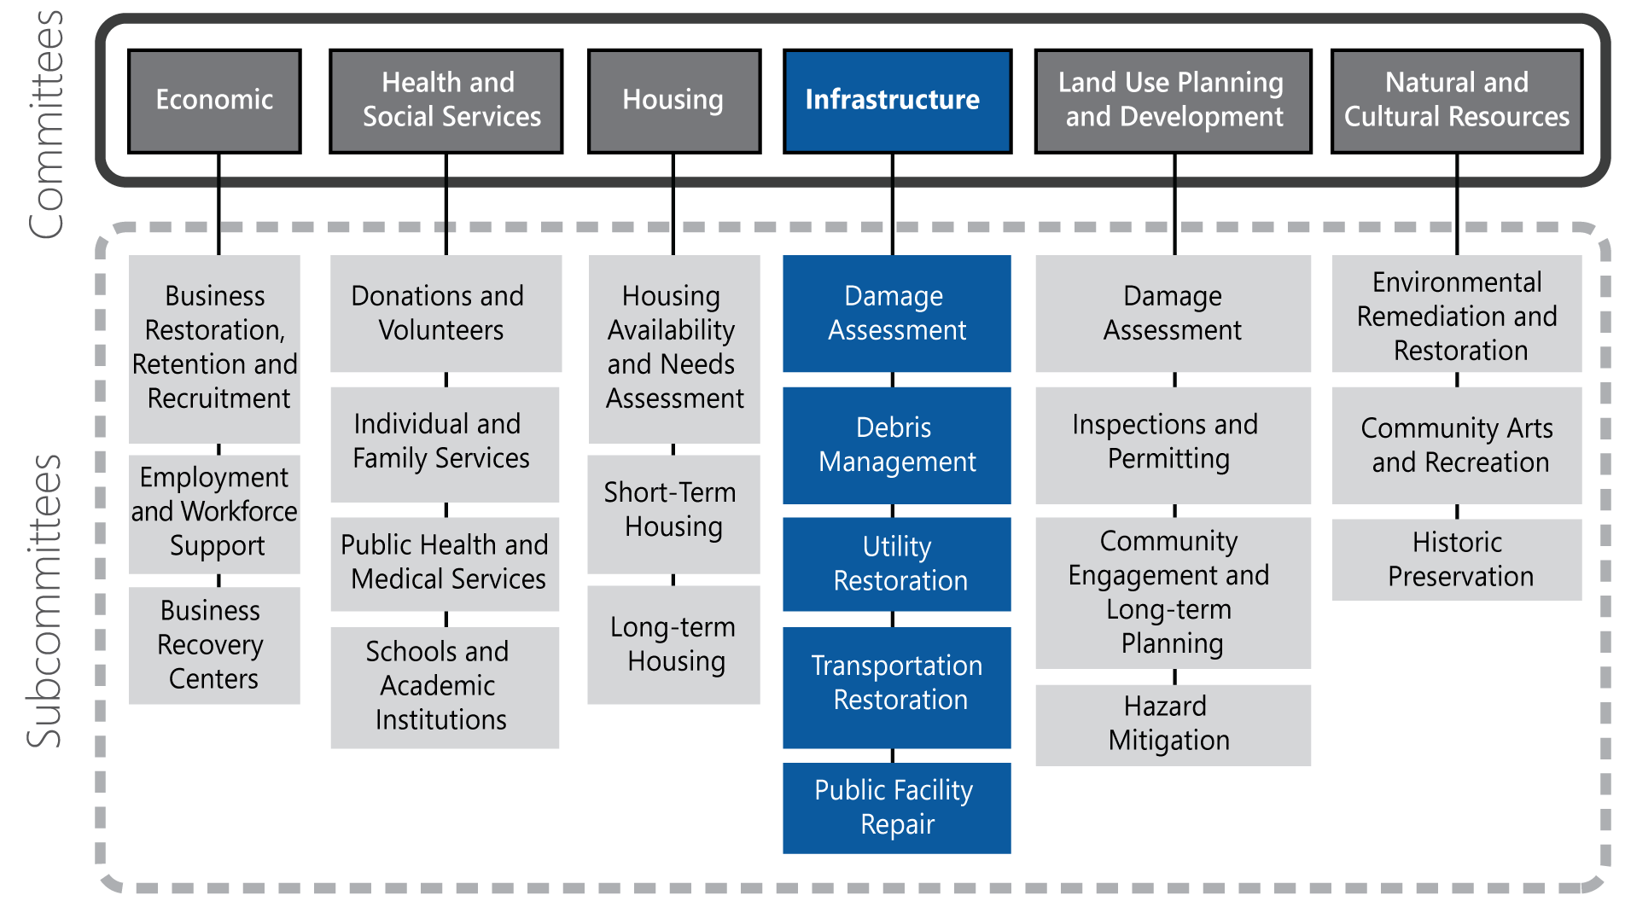

Local Recovery Partners

Local Organization | Damage Assessment | Debris Management | Utility Restoration | Transportation Restoration | Public Facility Repair
Department of Public Works | Lead | Lead | Support | Lead | Support
Building Services Department |  |  |  |  | Lead
Engineering Division | Support |  |  | Support | Support
Sanitation Services |  | Support
Communications and Information Technology Department |  |  | Support | Support
Department of Transportation |  |  |  | Support
Office of Emergency Management | Lead | Lead | Support | Support | Support
Department of Water | Support |  | Lead
Private Utilities  - Area Electrical Companies  (e.g., Oncor, Direct Energy, CoServ)  - Area Gas Companies (e.g., CoServ, Atmos Energy)  - Area Communications Companies  (e.g., AT&T, Verizon, Frontier) | Lead/  Support | Lead/  Support | Lead/  Support

State and Federal Recovery Partners
The table below lists state and federal recovery partners that may coordinate efforts with the Infrastructure Committee. The federal agencies listed have committed to these roles per the NDRF.
Effective September 1, 2019, House Bill 6 (HB6) enacts the Disaster Recovery Task Force through TDEM to help local communities throughout the long-term recovery period. The Task Force may use the resources of the Texas A&M University System, including the Texas A&M AgriLife Extension Service, the Texas A&M Engineering Extension Service, and the Texas A&M Forest Service, and other state agencies and organized volunteer groups. As this Task Force is in the initial stages of development, the table below lists state agencies that could potentially be called upon by the Task Force to provide resources to support these critical functions.

Texas (Potential Recovery Partners) | Federal Recovery Partners
Primary Agencies  - Texas A&M University System – Texas Division of Emergency Management  - Texas Department of Transportation  - Texas Public Utilities Commission | Coordinating Agency  - U.S. Army Corps of Engineers  Primary Agencies  - Federal Emergency Management Agency  - U.S. Army Corps of Engineers  - U.S. Department of Energy  - U.S. Department of Homeland Security  - U.S. Department of Transportation
Supporting Organizations  - Gulf Coast Waste Disposal Authority  - North Texas Tollway Authority  - Texas A&M Transportation Institute  - Texas Board of Professional Engineers  - Texas Center for Educational Technology  - Texas Commission on Environmental Quality  - Texas Department of Information Resources  - Texas Department of Public Safety  - Texas General Land Office  - Texas Groundwater Protection Committee  - Texas Health and Human Services Commission  - Texas Military Department  - Texas Office of Public Utility Counsel  - Texas Parks and Wildlife Department  - Texas Railroad Commission  - Texas Soil and Water Conservation Board  - Texas Water Development Board  - Toxic Substances Coordinating Committee  - Various Groundwater Conservation Districts  - Various Regional Water Authorities | Supporting Organizations  - Delta Regional Authority  - U.S. Department of Agriculture  - U.S. Department of Commerce  - U.S. Department of Defense  - U.S. Department of Education  - U.S. Department of Health and Human Services  - U.S. Department of Homeland Security  - U.S. Department of Housing and Urban Development  - U.S. Department of the Interior  - U.S. Department of the Treasury  - U.S. Environmental Protection Agency  - Federal Communications Commission  - General Services Administration  - Nuclear Regulatory Commission  - Tennessee Valley Authority

Damage Assessment

Objective
Evaluate impacts, identify needed repairs, and oversee the restoration of publicly-owned buildings, roads, water and wastewater infrastructure, bridges, etc.

Overview
The Infrastructure Damage Assessment Subcommittee comprises experts in the fields of transportation, transit, communications, water, power, gas, facilities, and general infrastructure. The damage assessment team requires qualified and credentialed representatives from public works, roads, utilities, information technology, communications, etc.

Pre-disaster Preparedness Activities
- Build agreements, processes, and technological supports to ensure that infrastructure-related GIS systems and staff can coordinate and share information easily.
- Annually review critical infrastructure system statuses to stay informed of new risks and challenges to the existing system.

Transition Phase Activities
- Continue to maintain proper cost documentation processes to ensure eligibility for reimbursement.
- Continue damage assessments of public facilities, water and wastewater infrastructure, roads, bridges, etc. and detail damages to the extent possible.
- Protect public safety by identifying structures or areas for which access should be restricted.
- Prepare maps locating infrastructure damages, power outages, road closures, and other conditions.
- Prioritize repairs to damaged infrastructure that impedes efforts to provide entry or essential services to disaster-affected areas.

Short-term Recovery Activities (initiated within 8 weeks post-disaster)
- Continue proper cost documentation of all infrastructure recovery efforts to ensure eligibility for reimbursement.
- Prepare for the arrival of state and federal agencies to conduct the joint PDA. Provide local representatives and qualified engineers to accompany PDA teams. The local representatives are responsible for ensuring that all damaged areas, estimated repair costs, insurance entitlements, and hazard mitigation opportunities are identified.
- Use a Public Property Site Assessment Worksheet (DEM-25) and a map in the local assessment of infrastructure losses.
- Provide transportation for PDA teams. Secure large-capacity vehicles that can accommodate up to six passengers.
- Determine the level of insurance coverage for affected structures.
- Review damage assessments of individual resources and aggregate this information to understand damage by neighborhood and asset type across the jurisdiction.
- Coordinate engineering surveys of major damage, identify repair and reconstruction needs, and estimate associated costs.

Long-term Recovery Activities
- Continue proper documentation of all infrastructure recovery efforts to ensure eligibility for reimbursement.
- Continue to coordinate engineering surveys of major damage, identify repair and reconstruction needs, and estimate associated costs.

Information Collection
Proposed measures of recovery progress in this area include:
- Damage assessment information including minor, major, and destroyed (e.g., impact assessment and PDA);
- Number and status of repairs and reconstruction, including mapping as needed; and
- Total grant funding received for infrastructure repair and/or reconstruction and capital projects.

Debris Management

Objective
Oversee movement, temporary storage, disposal, and documentation of debris management operations during disaster recovery.

Overview
The Debris Management Subcommittee requires experts and equipment to execute debris removal, transfer, and disposal. This Subcommittee must maintain meticulous cost documentation to ensure federal reimbursement for debris management costs.

Pre-disaster Preparedness Activities
- Create a Disaster Debris Removal Plan, including the execution of a standby contract with a debris-removal company and/or a disaster debris ordinance. Note: Per HB6, an emergency management program maintained by a county or in which a county participates must provide for debris management (A. Flores, Texas Association of Counties, 2019).
- Designate responsible departments and staff to oversee debris removal.
- Locate potential staging sites, create a list of pre-identified sites, and determine permit requirements.
- Execute and manage stand-by debris removal contracts.

Transition Phase Activities
- Ensure proper cost documentation of all infrastructure recovery efforts to ensure eligibility for reimbursement.
- Conduct debris removal activities with appropriate equipment. Activate debris management contract (if applicable) and oversee implementation of debris-removal operations including collection, disposal, and monitoring of debris.
- Conduct roadway and public right-of-way debris removal.

Short-term Recovery Activities (initiated within 8 weeks post-disaster)
- Ensure proper documentation processes to ensure eligibility for reimbursement.
- Coordinate debris removal activities, including oversight of contractors.
- Provide information on proper disposal and recycling programs and processes to residents and businesses.

Long-term Recovery Activities
- Ensure proper documentation processes to ensure eligibility for reimbursement.
- Coordinate debris removal activities, including oversight of contractors.
- Oversee debris disposal site capacity issues.
- Coordinate with the U.S. Army Corps of Engineers and any involved state agencies responsible for clearing debris from waterways, as necessary.

Information Collection
Proposed measures of recovery progress in this area include:
- Debris removal status and timeline; and
- Federal reimbursement for debris removal costs.

Utility Restoration

Objective
Support local utility service providers and private utility companies to restore water, wastewater, telecommunications, electricity, natural gas, and other utility services per the plans of individual infrastructure holders and in adherence to state and federal regulations.

Overview
The Utility Restoration Subcommittee should include experts in telecommunications, information technology, power, gas, and water who can monitor repairs by qualified engineers, work crews, and contractors to resume services. Close coordination with private sector companies providing these services is critical, as is the timely and accurate conveyance of public information.

Pre-disaster Preparedness Activities
- Conduct recovery planning and exercises with private-sector utility providers and establish information sharing agreements with public and private utility holders that extend into the recovery phase.
- Work with telecommunications and IT companies to pre-identify critical assets and equipment for the region. Pre-plan communications infrastructure repair processes so that they can occur in tandem with the recovery of transportation corridors.
- Examine energy-assurance plans and work with energy providers to identify priority customers. Communicate with priority customers and other infrastructure owners to develop a regional energy restoration plan.
- Establish plans for fuel distribution and supply for critical service providers during recovery.
- Establish a mapping program that tracks the operational status of water and wastewater conveyance lines.
- Develop a plan for the temporary distribution of potable water across the region while water infrastructure is repaired or rebuilt.
- Evaluate alternatives to and establish policy direction for the potential bypassing of wastewater into local water bodies at locations that will be the least detrimental to the environment.
- Develop a plan for providing portable or composting toilets for residents and businesses, perhaps using kits. Convene public health, solid waste, and wastewater stakeholders to establish strategies and roles for addressing this issue. Establish a post-disaster code that allows the use of portable and composting toilets.

Transition Phase Activities
- Continue coordination of response-phase power restoration activities and support utility companies as requested.
- Identify priority areas for restoration of systems that support the safety and welfare of vulnerable populations (e.g., electric power and water systems for hospitals and healthcare facilities).
- Provide utility restoration timelines and service outage information to the public.

Short-term Recovery Activities (initiated within 8 weeks post-disaster)
- Continue utility restoration activities and provide information on utility restoration timelines, service outages, and utility payment relief programs to the public.

Long-term Recovery Activities
- Coordinate repairs, reconstruction, and restoration of critical utilities infrastructure. If conducting a large-scale repair program, ensure that close scrutiny of costs and quality of repairs are maintained throughout the program.
- Identify hardening and mitigation opportunities to incorporate into reconstruction plans. Encourage investment in redundant assets to maintain communications and supply temporary service.
- Manage capital projects, as needed.

Information Collection
Proposed measures of recovery progress in this area include:
- Customers without power, water, wastewater, gas, Internet, and cellular services; and
- Timeline for resumption of service.

Transportation Restoration

Objective
Restore transportation infrastructure and services within the jurisdiction, including local and state-owned roads, bridges, and public transit systems.

Overview
The Transportation Restoration Subcommittee monitors operations of qualified engineers, work crews, and contractors to repair and restore the service of roads, highways, bridges, and public transit. The focus is on appropriate prioritization of repairs to ensure the safety and well-being of responders and the public. Clear, consistent public information is required to ensure the community is informed of the status of the various transportation systems throughout the recovery process.

Pre-disaster Preparedness Activities
- Develop and manage a list of transportation infrastructure and identify points of contact from relevant agencies, departments, companies, etc.
- Conduct planning efforts among emergency management, public works, and the state Department of Transportation to identify priority routes for transporting commodities into the jurisdiction and establishing processes for coordination and communications to reopen routes as quickly as possible.
- Engage major employers to identify transportation interdependencies that impact business supply chains.
- Encourage major employers to include workforce transportation in BCPs.

Transition Phase Activities
- Continue proper cost documentation of all infrastructure recovery efforts to ensure eligibility for reimbursement.
- Coordinate repairs and interim provisions to establish safe ingress and egress routes for response vehicles and equipment.
- Provide ongoing public status updates on the accessibility of roads and bridges and a timeline for re-entry.
- Conduct priority repairs to inroads for healthcare facilities and providers, supermarkets, home improvement stores, and gas stations to support continuity of supply chains and public re-entry into the area.
- If road capacity is constrained, limit access by private vehicles and/or work with local bus networks to expand public transit service and add additional routes.

Short-term Recovery Activities (initiated within 8 weeks post-disaster)
- Continue proper cost documentation of all infrastructure recovery efforts to ensure eligibility for reimbursement.
- Coordinate repairs and interim provisions to establish safe ingress and egress routes for response vehicles and equipment.
- Provide ongoing status updates on the accessibility of roads and bridges and a timeline for re-entry.
- Continue to conduct priority repairs of inroads for healthcare facilities and providers, supermarkets, home improvement stores, and gas stations to support continuity of supply chains and public re-entry into the area.
- If road capacity is constrained, continue to limit access by private vehicles and/or work with local bus networks to expand public transit service and add additional routes.
- Consider alternative uses for existing transportation infrastructure, such as enabling pedestrian or bicycle transportation on roadways. Also consider working with local or state park departments to open urban trails to limited vehicular traffic while roadways are repaired.
- Complete repairs to local roads through public works and contract support. Coordinate with state Department of Transportation to make repairs to state roads.
- Support engineering surveys of major damage, identify repair and reconstruction needs, and estimate associated costs.
- Coordinate procurement and contracting for significant repairs that exceed local capabilities.

Long-term Recovery Activities
- Continue proper cost documentation of all infrastructure recovery efforts to ensure eligibility for reimbursement.
- Coordinate public assistance projects, as needed.
- Support engineering surveys of major damage, identify repair and reconstruction needs, and estimate associated costs.
- Coordinate procurement and contracting for significant repairs that exceed local capabilities.
- Identify hardening and mitigation opportunities to incorporate into reconstruction plans, including those included in the local Hazard Mitigation Plan.
- Coordinate repairs and reconstruction of roads and bridges. If conducting a large-scale repair program, ensure that close scrutiny of costs and quality of repairs are maintained throughout the program.
- Provide ongoing updates on the status of transportation infrastructure and public transit service.
- Work with the Land Use Planning and Development Committee to integrate sustainable transportation strategies into recovery efforts and identify opportunities to support multi-modal transportation systems (e.g., bike lanes, expanded bus services and/or light rail, and retrofits to pedestrian crossings).
- Manage capital projects, as needed.

Information Collection
Proposed measures of recovery progress in this area include:
- Repair timeline of damaged roads and bridges;
- Project funding for transportation reconstruction and improvement projects; and
- Status of transportation reconstruction and improvement projects.

Public Facility Repair

Objective
Coordinate efforts to repair and restore operations of local government-owned facilities.

Overview
The Public Facility Repair Subcommittee requires city/county staff who are familiar with government buildings and other city- and county-owned facilities, such as jails, event halls, and museums. This team should include local government staff that oversee maintenance and operations of facilities, such as general services and facilities management staff.

Pre-disaster Preparedness Activities
- Develop and manage an inventory of public buildings and identify points of contact for the relevant department(s). Maintain a directory of existing facility repair contractors (i.e., those that have been vetted through the procurement process).
- Maintain COOP plans for all government buildings.
- Conduct assessments of public buildings to identify mitigation measures and include as part of the current Hazard Mitigation Plan.

Transition Phase Activities
- Continue to maintain proper cost documentation processes to ensure eligibility for reimbursement.
- Implement departmental COOP plans and continuity of government (COG) plans and relocate to alternate facilities, where possible, to resume essential government functions.

Short-term Recovery Activities (initiated within 8 weeks post-disaster)
- Continue proper cost documentation of all infrastructure recovery efforts to ensure eligibility for reimbursement.
- Continue implementation of departmental COOP and COG plans as long as necessary.
- Complete minor repairs to facilities through existing city and county maintenance staff.
- Provide ongoing updates to the public about the status of public facilities and the timeline for reestablishing operations.

Long-term Recovery Activities
- Continue proper cost documentation of all infrastructure recovery efforts to ensure eligibility for reimbursement.
- Coordinate Public Assistance program activities with FEMA.
- Provide the public with periodic updates on facility status until operations and services are fully restored.
- Conduct engineering surveys of major damage, identify repair and reconstruction needs, and estimate associated costs.
- Coordinate procurement and contracting for significant repairs that exceed the capabilities of maintenance staff.
- Work with the Land Use Planning and Development Committee to identify hardening and mitigation opportunities to incorporate into reconstruction plans. Consider projects included in the most up-to-date local Hazard Mitigation Plan.
- Coordinate Public Assistance projects, as needed.
- Manage capital projects, as needed.

Information Collection
Proposed measures of recovery progress in this area include:
- Operation status of public facilities; and
- Status of repairs to and/or reconstruction of public facilities.

This page intentionally left blank.

Land Use Planning and Development Committee Annex

Mission
The Land Use Planning and Development Committee’s goal is to facilitate repair and reconstruction in an orderly, safe, and timely manner. The Committee provides recommendations on appropriate procedures and requirements for rebuilding and works to ensure quality construction and adherence to codes. It also reviews and recommends potential updates or revisions to current land use strategies in order to lessen the impacts from future damages.

Recovery Objectives
- Perform damage assessments.
- Conduct building inspections.
- Engage community members in rebuilding efforts.
- Facilitate the review of current and future land use strategies.
- Ensure pre-disaster planning and mitigation activities are ongoing.

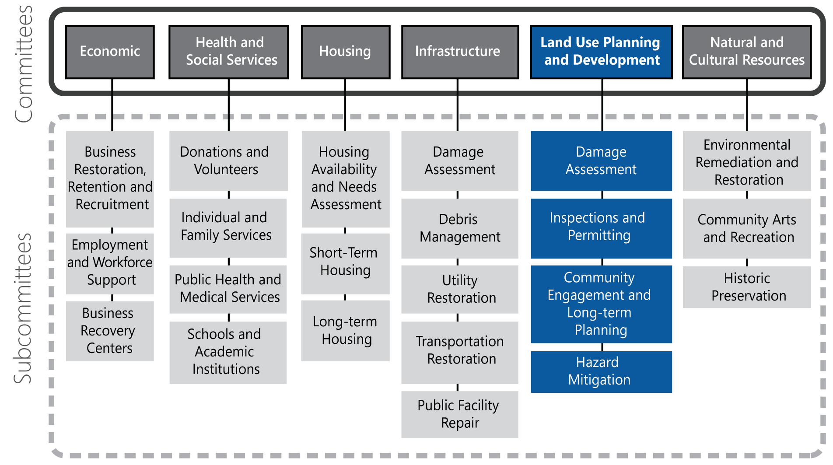

Local Recovery Partners

Local Organization | Damage Assessment | Inspections and Permitting | Community Engagement and Long-term Planning | Hazard Mitigation
Planning/Zoning | Support | Support | Lead | Lead
Building Inspections Department | Lead | Lead | Support | Support
Community Development Commission |  |  | Support | Support
Office of Emergency Management | Lead | Support | Support

State and Federal Recovery Partners
The table below lists state and federal recovery partners that may coordinate efforts with the Land Use Planning and Development Committee. The federal agencies listed have committed to these roles per the NDRF.
Effective September 1, 2019, House Bill 6 (HB6) enacts the Disaster Recovery Task Force through TDEM to help local communities throughout the long-term recovery period. The Task Force may use the resources of the Texas A&M University System, including the Texas A&M AgriLife Extension Service, the Texas A&M Engineering Extension Service, and the Texas A&M Forest Service, and other state agencies and organized volunteer groups. As this Task Force is in the initial stages of development, the table below lists state agencies that could potentially be called upon by the Task Force to provide resources to support these critical functions.

Texas (Potential Recovery Partners) | Federal Recovery Partners
Primary Agencies  - Texas A&M University System–Texas Division of Emergency Management  - Texas General Land Office  - Texas Water Development Board | Coordinating Agency  - U.S. Department of Homeland Security/Federal Emergency Management Agency  Primary Agency  - U.S. Department of Housing and Urban Development
Supporting Organizations  - Texas Division of Emergency Management  - Texas Floodplain Management Association  - Texas Commission on Environmental Quality | Supporting Organizations  - American Planning Association  - American Red Cross  - Corporation for National and Community Service  - International City/County Management Association  - National Voluntary Organizations Active in Disaster  - Small Business Administration  - U.S. Department of Agriculture  - U.S. Department of Commerce  - U.S. Department of Education  - U.S. Department of Energy  - U.S. Department of Health and Human Services  - U.S. Department of the Interior  - U.S. Department of Justice  - U.S. Department of Transportation  - U.S. Environmental Protection Agency  - U.S. Army Corps of Engineers  - U.S. Access Board

Damage Assessment

Objective
Provide staffing and expertise to identify, catalog, and assess the level of damage sustained after a disaster.

Overview
The Damage Assessment Subcommittee should be made up of members with expertise in collecting damage assessment data and data collection technologies such as windshield surveys. Subcommittee members require access to current maps, general working knowledge of the area, communications, and information-collection technologies. Local jurisdictions should be prepared to provide transportation to damage assessment teams and possibly law enforcement escorts if deemed necessary.

Pre-disaster Preparedness Activities
- Participate in pre-disaster recovery and mitigation planning and provide recommendations to mitigate or lessen impacts from damage.
- Determine damage assessment processes and data collection methods. Establish data sharing protocols.
- Establish damage assessment teams and determine activation protocols
- Identify items needed for damage assessment teams (e.g., forms, color-coded cards, cameras, cell phones, tablets) and supporting resources (e.g., county maps, temporary permit forms).
- Coordinate with Planning Department GIS specialists to access readily available maps that could be used for conducting impact and damage assessments.
- Maintain pre-disaster information such as maps, photos, and other documents for pre-disaster conditions.
- Review local, state, and federal regulations for operating unmanned aerial vehicles (i.e., drones) for damage assessment. If possible, integrate drone technology into pre- and post-disaster documentation procedures.

Transition Phase Activities
- Activate damage assessment teams to collect information on the amount, extent, and type of damage caused by the disaster using windshield surveys, aerial surveys, etc. and the Public Property Site Assessment Worksheet (TDEM form DEM-25).
- Work with local GIS resources to obtain current maps for affected areas and ensure damage assessment data is uploaded to maps to share damage intelligence.

Short-term Recovery Activities (initiated within 8 weeks post-disaster)
- Continue to utilize damage assessment teams to collect information on the amount, extent, and type of damage caused by the disaster using windshield surveys, aerial surveys, etc. and the Public Property Site Assessment Worksheet (TDEM form DEM-25).
- Maintain damage assessment data and GIS systems.
- Work with the Texas Department of Insurance to collect data on insurance coverage for affected areas.
- Ensure data sharing mechanisms exist among damage assessment teams and pertinent local, state, and federal partners.
- Provide a local representative to accompany any federal and/or state inspection teams conducting PDAs to ensure that all damaged areas, estimated repair costs, insurance entitlements, and hazard mitigation opportunities are identified. Additionally, transportation for assessment teams should be provided.
- Coordinate with the Housing Committee to evaluate the need for construction moratoria, reconstruction phasing, and other policies to pace construction.

Long-term Recovery Activities
- Develop processes to collect, analyze, and present disaster damage assessment results to incorporate into public-facing resources for elected officials and the public and recommend mitigation measures that could lessen impacts in the future.
- Identify properties or structures for abatement that constitute a public safety hazard or that have endured damage beyond repair.
- Consider the cost benefit of future technology implements to enhance damage assessments (e.g., increased camera coverage, use of drones, electronic field data collection and transfer).

Information Collection
Proposed measures of recovery progress in this area include:
- Damage assessment information including minor, major, and destroyed (e.g., impact assessment and PDA);
- Number and status of home and business repairs and reconstruction, including mapping as needed; and
- Number of insured versus uninsured properties.

Inspections and Permitting

Objective
Oversee safe repair, restoration, and rebuilding of damaged structures.

Overview
The Inspections and Permitting Subcommittee requires certified building inspectors and engineers to carry out inspections and requires staff knowledgeable in permitting policies and procedures. Staff should have access to policy makers to enact temporary amendments to permitting procedures or development restrictions such as temporary moratoria, when necessary.

Pre-disaster Preparedness Activities
- Develop policies and procedures for expedited permit processing.
- Develop policies and procedures for waiving or reducing permit and development fees post-disaster.
- Collaborate with the Texas Commission on Environmental Quality to develop guidelines for emergency generator permit waivers to allow longer use of emergency generators for critical infrastructures.
- Collaborate with adjacent jurisdictions to identify additional building inspector and engineer resources and develop a mutual aid process.
- Ensure existing data collection and management systems are able to handle increased inspection data loads.

Transition Phase Activities
- Assess the need for additional certified inspectors and engineers and implement a mutual aid process if necessary.
- Establish a method to indicate building safety status with building owners and the general public (e.g., green, yellow, or red placards to communicate okay to occupy, restricted entry, or unsafe to occupy).

Short-term Recovery Activities (initiated within 8 weeks post-disaster)
- Continue to monitor the need for additional certified inspectors and engineers and implement a mutual aid process if necessary.
- Implement processes to expedite permitting (potentially including waiving fees, implementing surge staffing in permitting office, establishing field permitting centers, etc.).
- Develop procedures and criteria for allowing temporary permits for campers, recreational vehicles, and temporary shelters on property owners' land for a specified period.
- Depending on the size of the affected area and accessibility to the permitting office, consider opening a separate or mobile recovery one-stop shop permitting center exclusively for dealing with disaster repair and rebuilding permits.
- Provide affected residents with information on proper permitting procedures and required contractor licensing to prevent the use of unlicensed contractors.

Long-term Recovery Activities
- Coordinate with the Damage Assessment Subcommittee to cross-reference damage assessment data to permit applications to ensure property owners are making progress on repairs. Gaps may indicate that affected residents are not receiving sufficient resources for permit applications or there are other barriers to progress, such as fees or contractor shortages.
- Widely distribute information on any amended construction permit application processes to the public.
- Monitor possible contractor scams by unlicensed contractors by maintaining a list of known unlicensed contractor offenders and provide outreach to residents to warn them against scams and unlicensed contractors.

Information Collection
Proposed measures of recovery progress in this area include:
- Number of permit applications processed;
- Average time for permit processing and approval; and
- Number of generator waivers processed.

Community Engagement and Long-term Planning

Objective
Work with the community to identify recovery objectives and priorities and execute the vision for a new and improved community.

Overview
The Community Engagement and Long-term Planning Subcommittee requires close coordination with other Land Use Planning and Development subcommittees. This Subcommittee can be led jointly by the Emergency Management Department and the local Planning Department. The Planning Department can leverage its ongoing efforts to develop local comprehensive and neighborhood plans to inform post-disaster recovery planning and support development of the Recovery Strategy. This Subcommittee facilitates public meetings, forums, and other community events to gather community input and feedback on recovery progress. Members of the Subcommittee need a strong understanding of the makeup of the community, including the complex social, economic, and demographic factors related to recovery. Local nonprofits and VOAD can serve as a great resource to help the Subcommittee engage the whole community in post-disaster recovery planning.

Pre-disaster Preparedness Activities
- Identify existing land-use regulations that may inhibit repair and rebuilding processes to address widespread damage.
- Develop and adopt a pre-disaster recovery ordinance, possibly to include a temporary building moratorium, that will go into effect once there is a disaster declaration; or develop draft ordinance language that will be ready for adoption immediately following a disaster.
- Establish a connection with local VOAD and work with them to create an inventory of nonprofits in the area and resources they can provide during disasters.
- Coordinate a local community preparedness engagement and planning effort with public forums and town hall meetings focused on disaster preparedness.
- Prepare neighborhood-specific overviews, including data on languages spoken, age ranges, economic data, and vulnerable populations, to anticipate particular recovery needs of various neighborhoods.
- Encourage a whole community effort by conducting community-based response and recovery planning workshops, trainings, and events.
- Develop a pre-disaster public campaign to discourage unsolicited donations.
- Promote individual and family disaster preparedness, especially for people with disabilities and others with access and functional needs.

Transition Phase Activities
- Monitor recovery activities.

Short-term Recovery Activities (initiated within 8 weeks post-disaster)
- Initiate community engagement by coordinating events that solicit input and feedback on community objectives for recovery and rebuilding.

Long-term Recovery Activities
- Conduct public meetings to engage the community on rebuilding issues and gather public input on recovery priorities.
- Review existing zoning and ordinance provisions to identify possible roadblocks and ways to lift restrictions to expedite recovery efforts.
- Coordinate information sharing and resources with state and federal partners, including the FEMA Community Planning and Capacity Building RSF.
- Engage the Recovery Task Force, other Recovery Committees, and local recovery partners—including government organizations, VOADs, and NGOs—to identify long-term recovery programs, gaps in recovery efforts, and other projects and initiatives to inform the Recovery Strategy.
- Develop a draft Recovery Strategy document, coordinate internal reviews, and conduct public outreach for public input. Prepare and present the Strategy for adoption by elected officials.
- Track Recovery Strategy implementation and milestones and prepare updates and reports for elected officials and the public.

Information Collection
Proposed measures of recovery progress in this area include:
- Number of public meetings and public forums;
- Number of community outreach events; and
- Progress of Recovery Strategy development and implementation.

Hazard Mitigation

Objective
Identify opportunities to build resiliency and incorporate hazard mitigation actions into recovery.

Overview
The Hazard Mitigation Subcommittee should comprise individuals who contributed to pre-disaster hazard mitigation planning and review. Subcommittee members will work with the Office of Emergency Management to evaluate how approved mitigation plans can be integrated into recovery efforts and what additional mitigation opportunities exist.

Pre-disaster Preparedness Activities
- Coordinate development of an approved local Hazard Mitigation Plan and update it per FEMA requirements.
- Conduct and maintain risk assessment and hazard mitigation planning, including assessing risks and mitigation strategies for environmental resource protection and public health concerns.
- Participate in pre-disaster mitigation planning and develop potential long-term relocation strategies, which can include things such as buy-outs, property swaps, and other incentives to facilitate relocation.
- Develop strategies to build in future resilience, sustainability, and universal accessibility through mitigation goals.
- Ensure that mitigation strategies and goals are incorporated into and do not conflict with other local, state, and federal plans.

Transition Phase Activities
- Monitor recovery progress.

Short-term Recovery Activities (initiated within 8 weeks post-disaster)
- Monitor recovery progress.

Long-term Recovery Activities
- Coordinate with FEMA to manage Environmental and Historic Preservation (EHP) review processes as needed.
- Review the existing Hazard Mitigation Plan to identify potential opportunities for mitigation projects and programs.
- Develop processes to collect, analyze, and present disaster damage assessment results to incorporate into public-facing resources for elected officials and the public and recommend mitigation measures that could lessen impacts in the future.
- Review and assess repetitive-loss properties and consider abatement options and/or potential ordinance or zoning changes.
- Identify mitigation goals, objectives, and proposed projects to incorporate into the Recovery Strategy.
- Support coordination of projects funded by FEMA Hazard Mitigation Assistance programs.

Information Collection
Proposed measures of recovery progress in this area include:
- Status of hazard mitigation projects undertaken with recovery funding.

This page intentionally left blank.

Natural and Cultural Resources Committee Annex

Mission
The Natural and Cultural Resources Committee works to remediate disaster impacts to ecosystems and culturally-significant places in compliance with applicable state and federal regulations.

Recovery Objectives
- Rehabilitate damaged environmental resources to return them to their pre-disaster condition or better.
- Restore and preserve culturally and historically significant buildings, monuments, and places.
- Coordinate with private-sector companies, conservation groups, and nonprofit organizations to assist with recovery activities.
- Maintain compliance with all environmental regulatory requirements of state and federal agencies.

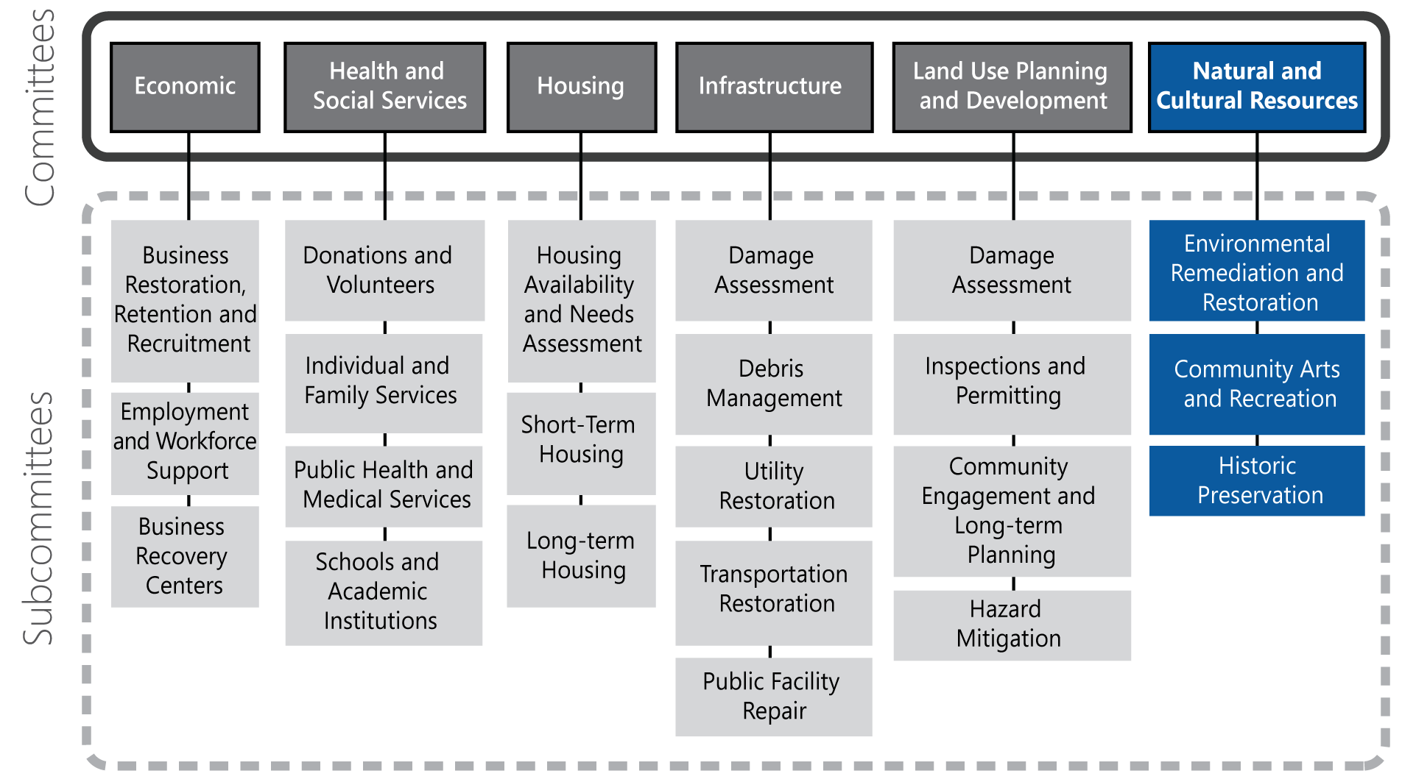

Local Recovery Partners

Local Organization | Environmental Remediation and Restoration | Community Arts and Recreation | Historic Preservation
Office of Environmental Quality | Lead
Office of Cultural Affairs |  | Lead
Cultural Nongovernmental Organizations (e.g., Cultural Advocacy Coalition, Center for the Arts) |  | Support | Support
Parks and Recreation Department | Support | Support
Neighborhood Associations and Business Districts |  | Support | Support
University Cultural and Natural Resource Departments | Support | Support | Support
Public Libraries |  | Support
Museums, Art Galleries, Performing Arts Venues |  | Support
Historical Society or Historic Preservation Commission |  | Support | Lead

State and Federal Recovery Partners
The table below lists state and federal recovery partners that may coordinate efforts with the Natural and Cultural Resources Committee. The federal agencies listed have committed to these roles per the NDRF.
Effective September 1, 2019, House Bill 6 (HB6) enacts the Disaster Recovery Task Force through TDEM to help local communities throughout the long-term recovery period. The Task Force may use the resources of the Texas A&M University System, including the Texas A&M AgriLife Extension Service, the Texas A&M Engineering Extension Service, and the Texas A&M Forest Service, and other state agencies and organized volunteer groups. As this Task Force is in the initial stages of development, the table below lists state agencies that could potentially be called upon by the Task Force to provide resources to support these critical functions.

Texas (Potential Recovery Partners) | Federal Recovery Partners
Primary Agencies  - Texas A&M University System – Texas Division of Emergency Management  - Texas Commission on the Arts  - Texas Parks and Wildlife Department | Coordinating Agency  - U.S. Department of the Interior  Primary Agencies  - Federal Emergency Management Agency  - U.S. Department of the Interior  - U.S. Environmental Protection Agency
Supporting Organizations  - Texas Commission on Environmental Quality  - Texas Commission on Fire Protection  - Texas Forest Service  - Texas Library and Archives Commission  - Texas Preservation Board  - Texas Wildlife Services  - Texas Historical Commission  - Texas Historical Foundation | Supporting Organizations  - Corporation for National and Community Service  - Council on Environmental Quality  - Delta Regional Authority  - General Services Administration  - Heritage Emergency National Task Force  - Institute of Museum and Library Services  - Library of Congress  - National Archives and Records Administration  - National Endowment for the Arts  - National Endowment for the Humanities  - U.S. Army Corps of Engineers  - U.S. Department of Agriculture  - U.S. Department of Commerce  - U.S. Department of Homeland Security/Cybersecurity and Infrastructure Security Agency

Environmental Remediation and Restoration

Objective
Ensure proper cleanup of the natural environment from contamination resulting from the disaster and take steps to avoid further damage.

Overview
The Environmental Remediation and Restoration Subcommittee requires representatives with knowledge of environmental regulations, hazardous materials, permitting processes, and waste removal and management. This Subcommittee will coordinate and oversee cleanup activities and liaise with state and federal environmental quality regulators.

Pre-disaster Preparedness Activities
- Conduct emergency planning, training, and exercises for response and recovery from potential contamination incidents.

Transition Phase Activities
- Support response operations to stabilize disaster impacts to environmental resources and prevent further damage.
- Provide subject-matter experts to assist with damage assessments to evaluate disaster-related impacts to environmental resources.
- Support debris management operations to ensure that they do not cause environmental damage (such as a release of hazardous substances).

Short-term Recovery Activities (initiated within 8 weeks post-disaster)
- Provide local representatives to the joint PDA team, as needed, to evaluate disaster-related impacts to environmental resources.
- Identify environmental repair and restoration needs and available personnel assets. Estimate local, state, and federal resource requirements.
- Communicate the importance of adhering to proper environmental regulations and development processes to property owners, infrastructure holders, contractors, builders, and others.
- Develop and disseminate public messaging for preventing environmental contamination during residential and business cleanup activities.
- Provide ongoing support to debris management operations to ensure that they do not cause environmental damage (such as a release of hazardous substances).
- Conduct ongoing monitoring and testing for potential contamination of soil, water, etc.
- Coordinate with state and federal agencies to ensure compliance with environmental regulations.

Long-term Recovery Activities
- Continue public outreach to promote environmental stewardship during recovery efforts.
- Continue providing support to debris management operations to ensure that they do not cause environmental damage (such as a release of hazardous substances).
- Continue monitoring and testing for potential contamination of soil, water, etc.
- Develop and implement an action plan with identified restoration projects and programs (e.g., cleanup of waterways, reconstitution of wetlands, conversion of flood-prone areas to open space). Outline implementation actions, costs, and timeline. Ensure all projects and programs comply with state and federal regulatory requirements and receive proper approvals.
- Identify federal, state, NGO, and private programs and/or funding opportunities to implement the action plan.
- Coordinate with FEMA to manage EHP review processes.
- Support Public Assistance projects, as applicable.
- Proactively advise and support other Recovery Committees in meeting environmental requirements.

Information Collection
Proposed measures of recovery progress in this area include:
- Adherence to federal requirements; and
- Progress of cleanup activities and recovery projects.

Community Arts and Recreation

Objective
Repair damaged cultural resources and restore arts and recreation programming.

Overview
The Community Arts and Recreation Subcommittee involves participation from representatives of art galleries, museums, and recreational programs. This Subcommittee focuses on retaining, restoring, and rebuilding the unique cultural assets that are important to the community and identifying opportunities to expand them. These assets can help a community reflect, heal, and celebrate during recovery.

Pre-disaster Preparedness Activities
- Create a database of cultural resources and points of contact.
- Convene community arts and philanthropic organizations to discuss the protection of cultural assets and structures and how disasters might impact them.
- Identify opportunities for hazard mitigation measures to increase resilience of culturally significant buildings.
- Encourage arts and cultural organizations to plan for continuity of operations and preservation of valuable items or resources.

Transition Phase Activities
- Participate in damage assessment activities, as requested, to evaluate disaster impacts to cultural resources (e.g., parks, open spaces, museums and galleries, performing arts venues, landmarks, etc.).

Short-term Recovery Activities (initiated within 8 weeks post-disaster)
- Identify repair and restoration needs for culturally significant structures, documents, and objects. Estimate needed local, state, and federal resources.
- Implement measures to repair damage to structures and protect and preserve culturally significant documents and objects.
- Prioritize reopening libraries and other popular public spaces that can serve as recovery information centers and Internet access hubs.
- Work with the Land Use Planning and Development Committee to identify parks and open spaces that can be temporarily repurposed for recovery efforts such as parking for mobile homes, equipment staging, donation storage and distribution, and information centers.

Long-term Recovery Activities
- Prioritize repair of popular community facilities, such as sports fields and recreation centers, to support the well-being of residents.
- Coordinate public engagement opportunities with residents to identify opportunities for improving local arts and recreation programs and facilities during recovery.
- Identify ways that private donors, endowments, and philanthropic organizations can support recovery projects that expand arts and cultural programs.
- Use abandoned structures and vacant shop windows for visual art displays and identify vacant lots and other outdoor sites to locate community projects and gathering spots.
- Leverage existing mobile programming, such as library bookmobiles, to bring arts and culture to neighborhoods and community gatherings.
- Hold celebratory recovery events at community arts and recreation facilities to engage the whole community.

Information Collection
Proposed measures of recovery progress in this area include:
- Status of arts facilities and recreation areas;
- Attendance at community events; and
- New arts and recreation facilities and programs.

Historic Preservation

Objective
Support efforts to maintain the historic character of the community during the rebuilding process.

Overview
The Historic Preservation Subcommittee facilitates timely and proper repairs to historic sites and properties. This Subcommittee must have knowledge of the local historic preservation and restoration guidelines and processes, applicable covenants and regulations, and permitting and construction procedures.

Pre-disaster Preparedness Activities
- Identify strategies to streamline regulatory approvals and permitting for repairs and reconstruction in historic districts.
- Perform a vulnerability assessment for listed historical sites to determine potential risks to hazards.

Transition Phase Activities
- Coordinate stabilization efforts to salvage historic sites that are not completely destroyed.
- Coordinate the secure removal and storage for historic artifacts to prevent further damage.

Short-term Recovery Activities (initiated within 8 weeks post-disaster)
- Coordinate with the Damage Assessment Subcommittee to obtain status of historic properties.
- Provide owners of historic buildings with information for repair and restoration in accordance with historic preservation guidelines.

Long-term Recovery Activities
- Coordinate with FEMA to manage EHP review processes, as needed.
- Determine long-term strategies to restore damaged historic sites and enhance resilience to future disasters.

Information Collection
Proposed measures of recovery progress in this area include:
- Number of historic sites and properties pre-disaster;
- Number of damaged or destroyed historic properties;
- Number of culturally or historically sensitive artifacts damaged or destroyed; and
- Number of restored historic properties, sites, or artifacts.

