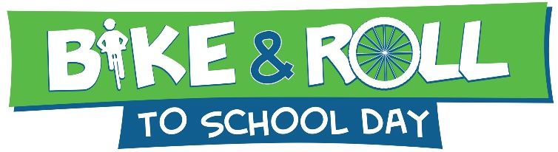
May x, 20xx
Text for Parent Outreach Materials

Copy and paste this text into an email to parents to raise awareness about and solicit volunteers for Bike & Roll to School Day.

Dear Parents,
You and your student(s) are invited to participate in Bike & Roll to School Day 20xx at [insert your school name here] on [insert day of week] [insert date]! Bike & Roll to School Day is an annual nationwide celebration to encourage physical activity among children. On Bike & Roll to School Day, parents, students, school personnel, and community members walk together to school. It is a fun way to teach students about the importance of physical activity, the benefits of walking, and to help students and their families identify safety concerns along routes to school.
Please contact me at [insert contact information here] to volunteer for a fun, easy morning of activities. You can choose to help plan the event or help on the event morning. All activities will conclude before the school day begins.
- Visit nctcog.org/walkbikeroll for more information about Bike & Roll to School Day.

Thank you!
[Your name here]

