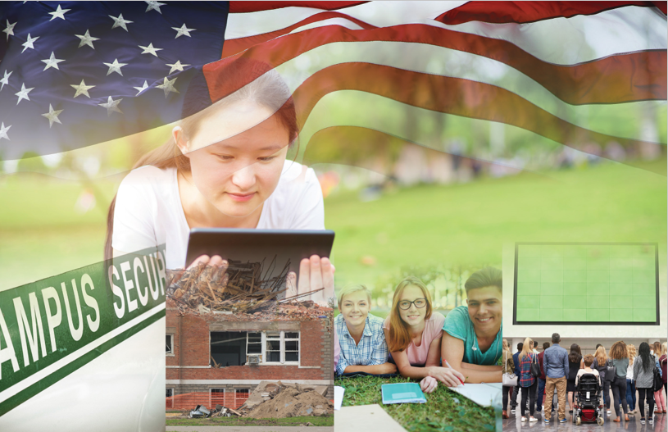
Campus Resilience Program
Exercise Starter Kit
Active Shooter: High School Tabletop Exercise

Situation Manual
[Insert Date]
Sponsor Logo

Handling Instructions
[Planner Note: The purpose of this Situation Manual is to provide a baseline exercise document that High Schools can use to assess their emergency plans, policies, and procedures. The sample content contained in this document can be tailored as necessary to meet the desired goals and outcomes for the exercise by filling in all bracketed content that is highlighted in red. This document is to be used in tandem with the Active Shooter: High School Tabletop Exercise Conduct Briefing and Facilitator Guide, therefore any changes made to this document will also need to be aligned with those documents.]
The title of this document is the Active Shooter: High School Tabletop Exercise (TTX) Situation Manual. This document should be safeguarded, handled, transmitted, and stored in accordance with appropriate security directives. Reproduction of this document, in whole or in part, is prohibited without prior approval from the exercise planning team. This document has been marked as “FOR DISCUSSION PURPOSES ONLY.”
For more information on this exercise, please consult the following point of contact:
[Lead Planner Name]
[Position]
[Organization]
[Division within Organization]
[Phone]
[Email]

Table of Contents

Handling Instructions i
Table of Contents ii
Agenda iii
Overview 1
General Information 2
Introduction 2
Overview 2
Objectives and Core Capabilities 2
Participant Information and Guidance 3
Participant Roles and Responsibilities 3
Exercise Structure 3
Exercise Guidelines 4
Assumptions and Artificialities 4
Assumptions 4
Artificialities 4
Module 1: Initial Response 5
Scenario 5
Discussion Questions 6
Module 2: Continued Response 8
Scenario 8
Discussion Questions 8
Module 3: Short-Term Recovery 10
Scenario 10
Discussion Questions 10
Appendix A: Relevant Plans A-1
Appendix B: Participating Organizations B-1
Appendix C: Acronyms C-1

Agenda
Active Shooter: High School Tabletop Exercise
[Date]; [Time]
[Location of Exercise]
[Planner Note: The agenda items and times listed below are general suggestions for the exercise breakdown. Activities and times may be adjusted based on a school’s exercise scope, planned attendance, and duration.]
[00:00 a.m.] | [Welcome and Introductions] [Recommended Time: 5 Minutes]
[00:00 a.m.] | [Exercise Overview] [Recommended Time: 10 Minutes]
[00:00 a.m.] | Module 1: Initial Response [Recommended Time: 60 Minutes]
[00:00 a.m.] | Break [Recommended Time: 10 Minutes]
[00:00 p.m.] | Module 2: Continued Response [Recommended Time: 60 Minutes]
[00:00 p.m.] | Break [Recommended Time: 10 Minutes]
[00:00 p.m.] | Module 3: Short-Term Recovery [Recommended Time: 60 Minutes]
[00:00 p.m.] | [Exercise Hot Wash] [Recommended Time: 15 Minutes]
[00:00 p.m.] | [Closing Comments] [Recommended Time: 10 Minutes]

Overview
Exercise Name | Active Shooter: High School Tabletop Exercise
Exercise Date | [Insert Date]; [Insert Start Time – End Time]
Scope | This exercise is a discussion-based tabletop exercise, planned for [insert exercise duration] at [insert exercise location]. Divided into three Modules, this exercise will examine response to and recovery operations related to an active shooter scenario.
Mission Areas | Response and Recovery
Objectives | - Operational Coordination: Assess the ability to establish an effective command structure that integrates all critical stakeholders to ensure school and community resources are used efficiently to respond to and recover from an active shooter incident.  - On-Scene Security, Protection, and Law Enforcement: Evaluate the ability to provide a safe and secure environment for students and staff, as well as first responders, during the response to an active shooter incident occurring on school grounds.  - Mass Care Services: Examine processes and procedures to provide and coordinate mass care services to include life-sustaining, human services, and Psychological First Aid for Schools (PFA-S) during the response to and recovery from an active shooter incident.  - Public Information and Warning: Assess the ability to deliver coordinated, actionable, age-appropriate, and timely information to critical partners and stakeholders when faced with an active shooter incident.  - Community Resilience: Assess recovery plans that capture expectations, priorities, and actions of students, staff, families, and the community in the aftermath of an active shooter incident.
Scenario | The exercise scenario will include an active shooting incident that results in mass-casualty and mass-fatality on [insert your school’s name] grounds.
Participating Groups/Departments | - [Insert Participating Organization]  - [Insert Participating Sub-Organization]  - [Insert Participating Organization]  - [Insert Participating Sub-Organization]  A full list of participating organizations is provided in Appendix B.
Sponsoring Organization | [Insert Sponsoring Organization(s)]
Point of Contact | [Insert Point of Contact Name], [Position], [Organization]  [Phone number], [Email]

General Information

Introduction
This document serves as the Active Shooter: High School Tabletop Exercise Situation Manual (SitMan). It includes the exercise goals and objectives, scenario details, as well as discussion questions for use during the exercise. In addition to aligning with the National Preparedness Goal, the content contained in this SitMan has been designed in accordance with Homeland Security Exercise and Evaluation Program (HSEEP) doctrine.

Overview
The U.S. Department of Homeland Security (DHS), Office of Academic Engagement (OAE) is pleased to support the Active Shooter: High School Tabletop Exercise as part of the broader Campus Resilience Program (CR Program) Exercise Starter Kits. This Exercise Starter Kit was made possible through the collaboration and coordination with the Federal Emergency Management Agency (FEMA) National Exercise Division (NED).
The broader purpose of each Exercise Starter Kit offered through the CR Program is to support practitioners and senior leaders from the High School education community in assessing emergency plans, policies, and procedures while also enhancing overall resilience. Specifically, this Exercise Starter Kit will provide the opportunity to examine response and recovery operations related to a school mass shooting.

Objectives and Core Capabilities
The following objectives in Table 1 describe the expected outcomes for this exercise. The objectives are linked to core capabilities, which are distinct critical elements necessary to achieve the specific mission area(s).
Table 1: Exercise Objectives and Core Capabilities
Exercise Objective | Core Capability
- Assess the ability to establish an effective command structure that integrates all critical stakeholders to ensure school and community resources are used efficiently to respond to and recover from an active shooter incident. | - Operational Coordination
- Evaluate the ability to provide a safe and secure environment for students and staff, as well as first responders, during the response to an active shooter incident occurring on school grounds. | - On-Scene Security, Protection, and Law Enforcement
- Examine processes and procedures to provide and coordinate mass care services to include life-sustaining, human services, and Psychological First Aid for Schools (PFA-S) during the response to and recovery from an active shooter incident. | - Mass Care Services
- Assess the ability to deliver coordinated, actionable, age-appropriate, and timely information to critical partners and stakeholders when faced with an active shooter incident | - Public Information and Warning
- Assess recovery plans that capture expectations, priorities, and actions of students, staff, families, and the community in the aftermath of an active shooter incident. | - Community Resilience

Participant Information and Guidance

Participant Roles and Responsibilities
The term participant encompasses many groups of people, not just those playing in the exercise. Groups of participants involved in the exercise, and their respective roles and responsibilities, are detailed below.

Facilitator(s)
The Facilitator will guide exercise play and is responsible for ensuring that participant discussions remain focused on the exercise objectives. They provide additional information and resolve questions as required. They are also responsible for making sure everyone is included in the conversation and has the opportunity to participate.

Players
Players have an active role in discussing their preparedness, response, and recovery activities during the exercise. Players should discuss or initiate actions based on the simulated exercise scenario.

Observers
Observers may visit or view selected segments of the exercise but do not actively engage in exercise discussions.

Support Staff
The exercise support staff includes individuals who perform administrative and logistical support tasks during the exercise (e.g., registration, catering, etc.).

Exercise Structure
The Active Shooter: High School Tabletop Exercise will consist of three, [insert duration]-minute Modules that focus on response and recovery operations. Each Module will consist of two separate activities: a scenario overview and facilitated discussions. The exercise facilitator will first provide an overview of the scenario and will then engage participants in facilitated discussions around a set of questions. Discussions should focus on key actions, activities, and decisions that each player would perform given the specific scenario conditions. The three exercise Modules include:
- Module 1 will focus on initial response operations to an active shooter incident
- Module 2 will focus on continued response operations to an active shooter incident
- Module 3 will focus on short-term recovery operations following an active shooter incident
The approximate duration of each exercise activity is noted in Table 2 below.
[Planner Note: The timing of the items in Table 2 are general suggestions. Activities and times may be adjusted based on a school’s exercise scope, planned attendance, and duration.]

Table 2: Module Structure
 | Module 1 | Module 2 | Module 3
Total Minutes | [60 Minutes] | [60 Minutes] | [60 Minutes]
Scenario Updates | [5 Minutes] | [5 Minutes] | [5 Minutes]
Facilitated Discussions | [55 Minutes] | [55 Minutes] | [55 Minutes]

Exercise Guidelines
This exercise will incorporate a scenario-based format guided by the event objectives. The Modules and associated discussion questions support achievement of the objectives by initiating discussions, facilitating decision-making, and assisting participants in the arrival of appropriate response outcomes. This approach allows the discussions to focus on situations within a moving timeline and for participants to contribute to the discussion from the perspective of their role in the scenario. The Facilitator will ensure that the scenario moves along at an appropriate pace and that all participants have an opportunity to contribute.

Assumptions and Artificialities

Assumptions
Assumptions are the implied factual foundation for the exercise and are assumed to be present before the exercise starts. The following assumptions apply to the exercise:
- Exercise players will use existing plans, policies, procedures, and resources to guide responses
- Participants may need to balance exercise play with real-world emergencies; real-world emergencies take priority
- [Insert any additional assumptions that may be relevant to the exercise]

Artificialities
During this exercise, the following artificialities apply:
- The scenario is plausible, and events occur as they are presented
- There is no “hidden agenda” nor are there any trick questions
- The scenario assumes certain player actions as it moves through each phase; players should first discuss the actions stipulated by the scenario
- Players are welcome to engage in “what if” discussions of alternative scenario conditions
- [Insert any additional artificialities that may be relevant to the exercise]

Module 1: Initial Response

Background
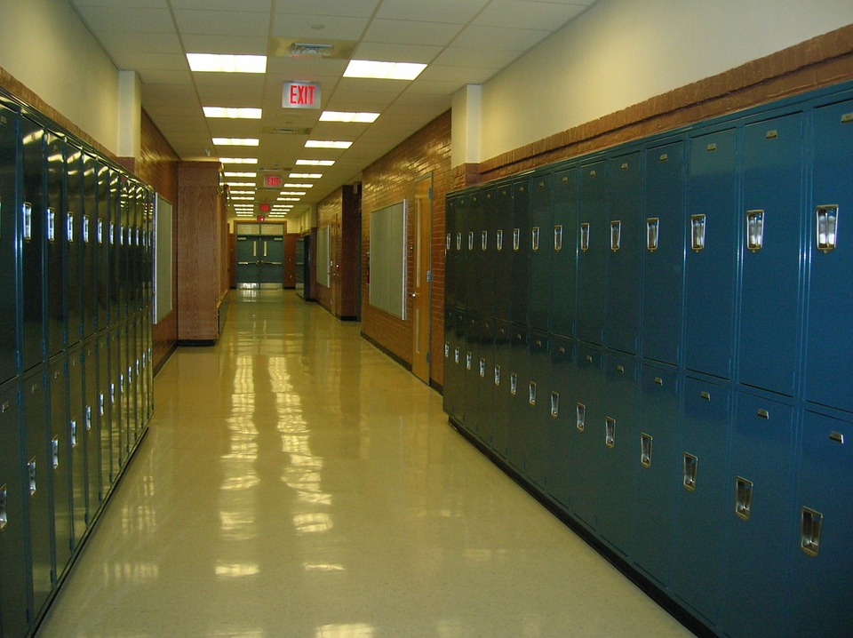
It is a few days before homecoming at your school and students and staff are preparing for a rally for your school’s sports team. Decorations are being put up in the auditorium, and due to the sunny weather, the band is practicing outside in the sports fields.
Figure 1: High School Building
A student notifies a teacher [insert school resource officer if applicable] that another student has posted disturbing messages on social media about wanting to hurt students and teachers at the school.

Scenario
[Insert Date and Time]
Two hours later, an unidentified individual with two large duffle bags is seen entering [insert school name], where classes are currently taking place, and activities are occurring inside the auditorium and outside on the sports fields. Soon after, loud “popping noises” and screams can be heard coming from a hallway on the first floor. The suspect enters classrooms one by one and begins firing a rifle indiscriminately at anyone he sees. Students and staff in other classrooms, hearing the shots and screams, begin turning off lights, barricading doors, and hiding. Several students are seen fleeing the building and some of them are covered in blood and appear to be in shock. The gunman leaves the first floor through a stairwell and proceeds to walk up the stairs towards the second floor. The sound of popping noises and screaming continues sporadically.
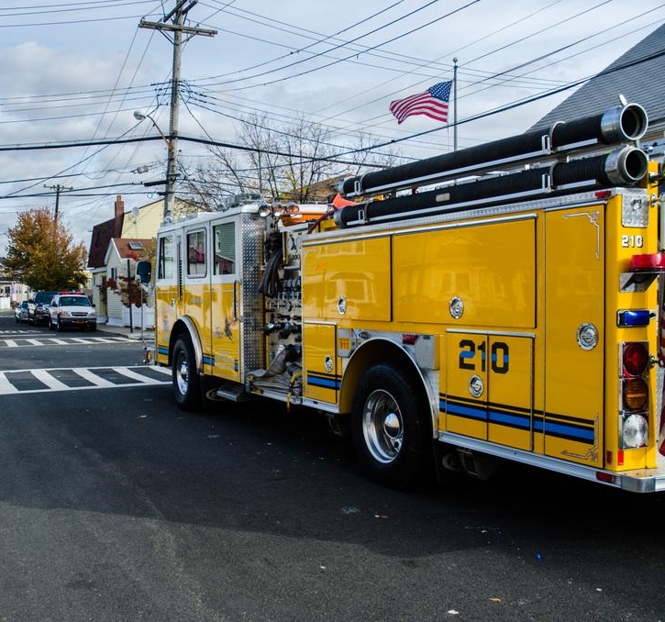
Local 9-1-1 operators receive calls from students and staff both inside and outside the school reporting popping noises, screaming, and flashes of light. Calls are frantic and do not provide a detailed understanding of the threat.
Figure 2: Fire/EMS Services
Additionally, posts on social media from students frantically reporting their experience both in and out of the [insert school name] begin trending. Students who had been in the sports fields begin to flee.
[The school resource officer hears gun shots and sees people frantically fleeing the building and leaving the surrounding area. She runs into the building and hears shots coming from an upper floor. She runs up the stairs and encounters the gunman in a second-floor hallway. The officer is hit and goes down outside one of the classrooms. The officer contacts dispatch and requests back up and medical assistance as she crawls to find cover.]
First responders from the local police department, fire-rescue, and emergency medical services (EMS) begin to arrive on scene.

Discussion Questions

Operational Coordination
- What plans, policies, and procedures does your school have in place to respond to an active shooter event?
  - Does your school have an Emergency Operations Plan (EOP)?
  - Has the EOP been shared with local first responders?
- What are your school’s initial priorities?
- How would your school establish a command structure to coordinate your immediate response efforts?
  - Is there a single individual (or position) within your school who would make leadership decisions?
  - Who are your key internal and external partners and how would your school incorporate them into this command structure?
    - Does your school have a school resource officer?
    - Does your school have existing partnerships with local first responders?
    - Are there roles and responsibilities for leadership within your school district, as applicable?
  - How can your school coordinate with private and public partners to ensure a unified response effort?
- What resource gaps could limit your school’s ability to respond to an active shooter?
  - What community resources and aid agreements could compensate for these resource gaps?
- [Insert additional discussion questions as appropriate]

On-Scene Security, Protection, and Law Enforcement
- In terms of securing the scene, what are the immediate priorities?
  - What plans, policies, or procedures are in place to maintain the safety of your students and staff during initial response efforts?
  - Do these plans address accessibility concerns for shelter sites and evacuation routes for those with access and functional needs and / or language needs?
  - Do these plans address those students who may not be with staff or in a classroom?
- Given the situation, what protective measures would you adopt at this point, if any?
  - Do you have plans to evacuate, lock-down, or shelter-in-place students, staff, and visitors?
  - Do your staff and your local first responders have access to the building schematics and other pertinent information regarding locations of locks and access controls?
  - Do your local first responders have advance information on where students and staff are likely to be sheltering or evacuating based on your existing plans?
  - Do your staff and your local first responders know the location of public address systems, security cameras, and alarm controls?
- How would resource needs be prioritized in the event of a secondary attack?
- Have you trained or exercised with your local first responders?
- [Insert additional discussion questions as appropriate]

Mass Care Services
- What are your school’s immediate mass care priorities?
  - Do your staff and your local first responders know the location of medical supplies?
  - Have any of your staff participated in the “Stop the Bleed” campaign?
  - Are any of your staff trained to provide Psychological First Aid for Schools (PFA-S)?
- What partners would you begin to coordinate with at this point?
  - Who are your internal partners?
  - Who are your external partners?
  - Do you have existing partnerships with these individuals or organizations?
- What critical decisions might need to be made at this point?
  - Who at your school is responsible for making and coordinating these decisions?
- [Insert additional discussion questions as appropriate]

Public Information and Warning
- How does your school issue warnings, alerts, and other emergency messaging?
  - Does your school use pre-scripted or automated messaging that would expedite critical communications?
  - Does your school have age-appropriate messaging for this type of incident?
  - Do your communications methods include the capability to communicate with students and staff who have language or access and functional needs requirements?
  - Are your communications protocols known and accessible to staff and your local emergency responders who may need to implement these protocols?
- What plans, policies, and procedures does your school have in place to guide your internal and external communications strategies?
  - Who are your internal and external partners?
  - What information should your school release to them at this time?
- What individual (or position) coordinates and delivers your school’s public messaging?
- How does your school encourage students, staff, and families to take individual steps to prepare for a potential active shooter incident?
- [Insert additional discussion questions as appropriate]

Module 2: Continued Response

Scenario
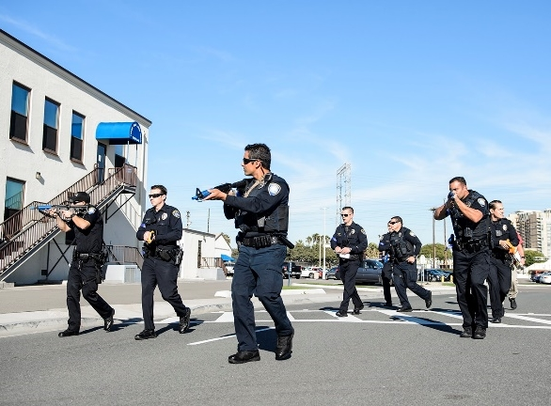
[Insert Date and Time + 15 Minutes]
Figure 3: Law Enforcement Officers on Scene
Local law enforcement officials arrive on scene within minutes of the first 9-1-1 call from a student cell phone inside the building. [Police quickly enter the building and ascend the stairs to the second floor where the wounded officer called in her request for backup.] They begin a systematic search of the building for the gunman and call for the local special weapons and tactics (SWAT) team to respond and aid in the search for the suspect.
The shooter barricades himself inside a second-floor stairwell and hears police activity below. Once he sees SWAT on the second-floor landing, he fatally shoots himself. SWAT and local authorities begin rescue operations.
[Insert Date and Time + 1 Hour]
National and local media outlets are beginning to provide coverage of the incident, and there is reporting on social media posts as the event unfolds. Conflicting information is being reported on various networks to include multiple suspects involved in a shooting rampage at the school.
Upon hearing the news reports, parents begin arriving at the school and begin inundating the school with phone calls, wanting to know if their children are safe and demanding information. Several distraught parents require medical attention. Many students were seen fleeing either on foot, in their vehicles, and on bikes potentially complicating accountability and reunification efforts.

Discussion Questions

Operational Coordination
- What plans, policies, and procedures does your school have in place to guide response efforts at this point?
  - How have your priorities shifted?
  - If applicable, does your school district have specific plans for all schools within the district?
- How would your school maintain an effective command structure to coordinate emergency response efforts?
  - Who are the key decision-makers at this point?
  - What are their specific roles and responsibilities?
  - If applicable, what is the role of your school district, the district authorities, and public officials?
- How do key decision-makers collect information to assess the extent of the situation, to include injuries and fatalities?
- What resources are currently available?
  - What plans, agreements, and contingency contracts are in place to address potential resource shortages?
- Who are the key external partners that would support response efforts?
  - How would your school coordinate and communicate with these partners?
- [Insert additional discussion questions as appropriate]

On-Scene Security, Protection, and Law Enforcement
- What response plans and protocols would your school activate at this point?
  - What partners would be involved in managing and securing the scene?
  - Are your students and staff familiar with rescue operations and procedures and the expected actions of the local first responders at the scene?
- How will students and staff know when the school is safe and the scene is secure?
- What additional protective measures would be implemented at this time based on your earlier decision to either evacuate, shelter-in-place, or lock-down the school?
- How would you begin to conduct personnel accountability for students and staff?
- [Insert additional discussion questions as appropriate]

Mass Care Services
- What potential mass care challenges does this type of incident pose for emergency managers and law enforcement response personnel?
  - What challenges does this incident pose, if any, for resource coordination efforts?
- How would your school address challenges of injured students and staff both on-scene and those fleeing away from the scene?
  - How will you coordinate with emergency responders and emergency care facilities to identify, locate, and transport injured or deceased persons?
- Does your school have a family reunification plan in place?
  - If yes, has the plan been shared with parents, guardians, and designated emergency contacts? With your staff and with the applicable local first responders?
  - Does the plan address pre-designated locations and communications requirements?
  - What external partners, if any, would support family reunification?
  - What challenges does this incident pose, if any, for family reunification efforts?
- [Insert additional discussion questions as appropriate]

Public Information and Warning
- How does your school ensure consistent, coordinated public messaging throughout this phase of response operations?
  - Who is responsible for delivering this public messaging?
  - How does this messaging accommodate students, staff, and families with language needs or access and functional needs?
- How does your school ensure timely and accurate updates for internal and external partners throughout the response period?
  - Who is responsible for delivering these updates?
  - What sort of information is your school releasing at this point?
- Does your school have a crisis communications plan? If so, how and when is it activated?
- How does your school notify families, key partners, and the public of fatalities or serious injuries?
- [Insert additional discussion questions as appropriate]

Module 3: Short-Term Recovery

Scenario
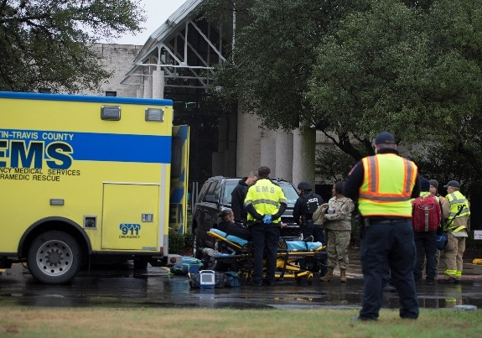
[Insert Date and Time + 4 Hours]
Figure 4: EMS Personnel on Scene
After a few hours, response personnel confirm that the threat has been neutralized. Law enforcement confirm that the gunman was indeed related to the credible threat of the social media post reported earlier in the day. Law enforcement also conduct a building and grounds search for possible accomplices and clear the school and grounds of any additional suspects or threats.
Individuals that sustained gunshot wounds and other injuries at the scene of the shooting have been transported to healthcare facilities and hospitals in the area. At this time, your school is still compiling information on the number of wounded and how many patients each hospital has received. Additionally, your school has transitioned from emergency response to fatality management operations for approximately [insert number] fatalities on several floors of the [insert school name] building. Your school is working to confirm the identities of the deceased.
Your school has implemented family reunification protocols to provide other resources and services to the impacted families, students, and staff.
Local and national media continue to cover the story. Students are active on social media, posting that they are worried about returning to school and participating in upcoming school activities and sports events.

Discussion Questions

Operational Coordination
- How does your school coordinate the transition from response to short-term recovery efforts?
- What plans, policies, and procedures guide your school’s recovery process?
  - Who is responsible for coordinating short- and long-term recovery efforts?
  - What are your school’s priorities for short-term recovery?
- What resource gaps could limit your school’s ability to meet these priorities?
  - What community resources or aid agreements could compensate for those gaps?
  - How can your school coordinate with private and public partners to ensure a whole-community recovery effort?
- [Insert additional discussion questions as appropriate]

On-Scene Security, Protection, and Law Enforcement
- What plans or procedures are in place to manage and secure the scene following the incident?
  - How do these account for situations involving mass fatalities or casualties?
  - At what point can a scene be considered safe or secure?
  - Who is responsible for making this determination?
- What partners would be engaged to assist with these efforts?
- What is the process for tracking the status and location of individuals who have been injured or fatally wounded?
- [Insert additional discussion questions as appropriate]

Mass Care Services
- What are your school’s mass care recovery priorities at this point?
  - What type of information or services are you providing?
  - What stakeholders would your school engage to assist with this effort?
- How does your school handle the notification of death or injury to relatives?
  - How does this account for families of international students?
- What plans or policies are in place to support affected populations with counseling and behavioral health resources?
- What additional resources, if any, would be needed to support family reunification and other support services for families, students, and staff?
- [Insert additional discussion questions as appropriate]

Public Information and Warning
- How does your school ensure consistent, coordinated public messaging throughout the recovery period?
  - How does your school’s communications strategy transition from response-oriented to recovery-oriented messaging?
- How does your school provide internal and external partners with timely updates concerning recovery efforts? With families, students, staff, and alumni?
- Do your recovery communications methods include the capability to communicate with students and staff who have language or access and functional needs requirements?
- [Insert additional discussion questions as appropriate]

Community Resilience
- Has your school and your community thought about the aftermath of this type of incident and what the priorities, needs, and expectations are of the students, staff, families, and community?
- Does your school have the ability to support long-term behavioral health needs for students and staff? If not, are there public or private resources that can support these requirements?
- What actions, if any, have been identified to help the community heal?
- [Insert additional discussion questions as appropriate]

Appendix A: Relevant Plans
[List any relevant plans, policies, or procedures to be tested during the exercise]

Appendix B: Participating Organizations
Participating Organizations
[Insert Participating Organization]
[Insert Participating Organization]
[Insert Participating Organization]
[Insert Participating Organization]
[Insert Participating Organization]
[Insert Participating Organization]
[Insert Participating Organization]

Appendix C: Acronyms
Acronym | Term
CR Program | Campus Resilience Program
DHS | Department of Homeland Security
EMS | Emergency Medical Services
FEMA | Federal Emergency Management Agency
HSEEP | Homeland Security Exercise and Evaluation Program
NED | National Exercise Division
OAE | Office of Academic Engagement
SitMan | Situation Manual
SWAT | Special Weapons and Tactics
TTX | Tabletop Exercise
[Acronym] | [Term]
[Acronym] | [Term]
[Acronym] | [Term]

